|  |
| --- |
|  |
| AI Tic Tac Toe  Computer Science Coursework |
| |  |  |  | | --- | --- | --- | |  | Dmytro Dudarenko |  | |

Contents

Analysis 6

Outline of the idea 6

Research 6

Stakeholders 9

Demographics of the stakeholders: 9

Questions to ask stakeholders: 10

Survey Results and Feedback Review: 10

User Requirements 12

Introduction 12

Limitations 16

Summary 16

Hardware Requirements: 16

Software Requirements 17

Computational Methods 17

Design 18

GUI Design 18

Main Menu 18

About Project Screen 19

Game Screen 21

Program Diagrams 23

Structure Diagram 23

Summary: 23

Stages of Development 24

Introduction 24

Plan of Stages 24

Order Justification 26

Robustness testing 27

Plan 27

Tests table 27

Stage 1 – Design of the Screens 28

Substage – Game Screen 28

Stage 1 Flowchart 30

Justification: 30

Stage 1 Development 31

Summary: 31

Bug Fixes: 34

Stage 1 Review 36

Stage 2 – Functionality of the Screens 37

Substage – Game Screen 37

Stage 2 Flowchart 38

Summary: 38

Justification: 38

Stage 2 Development 40

Summary: 40

Bug Fixes: 45

Stage 2 Review 47

Stage 3 – Result Detection 48

Substage – A win 48

Stage 3 Flowchart 51

Substage – A win 51

Summary: 51

Stage 3 Development 54

Substage – A win 54

Summary: 54

Bug Fixes: 58

Stage 3 – Result Detection 62

Substage – A tie 62

Stage 3 Flowchart 63

Substage – A tie 63

Summary: 63

Stage 3 Development 64

Substage – A tie 64

Summary: 64

Bug Fixes: 64

Stage 3 Review 65

Stage 4 – AI Functionality 66

Substage – Game Screen 66

Stage 4 Flowchart 69

Summary: 69

Stage 4 Development 70

Summary: 70

Q Learning Algorithm: 77

Summary: 77

Bug fixes: 78

Stage 4 Review 85

Stage 5 – Design of the Screens 86

Substage – Menu Screen 86

Stage 5 Flowchart 88

Summary: 88

Stage 5 Development 88

Summary: 88

Stage 5 – Design of the Screens 92

Substage – About Screen 92

Stage 5 Flowchart 93

Summary: 93

Stage 5 Development 94

Summary: 94

Stage 5 Review 96

Stage 6 – Functionality of the Screens 97

Substage – Menu Screen 97

Stage 6 Flowchart 98

Summary: 98

Stage 6 Development 99

Summary: 99

Stage 6 – Functionality of the Screens 102

Substage – About Screen 102

Stage 6 Flowchart 103

Summary: 103

Stage 6 Development 104

Summary: 104

Stage 6 Review 105

Stage 7 – Settings 105

Substage – Design development 105

Summary: 105

Stage 7 Flowchart 107

Summary: 107

Stage 7 Development 108

Summary: 108

Design development: 108

Programming the design: 109

Stage 7 – Settings 113

Substage – Functionality implementation 113

Summary: 113

Stage 7 Flowchart 117

Summary: 117

Stage 7 Development 118

Summary: 118

Stage 7 Review 128

Stage 8 – Statistical Graph 129

Summary: 129

Stage 8 Flowchart 130

Summary: 130

Stage 8 Development 132

Summary: 132

Design development: 132

Coding: 134

Bug Fixes: 137

Stage 8 Review 142

Post-Development Stage 143

Testing For Function 143

Beta/Acceptance testing 143

Plan 143

Questions to ask stakeholders: 143

Survey Results and Feedback Review: 144

Robustness testing 146

Plan 146

Tests table 146

Evaluation 148

Summary 148

Evaluating Features (user requirements and success criteria) 148

Evaluating Stakeholder Preferences: 154

Evaluating Design Changes: 155

Evaluating Usability: 156

Limitations and Solutions: 157

Maintainability: 157

Conclusion: 158

Development Plan Changes (DPC) 159

Summary 159

# Analysis

## Outline of the idea

AI Tic Tac Toe. The name of the project gives a rough idea of what it is about, but at the same time a massive number of different questions come up – “How will the AI be implemented?”, “Will it be AI vs AI?”, “What’s the impact of the user on the game?”, and this is definitely not the whole set of questions, so I suggest we start from the very beginning exploring the idea of the project.

“Tic Tac Toe” or “Noughts and Crosses” is a simple game, which is known all over the world, for two players that is usually played on a piece of paper. A 3x3 grid is drawn and characters “X” or “O” are picked, then the players try to make a line that consists of 3 same characters. An important fact to say is that if two players do not make any tactical mistakes, the game result will always be a draw. However, what if one player is changed to a robot with artificial intelligence implemented? And that question is what the project is generally about, moreover, moreover, it will be discovered what happens when human plays against AI, how it develops over time, and will it play better than human in the end.

The AI-related project has been picked as I want to try myself in a new sphere, in which I have not had any previous experience and the one I am fascinated about. In addition, artificial intelligence is getting more and more popular nowadays and being used in various spheres, starting with medicine and ending with self-driven, so it is good to be a part of it.

I have to do a considerable amount of research and even contact people who are working in this sphere, so they could give me some advice, which would definitely help me to save time at certain moments and what is more important improve my project.

To sum up, throughout this project I will learn loads of new skills and struggle with an unbelievable number of problems, but in the end, I will be able to present the results of my experiment and answer the main question – how the game will go if a player is playing against AI and how artificial intelligence will develop!

## Research

**AI Trainable Tic Tac Toe:** [link to the website](https://www.tensorflowtictactoe.co/)

This project is similar to what I want to develop. They used TensorFlow, which did all the job for them, so this option is not for me, but the logic of the project is going to be similar. I do like their design, especially the way “X” and “O” look like. I also find the about window well-designed.

On the other side, I do not like that the line crossing the winning combination is shifted a lot. It is worth mentioning that it is quite annoying to press the button “Make AI move” after every user’s move. It might be important for the game to function, but I cannot see the direct purpose of it.

Last but not least, the user can play for both sides (X and O) and then show some winning combinations to the AI and how to play against them and press train AI to play like X or O, which is a really good thing, as it significantly decreases the time needed to train the artificial intelligence, but it also increases the time I will have to spend coding.

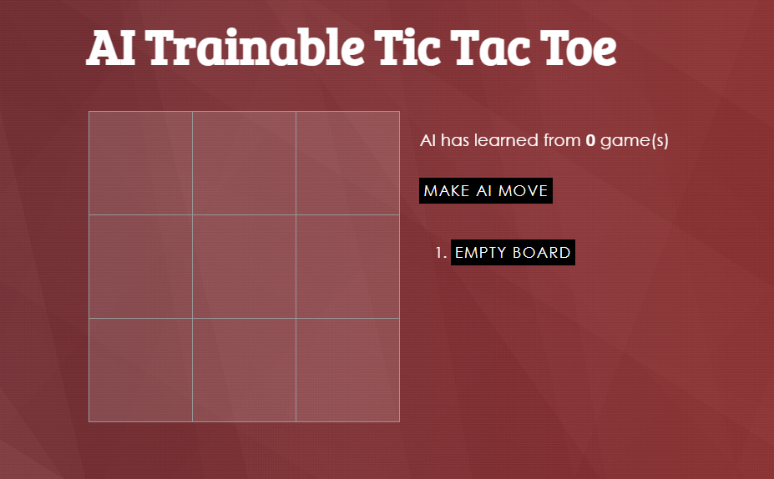

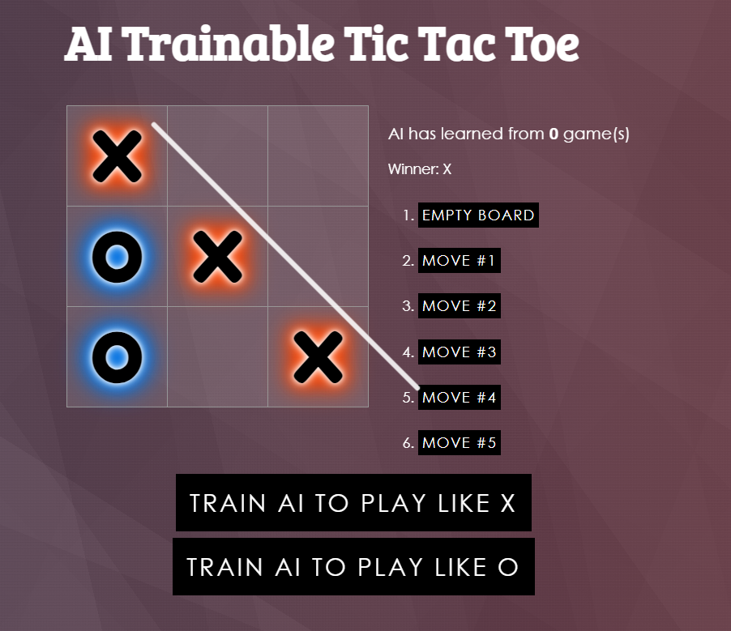

**Normal Tic Tac Toe:** [link to the website](https://playtictactoe.org/)

This Tic Tac Toe does not have any learning process involved in the game, most likely it is using the Minimax algorithm. But the reason I added it here is because I love their minimalistic design and the font.

Furthermore, they have an animation that runs every time you put a character on the grid. Instead of adding a line crossing the winning combination, they created an animation to show the winner by making all the rest of the characters dimmer, so they do not attract attention, which is an amazing idea. Furthermore, there are lots of different sounds added to the game that make it even more engaging.

One more thing is that they do not have a button to clear the board, so you just need to click on the grid, as the game finishes, and it will be cleared – that’s something I might do instead of adding a button.

It might take a lot of time to add all of that to my project, but I’m pretty sure it would be worth it.

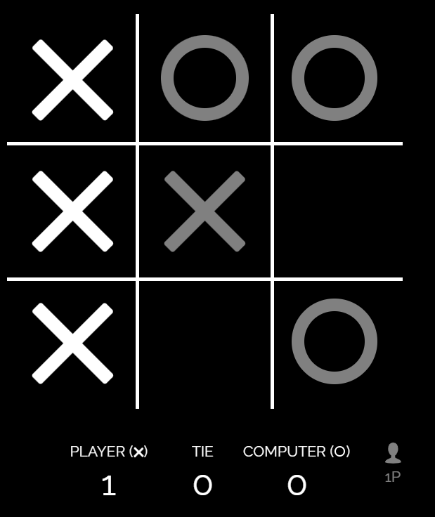

**Q Learning:** [link to the website](https://www.youtube.com/watch?v=nOBm4aYEYR4&t=1536s)

This video is not related to the Tic Tac Toe, but it is about a type of reinforcement learning algorithm – “Q learning”, that will be used to teach AI. As most of the analysed projects are using the Minimax algorithm, which basically goes through all the possible game results and picks the one where it gets the reward – wins. But I want to actually train AI and that’s why I will use Q learning and this video is an explanation of how it works.

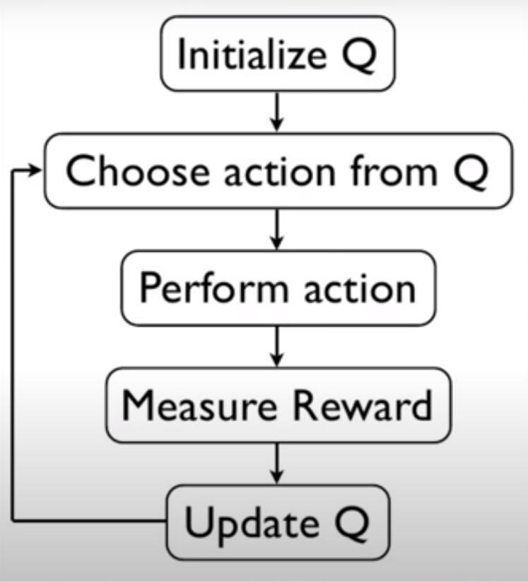

## Stakeholders

The target audience and my future stakeholders for this project are AI enthusiasts who want to understand how AI is used in gaming, people who are interested in mental challenges, and game players. Players will learn how AI develops and about its decision-making process, deepening their understanding about Artificial Intelligence. I think that the main age group for my project is 16 – 55, as I need people who have got at least a rough idea of what is AI and how it works.

I will try to involve my stakeholders in the game testing, to understand if a user will be able to train AI and to make sure that the project fits their expectations. In addition, I will ask for their feedback about the design to make it intuitively understandable for everyone.

### Demographics of the stakeholders:

|  |  |  |  |
| --- | --- | --- | --- |
| No. | Age Range | Work Sphere | Knowledge about AI |
| 1 | 16-20 | Computer Science Student | A general knowledge about AI with some experience in Reinforcement Learning algorithms |
| 2 | 25-35 | Law | No knowledge about AI |
| 3 | 25-35 | IT company | A high level of knowledge with loads of experience in Machine Learning and training models |
| 4 | 45-55 | IT company | General knowledge, no experience in working with AI |
| 5 | 45-55 | Design Agency | No knowledge about AI |

### Questions to ask stakeholders:

|  |  |
| --- | --- |
| Questions | Answer Options |
| 1. How important is it to have additional menus in the project apart from the game menu? (e.g. main menu, game guide) | Rating 1 – 10 (10 being extremely important and 1 not important at all) |
| 2. Do you expect the main menu to have anything besides the “Play button”? If yes, tell what | Text input field |
| 3. Do you expect to be able to change the parameters influencing AI’s learning rate? | Yes, No, Does not matter |
| 4. How important is it to have a visual representation of AI’s learning progress? | Rating 1 – 10 (10 being extremely important and 1 not important at all) |
| 5. Is it important to have visually responsive elements on the user’s actions? (e.g. Button changes its colour on hover) | Rating 1 – 10 (10 being extremely important and 1 not important at all) |
| 6. What aspects of UX design do you think are essential for this project’s success? | Text input field |
| 7. How important is it to have the translation of the game to different languages to improve accessibility? | Rating 1 – 10 (10 being extremely important and 1 not important at all) |
| 8. How important is it to have the game designed in different colour schemes, which can be changed by pressing a button, to improve accessibility? | Rating 1 – 10 (10 being extremely important and 1 not important at all) |
| 9. Do you have any design-related recommendations? | Text input field |

### Survey Results and Feedback Review:

**Question 1:** Based on the feedback provided, the importance of having additional menus in the project, apart from the game menu, received a high rating of 7.3 out of 10. This shows that users consider additional menus to be extremely important for enhancing the overall user experience. Additional menus, such as a main menu and game guide, can be used for different purposes, including access to the game menu, or telling the user what the project is about. Hence, this will be an essential part of the project

**Question 2:** The main menu will generally be created for the "Play" button. There are some other expectations such as having options like changing the colour theme (day/night), localisation, or accessing settings, which will all be added to the requirements but as nonessential. In addition, one of the stakeholders expects to see a Hidden Easter Egg somewhere in the game, so I will add it.

**Question 3:** Based on the feedback provided, most users expect to be able to change the parameters influencing AI's learning rate. This indicates a willing of users to have more impact on the game. Allowing to change AI parameters will enhance the gameplay experience. On the other hand, this will require having an extra menu where users will be able to change the parameters, hence more time on coding. Due to this I will add it as an inessential requirement and will not design the menu straight away as I might not have time to implement it.

**Question 4:** Based on the feedback provided, the importance of having a visual representation of AI's learning progress is rated at 7.1 out of 10. This indicates that users want to be able to see the AI's learning process and track its development over time. This will be added to the requirements as a desirable feature, but nonessential. This is because the implementation will require research about creating infographics in Python, work on visual aspects, and time to implement.

**Question 5:** The importance of visually responsive elements, such as buttons changing colour on hover, was rated as 9.7 out of 10. This shows that having such elements is important to users. Moreover, they will improve the overall usability of the game.

**Question 6:** The project's design will stick to these preferences, focusing on making things clear and simple so they are easy to understand and use. It will have a simple and flexible design to work well on different devices and screens. In addition, it will use neat and tidy graphics to make everything look nice and easy to follow.

**Question 7:** Based on the rating of 5.2 provided by the users, it suggests that translating the game into different languages is not significantly important. While multilingual support could still enhance the accessibility of the game, it might not be worth implementing it at this stage of the project as most people speak English.

**Question 8:** The rating of 5.7 indicates that the game designed in different colour schemes is not extremely significant. However, providing options for customisable colour schemes could enhance accessibility for users with specific visual preferences or problems, therefore improving their overall gaming experience.

**Question 9:** Bright and minimalistic design is recommended. Keeping it clean, easy to use, and avoiding adding many unnecessary elements is also improtant.

## User Requirements

### Introduction

In this section the user requirements for the project are shown. These requirements will be used in the development process as a guide for the design and implementation of features to meet the expectations of end users, and especially my stakeholders. By defining essential and desirable features I will make sure that the MVP is implemented, meaning that all the essential criteria are met, and then start implementation of the desirable features.

|  |  |
| --- | --- |
| Essential | Desirable |

|  |  |  |  |  |  |
| --- | --- | --- | --- | --- | --- |
| No. | Feature | Sub-feature | Explanation | Justification | Essential |
| 1 | Menu Screen | 1a. Title | The name of the game displayed on the menu screen | This element provides users with an initial understanding of the project's purpose. Its implementation is straightforward, requiring only the addition of text |  |
| 1b. Sub-title | The sub-title of the game displayed on the menu screen | The sub-title explains more about the project. Its implementation is simple. |  |
| 1c. Robot image | An image of a robot shown on the menu screen | While being added only for a visual purpose, the robot image enhances the aesthetic appeal of the menu screen. Its addition requires minimal effort to add. |  |
| 1d. Background image | A background image that will be displayed on the menu screen | The background image plays a crucial role in improving the visual appeal of the menu screen, creating a positive first impression for users. Its addition is essential for user experience. |  |
| 1e. Play button | A button that opens a game screen when clicked by the user | The play button is essential as it enables users to access the game. While its implementation may require some time to make it look the same way as it will be on the design picture, its addition is relatively straightforward |  |
| 2 | About Screen | 2a. “?” (About) button | A small button that opens About Project screen | An easy to add button that will allow user to access to the About screen |  |
| 2b. Title | Text – “About Project” displayed on the about project screen | The title of this screen makes the user understand which screen is currently being displayed. I am sure I will not have any problems with adding it. |  |
| 2c. Description | The description of the game displayed on the about project screen | This chunk of text is the main purpose of the about screen to exist. A short description of what will happen and what the user should do. Easy to add as it is just text |  |
| 2d. Background design | A background image that will be displayed on the about screen | It is an essential element of the design which will make the game look more polished. |  |
| 2e. Close button | The button displayed on the about project screen that closes it when clicked | The button with a cross drawn on it gives the user an opportunity to close the about project screen and get back to the Menu Screen. I am not sure if I will keep this button as it might be easier to use the close window button instead of my button which will send the user back to the main menu |  |
| 3 | Game Screen | 3a. Text – Pick a character | Text displayed at the top of the game screen | It is an important piece of text only if I decide to add an opportunity for the user to change the character. It might be that I will add a button “Make AI Move” as in the **research example 1,** which will automatically give the user a character depending on who goes first, but at the same time, it is very annoying to press it after each move. |  |
| 3b. Button for “X” | A button that lets a user choose the character he wants to play with | A button for the user to choose to play for X. As it was said earlier, a button Make AI Move might be added, so this button will not be added. In case it is added into the game, I need to make sure the user cannot change the character during the game |  |
| 3c. Button for “O” | A button that lets a user choose the character he wants to play with | A button for the user to choose to play for O. As it was said earlier, a button Make AI Move might be added, so this button will not be added. In case it is added into the game, I need to make sure the user cannot change the character during the game |  |
| 3d. Score | The score of victories for each character | It’s not an essential thing but the score adds some interest and a competitive feeling. Easy to add and manage. |  |
| 3e. Grid | A 3x3 grid displayed in the middle of the game screen | A significant element without which the game isn’t going to function. It might take a while to create a grid and put all the sections into one array. |  |
| 3f. A character appearing on the grid when the user clicks | A character (X or O) appears on the grid as one of the grid sections is clicked by the user | An important part of the game. As soon as the user clicks on the grid his character appears and straight after that the AI’s character appears. I need to make sure that the user or AI can only put a character in a free section. |  |
| 3g. Line crossing winning combination | A line displayed on the grid when a winning combination is found | It won’t be hard to add as I will write down all the possible winning combinations and run a function after each move to check whether there’s one or not. |  |
| 3h. Games played number | The total number of games that user played against AI | I put it into inessential group, as it will not significantly change the gameplay, but it might be a good idea to know how many games it took to train AI and in addition to that users can try different teaching ways and find the optimal one. |  |
| 3i. Clear Board button | A button to clear the board | Having this button will allow to analyse the game after playing it as the board will not be reset straight away. |  |
| 4 | AI | 4a. AI Development | Implementing Q Learning algorithm so AI will learn how to play Tic Tac Toe | This feature is extremely essential as, in fact, this is what the whole project is built around. By implementing Q learning algorithm, computer will learn on the games it has played against the user and develop by understanding what the best move in that particular situation would be. Moreover, the user will be able to see how AI develops. This will require coding helper functions to manage Q-Table and parameters |  |
| 4b. Second AI | Creating a second AI that will play instead of the user | This feature is quite essential, but it might be too hard to implement and also it actually does not completely align with the project’s concept, which is in the words “AI vs YOU” and having “AI vs AI” sounds like something completely different. But it would definitely decrease the amount of time needed for AI to develop |  |
| 5 | Additional elements | 5a. Sounds | Background music.  Character displayed sound. Adding sounds playing when the winning combination is found | This involves adding sounds to all the user actions like when the character is placed on the board or when the winning set is found. Moreover, a background music could be added, which would enhance user experience. However, this could be quite complicated and time consuming. So, this will only be done, if it will be done at all, after finishing and polishing all the main aspects of the project. |  |
| 5b. Animations | Animation on placing the characters on the board. Button pressing animations. Animation for a line crossing winning set | This is an inessential feature and an idea to create was taken from researched project 3. To my mind, this would be an awesome addition to the game, but it does not outweigh the effort that has to be put into implementing it. |  |
|  |  | 5c. Localisation | Adapting the game to different languages | Implementing language selection allows users to choose their preferred language. This enhances user engagement and satisfaction across diverse audiences. |  |
|  |  | 5d. Colour Theme | Allowing users to pick a colour theme for the game. | This feature was recommended by one of the stakeholders. There should be two options to pick from – light and dark themes. This is a nonessential feature, so I will design the dark theme will be designed only if I decide to implement the whole feature. |  |
| 6 | Settings Menu | 6a. Settings influencing AI’s learning rate | Buttons that will allow users to change AI learning parameters | Adding settings to influence the AI learning rate by pressing the buttons and entering the values for the parameters will enhance user experience. However, implementing this feature requires a proper explanation to the players of how their choices affect the game. |  |
| 6b. Settings displaying statistics | Buttons that will display the game statistics to users on click | Implementing settings to display statistics allow users to see AI learning progress, enhancing transparency and engagement. However, it requires careful design for user-friendly look. |  |
| 6c. Background design | A background image that will be displayed while the settings menu is opened | The background design of the settings menu should be similar to the About Screen for consistency in visual elements and user experience. |  |
| 6d. Close button | The button displayed on the settings screen in the right top corner that closes it when clicked | The button with a cross drawn on it gives the user an opportunity to close the settings and get back to the Game Screen. |  |
| 6e. Settings Button | A small button that opens Settings Menu when clicked | An easy to add button that will allow user to access to the Settings Menu |  |

## Limitations

### Summary

Limitations of a project are vital to think about before coding the project as if the boundaries are known, the process of making the project within them will be much simpler. Furthermore, understanding project constraints is significant because the project performance is influenced by them.

|  |  |
| --- | --- |
| Limitation | Explanation |
| Gameplay | I would like to add an option to make AI play against AI. It would be interesting to watch how they will start with making random moves and then get to the point where they play as professionals. Although it is possible, I will spend a lot of time coding and it might not be worth it, because it is hard to predict how AIs will decide to solve a problem. For instance, they could simply learn 1 combination of getting a draw and stop developing. |
| Language | My game will be only in English, so it might be inconvenient for some users and especially for my stakeholders, as some of them are not English speakers, to play the game. On the other side, the design is intuitive and user friendly, hence it will hopefully not be a huge problem. |
| Multiple Windows | As I am using PyGame for the GUI design of my projects, I am not able to have multiple windows due to the PyGame limitations. Because of this I must merge all the screens: Menu, About, Game, into one, which is not a problem, but it would be good if the about project menu was always visible and the user could read the guide while being in the game menu. |
| Time | As I have no previous experience in working with Artificial Intelligence or Machine Learning, I’m not sure how much time is going to take me to code it all. Therefore, in my stages of development I will firstly code the game screen with its functionality, implement AI, make sure that it works the way it is supposed to and then code the Menu and About screens. |
| System Performance and Space | One of the main disadvantages of Q-learning is that it becomes infeasible when dealing with large state spaces, as the size of the Q-table grows exponentially with the number of states and actions. In such cases, the algorithm becomes computationally expensive and requires a lot of memory to store the Q-values. Unfortunately, this might be the case with this project. |

### Hardware Requirements:

The hardware requirements for running the AI Tic Tac Toe game are modest and widely supported by most modern computing devices. They include:

**Processor:** A standard processor with sufficient processing power to handle Python scripts and graphical rendering. Most modern CPUs meet this requirement.

**Storage:** The game itself requires a considerable amount of storage space, also users should ensure they have disk space for installing Python and required libraries.

**Graphics:** Basic integrated graphics or dedicated graphics cards are sufficient for rendering the game's graphical elements. No high-end graphics hardware is necessary.

**Input Devices:** Users will need a standard input device such as a mouse to interact with the game interface.

Overall, the hardware requirements for running the AI Tic Tac Toe game should be met by most modern computers without any issues.

### Software Requirements

The game will be built using Python, making the software requirements flexible and widely compatible across various operating systems. The key software requirements include:

**Python Interpreter:** Users need to have Python installed on their system to run the game. Python is available for most major operating systems, including Windows, macOS, and Linux, making it accessible to a wide range of users.

**Libraries:** The game will use a GUI library such as PyGame to create an interactive user interface and some additional libraries. Therefore, users will need to install them separately.

**Operating System Compatibility:** The game is compatible with graphical operating systems such as Windows and macOS. Users should ensure they have a compatible operating system installed on their device to run the game.

Overall, the software requirements for running the AI Tic Tac Toe game are not high. Users can easily install Python and the required libraries to enjoy the game on their preferred operating system.

### Computational Methods

It well known that computers are good at going through all the possible combinations and good at doing repetitive tasks which is exactly what is needed for this project as the machine will play again and again, update its Q-Table, and therefore develop. The Tic Tac Toe game has a limited board size and well-defined rules which makes the project totally doable by using the computational approach.

Decomposition and data storage will be one of the main methods used in this program. Each section of the game will be broken down into smaller problems, hence it will be easier to manage them. For instance, the logic of AI will be decomposed, the algorithm detecting the victory, etc. Another computational method that will be used is representational abstraction. As there is no need to show the whole process of AI making decisions, the program will only visualise the move on the grid by displaying a character picked by the Q-learning algorithm. Moreover, concurrency will be used to update the screen (graphics of the game) and run the calculations at the same time.

Finally, computers can easily simulate the decision-making process, which is exactly what is needed to play a game against AI.

# Design

## GUI Design

My main task for the design of the program was to keep a minimalistic approach. Each screen is thoughtfully designed to present only important information, keeping the interface user-friendly.

To increase the visual appeal, a bright colour scheme of mainly red and white was chosen. The combination of these colours attracts attention and creates a gaming atmosphere. Additionally, the strategic use of red colour for the buttons, makes them easier to notice and identify. The interface's simplicity ensures that players can fully concentrate on the game without unnecessary distractions.

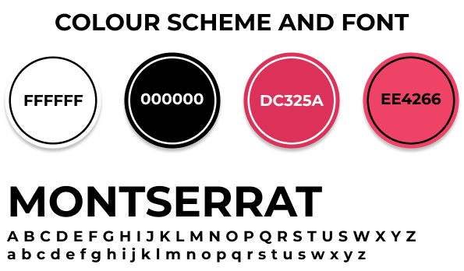

## Main Menu

After launching the game, users will be welcomed by a minimalist and clear menu. The menu displays two primary options: "Play" and "?". The strategic placement of the titles -“Tic Tac Toe”, “AI VS YOU” and the button "Play" on the left side of the screen making it easier for a user to navigate, as it is exactly in the order in which people usually scan documents, books, pictures, etc. The “?” button is in the right top corner, it is not in the area which the user will scan straightaway, as it is not a significant element, but at the same time it is possible to notice this button. With this thoughtful and intuitive design, players can easily access the game's features, entering the game of Tic Tac Toe against AI.

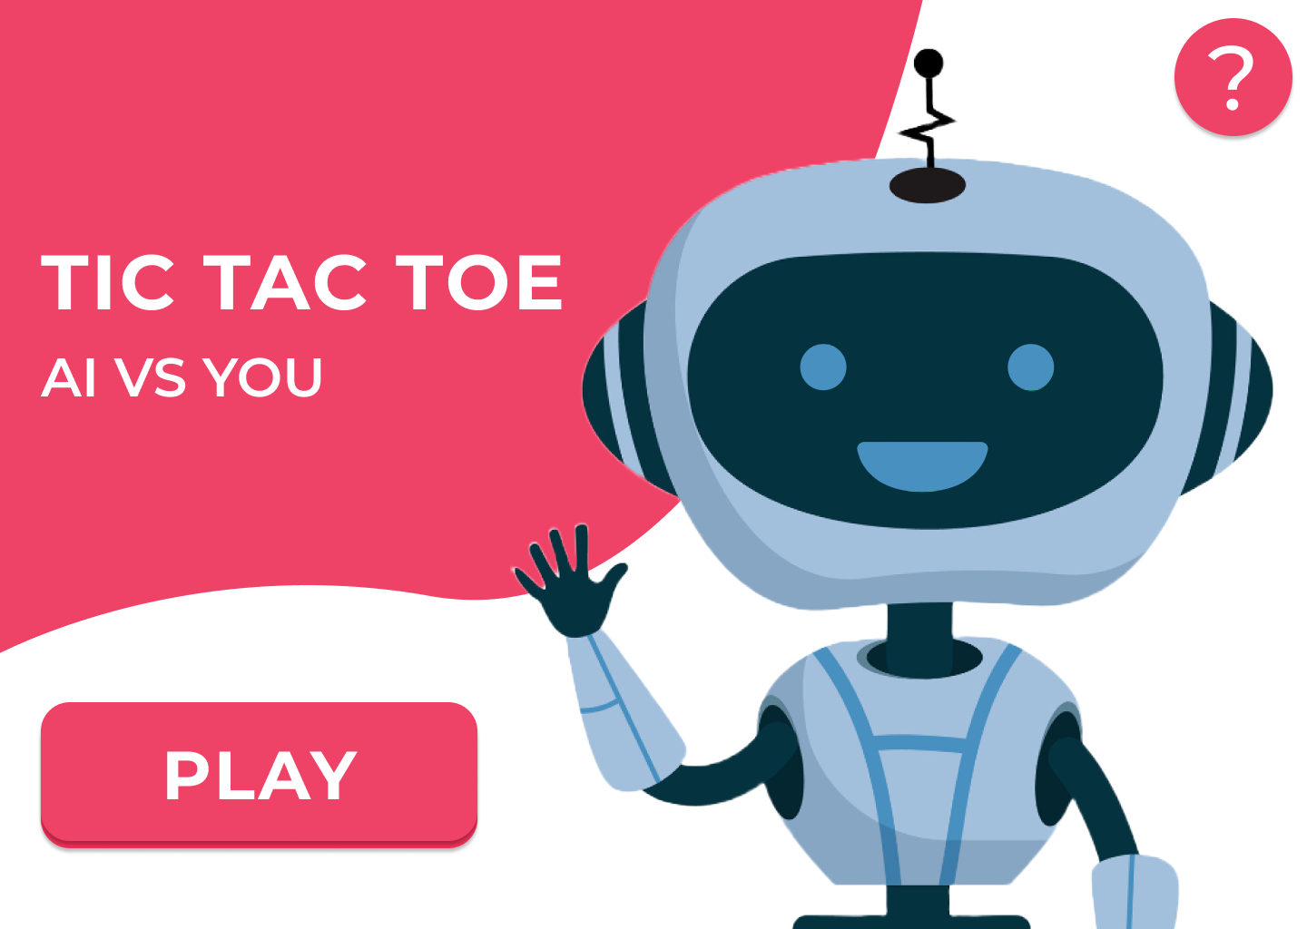

## About Project Screen

The About Project screen is entered from the main menu by clicking the “?” button in the top left corner. It is used to give users the main information about the game and encourage them to play. That is a simple menu consisting of the text and exit button done the minimalistic design and in the same colour theme.

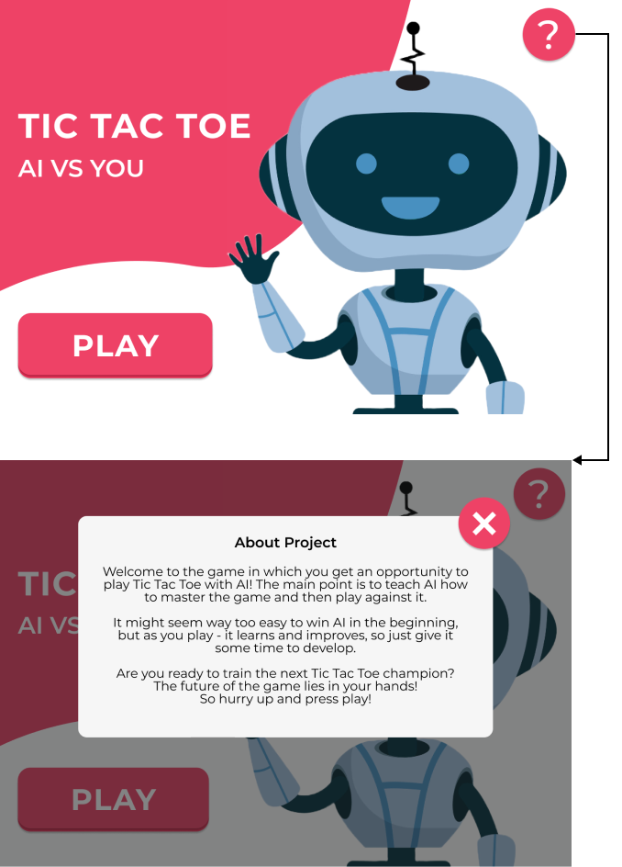

The image of the robot was not created by me, so here is a website where I took it from - [link](https://www.freepik.com/free-vector/futuristic-robot-constructor-flat-icon-set_8609178.htm#query=robot%20illustration&position=0&from_view=keyword&track=ais)

## Game Screen

Once the user presses the “Play” button, the game screen is displayed. The user is met with a scoreboard that keeps track of the game results. As the user prepares to start playing Tic Tac Toe, two buttons await his choice. The first, on the left side, allows the user to select the X (cross), while the second, on the right side, allows one to choose O (nought). In the middle of the screen, there is a grid laid out in red lines, showing the classic 3x3 Tic Tac Toe board. As the game is played, the moves will appear on this grid. When someone wins, the line crossing 3 characters is drawn showing the winning combination. At the same time, the scoreboard is updated. Once the game has finished the user can click on the clear board button to make the board empty and start a new round.

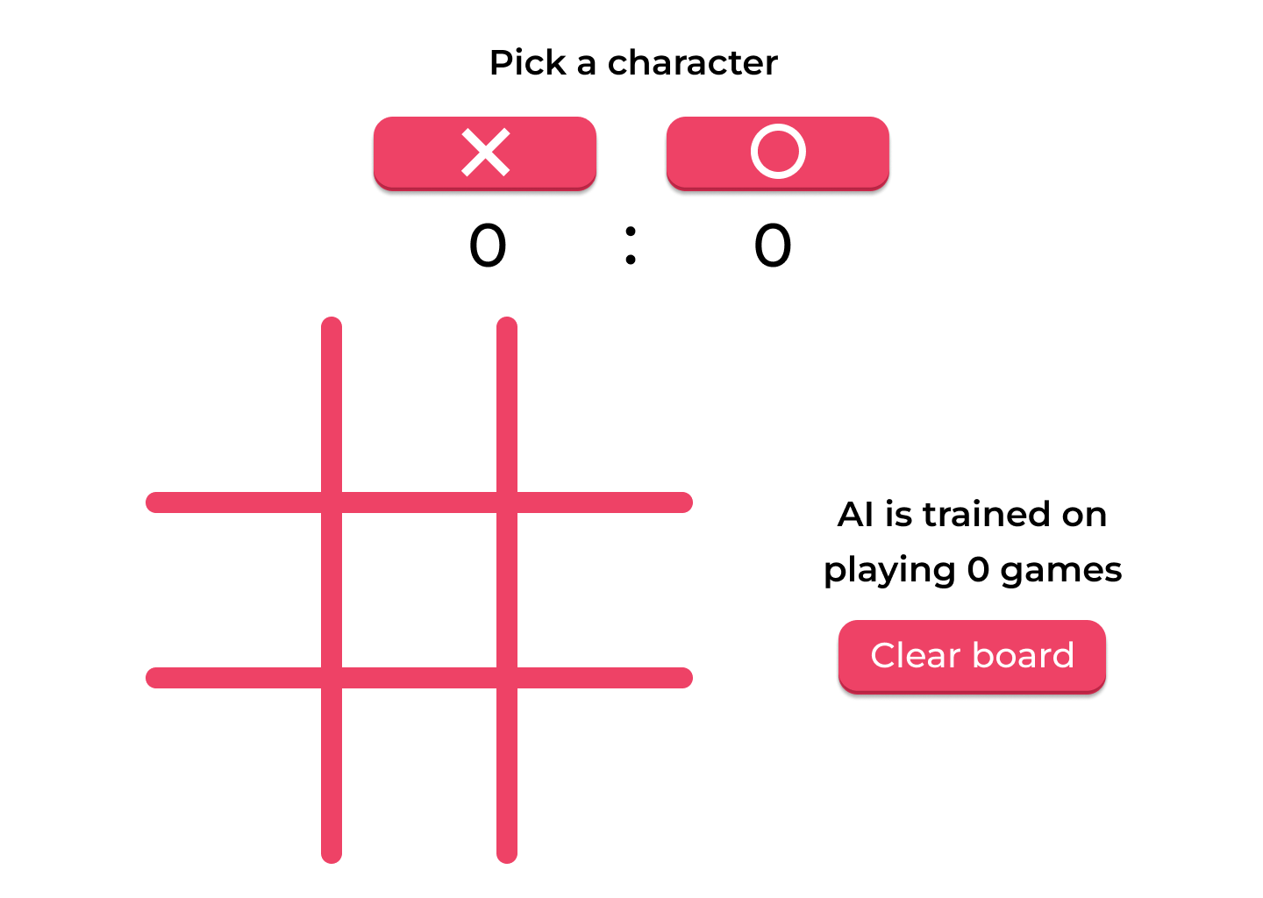

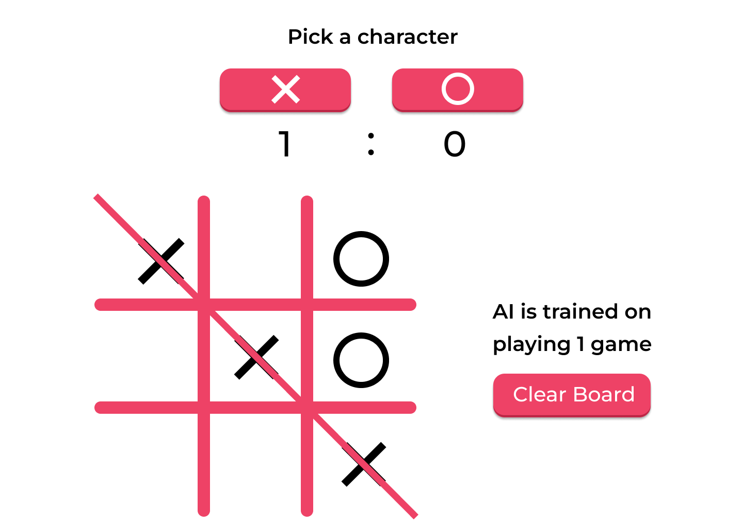

# Program Diagrams

## Structure Diagram

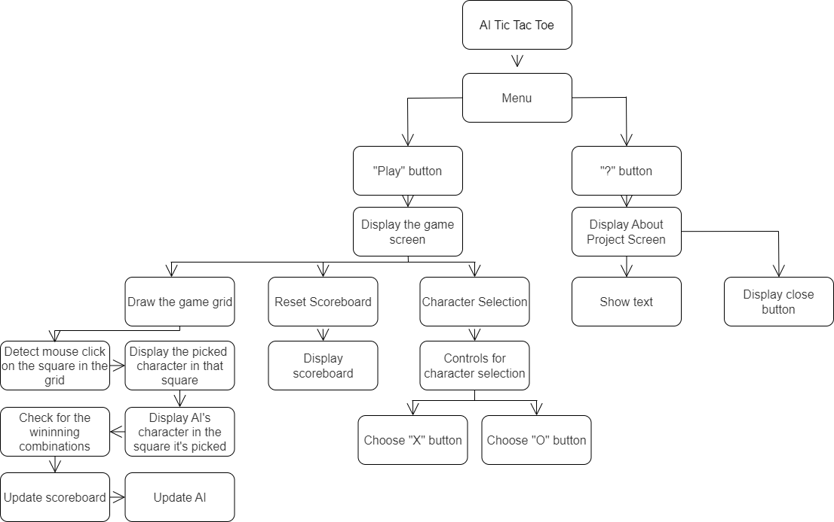

### Summary:

The structure diagram illustrates how each part of the project interacts with one another.

I split the problem into two main sections Game Menu – left branch of the tree which is accessed by pressing a play button in the Main menu and the right branch About Menu represented by “?” button.

The Game Menu then splits into three sub-sections, as these are the main three features of it. The very left one is responsible for the game grid, user interactions with it, and updating AI after each move.

The middle one is responsible for the scoreboard which should be displayed and updated at the end of every game.

The right branch illustrates how the character selection process is broken down.

Going back to the About Menu it can be seen that it is split into 2 main features – text arrangement and close button.

Moreover, the division of the problem was done in the way that every component can be coded separately and then merged together. Meaning that the branches are independent and if I do not have enough time or something goes the project will still be functional.

Last but not least, the component “Update AI” could be split into smaller manageable chunks, but then it would tell too much about the implementation of the algorithm so here is a general plan – AI is updated, meaning that its Q-Table for the current state is updated based on the position of the characters and parameters.

# Stages of Development

## Introduction

In this section the stages of development of the project are shown. They are listed in a certain order which is justified below the table. By splitting the development process into clear stages, I can implement different parts of the project individually, like the integration of AI, coding user interface components, and then combine them. In addition, in this section success criteria and how it can be achieved is presented for each stage.

## Plan of Stages

|  |  |  |  |
| --- | --- | --- | --- |
| Name of the stage | Name of the substage | Success Criteria | Achieving the Criteria |
| Design of the screens | Game Screen | A game screen with a grid in it, buttons (play as X or O), a “Clear” button and a counter. Doesn’t need to be functional. | When the program runs a game screen window should be opened and all mentioned in success criteria must be displayed on it |
| Functionality of the screens | Game Screen | All the essential sub-features are implemented – text is displayed, the grid appears on the screen and each square is functional, and the clear board buttons reset the grid when the user clicks on it. | If user clicks the grid, its character is displayed on it.  When a clear grid button is clicked, the grid clears all the characters from it  Depending on the choice of the user whether to play for X or O, a character picked should be stored and if O is picked the AI will make the move first. If X is picked, the user should make the move first |
| Result Detection | A win | The line crossing winning set is displayed when victory is detected.  The grid is blocked.  Counter increases | When a winning combination is found, a line should cross the characters that form a winning set. At the same time, it must restrict access to the grid (don’t let any characters be added to it). 1 point should be added to the counter. |
| A tie | The grid is blocked.  Counter increases | When all the grid’s cells are used and the winning combination isn’t found, the access to the grid has to be restricted. 1 point should be added to the counter. |
| AI Functionality | Game Screen | Q learning algorithm is successfully implemented. Q-Table is being updated as the user plays. AI learns and makes more educated moves as more games are played. | This stage’s main purpose is to implement AI and make it learn. This will be done by coding a reinforcement learning algorithm called Q learning. This will require adding a number of helper functions like get next move, update the Q Table, and other. |
| Design of the screens | Menu Screen | The menu screen looks the same as in the design concept. No functionality needed for this criterion | When the program runs a menu screen window should be opened and the design should be displayed |
| About Screen | About screen that looks the same as shown in the design concept. No functionality needed for this criterion | When the program runs a screen window should be opened and the design should be displayed |
| Functionality of the screens | Menu Screen | All the sub-features are implemented – text and background images are displayed. Play Button is displayed and sends the user to the game screen on click as well as the “?” button which opens the about screen | When the user clicks the button “Play” in the menu screen the game screen is displayed. And when the user clicks a “?” button it opens the about screen |
| About Screen | All the sub-features are implemented – title, description, and background design are displayed; Close Button is displayed and sends the user back to the menu screen on click. | When the user clicks the close button (not the system window close button) the user is sent back to the menu |
| Settings | Design Development | The style of the design is minimalistic, consistent with the game’s overall design and colour scheme. | This means using clean and simple design elements, same colours, and same fonts. |
| Functionality Implementation | The settings menu is accessible from the game screen, settings influencing AI’s learning rate and settings displaying statistics are implemented. The design is minimalistic and similar to the About Screen design. Close and settings buttons are functional | When the user clicks on one of the buttons in the settings menu the game should require an input and then change the respective parameter influencing AI’s learning rate or infographics are output if certain button is clicked. |
| Additional Elements | Localisation | There is a button that changes all the texts in the game to a different language (English to Ukrainian and back if clicked again.) | If the button is clicked, then all the texts in the game excluding Tittle and Sub-title should be changed. Title and Sub-title should be in English. |
| Colour Theme | A button that changes the colour theme of the game from light to dark or the other way round when clicked | When the user clicks on the button, the background colour has to change from light to dark or reverse, the text colour has to change as well, and the images for characters should also change. |
| Sounds | The sounds are played when characters are displayed on the grid and when results are detected. Background music is turned on when once the game is executed. | Adding a folder with sounds which will then be played when certain criteria are met like the character is displayed or result is detected |
| Animation | Animations are shown when the characters are displayed and when victory is detected. Animations on button presses. | When the user clicks on the grid, the character should appear with a certain animation. The line crossing winning combination should also have an animation. |

## Order Justification

This order for the development stages has been chosen as the essential elements have to be prioritised first and only then inessential elements should be implemented. The initial focus will be on the game screen design and its functionality as these is an integral part of the project. This will also allow me to understand how to use PyGame module which will make it easier to code other menus in the future.

After making sure the game screen is as functional as required at that stage, I will code the result detection algorithm, which will be used to detect wins and ties.

Next step is AI implementation. This stage involves coding Q learning algorithm to enable computer learn and develop by playing games against the user.

Finally, the menu and about screens will be added the game. By following this development order, even if something goes wrong or I run out of time, the project will still seem complete, and the main goal of AI implementation will be achieved.

In case all the other features have been implemented, I will start working on other desirable features like “Settings Menu” and “Additional Elements”. I will implement settings first as it will add more functionality to the game and by that time, I will have experience in coding menus so it will be easier rather than figuring out how to add sound and animations using Pygame.

## Robustness testing

### Plan

When all the stages will be developed, I will test the program myself, receive feedback from my stakeholder, I will test the boundaries of my program, and this is the test table that will be used for it. Important to say that the table might change after the development stages as I might find other areas that should be tested and add them to the table.

### Tests table

|  |  |  |  |  |  |
| --- | --- | --- | --- | --- | --- |
| Test No. | Description | Test Data | Type | Expected Result | Actual Result |
| 1 | Does the game run according to the requirements on different OS? | Windows, MacOS | Valid | The game will function the same on different OS. |  |
| 2 | Does the game freeze or crash if the buttons are pressed a lot of times in a short period of time? | Clicking on the button very fast | Valid | It should not affect the game |  |
| 3 | Does AI have enough time to analyse and make a new move if user makes moves really fast? | Putting characters on the grid fast | Valid | Machine’s speed is way faster than a user can possibly click, so it will not affect the program |  |
| 4 | Does the counter display the number in the wrong place as it reaches 6-digit values? | Turn Auto Mode and wait till game counter reaches 100 000 | Valid | The counter should be displayed correctly even when there are six digits |  |

## Stage 1 – Design of the Screens

### Substage – Game Screen

**Summary:**

To be able to implement AI and play the game the game screen design must be added. For now, when the program is run, the game screen will be opened straight away, as making the game functional is more important than adding the menu, but after the game is made fully functional, the game menu will be opened using the button in the menu

**Requirements met in this stage:**

|  |  |
| --- | --- |
| Requirement number and name | Test No. checking this requirement |
| 3a. Text – Pick a character | 7 |
| 3b. Button for “X” | 4 |
| 3c. Button for “O” | 5 |
| 3d. Score | 3 |
| 3e. Grid | 2 |
| 3h. Games played number | 3 |
| 3i. Clear Board button | 6 |

**Has to be implemented:**

|  |  |
| --- | --- |
| Feature | Justification |
| Game Window | A suitably sized game window has to be displayed |
| Grid | A grid with red-coloured lines has to be displayed |
| Score | A counter that counts how many games the user has won and lost |
| Games played number | A counter of the games AI has learnt on has to be displayed |
| Buttons | 3 buttons have to appear on the game screen with the design and text on them, such as “X” button, “O” button, and “Clear Board” button |
| Text | The text “Pick a character” and “The number of games AI has learnt on” have to be displayed |

**Example Tests Table:**

|  |  |  |  |  |  |
| --- | --- | --- | --- | --- | --- |
| Test No. | Description | Type of test | Test data | Expected Result | Actual Result |
| 1 | Does a correctly sized game window generate? | Valid | Run the program (Game Menu) | Game window opens |  |
| 2 | Does the grid generate? | Valid | Run the program (Game Menu) | A correctly sized grid generates |  |
| 3 | Does the counter of the number of games AI has learnt on generate? | Valid | Run the program (Game Menu) | The counter generates at the right middle of the screen |  |
| 4 | Does change character “X” button generate? | Valid | Run the program (Game Menu) | A button with the text “X” is displayed |  |
| 5 | Does change character “O” button generate? | Valid | Run the program (Game Menu) | A button with the text “O” is displayed |  |
| 6 | Does the “Clear Board” button generate? | Valid | Run the program (Game Menu) | The “Clear Board” button is generated |  |
| 7 | Does the text “Pick a character” generate? | Valid | Run the program (Game Menu) | The text “Pick a character” is generated at the top middle of the screen |  |
| 8 | Does the score counter generate? | Valid | Run the program (Game Menu) | The score counter should be displayed below the “pick a character“ buttons |  |

**Data Dictionary:**

|  |  |  |  |
| --- | --- | --- | --- |
| Name | Data Type | Description | Validation |
| width,  height | Integer | These are the constants that store window’s size |  |
| colour_white,  colour_black,  colour_redTop,  colour_redBottom | Colour | These variables store colours that are used in the program |  |
| current_screen | String | Stores the name of the screen that should be currently displayed |  |
| font | Font | There will be several variables storing different fonts that will be applied to certain texts |  |
| text | Text | A few variables storing the text with the font parameters applied. |  |

## Stage 1 Flowchart

### Justification:

The flowchart illustrates the processes related to the game screen design. When the game screen is displayed, it shows the following elements:

* Instruction to the users - "pick a character”
* Two buttons labelled 'X' and 'O,' allow the player to choose the character
* A grid is displayed, representing the 3x3 Tic Tac Toe game board
* The screen displays text showing the number of games AI is trained on
* A counter (score or move counter) is included to keep track of the game's progress
* A “Clear Board” button is displayed to reset the game board if the player wants to start a new game.

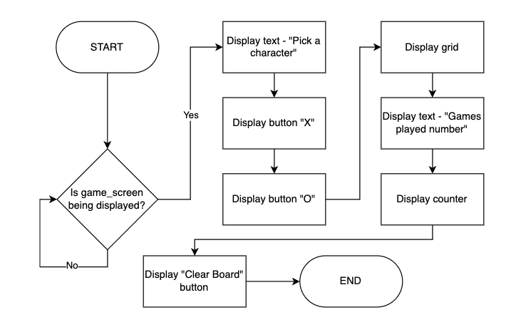

## Stage 1 Development

### Summary:

Pygame modules are used to create a graphical user interface for playing Tic Tac Toe. At this stage, all the window settings were set, and the GUI coded. In the table below a fully functional block of code is shown, which might be changed in the next stages, but it fulfils all the requirements for the current stage. For this reason, the actual development (bugs and how the program was changing) is shown below in the bug fixes section.

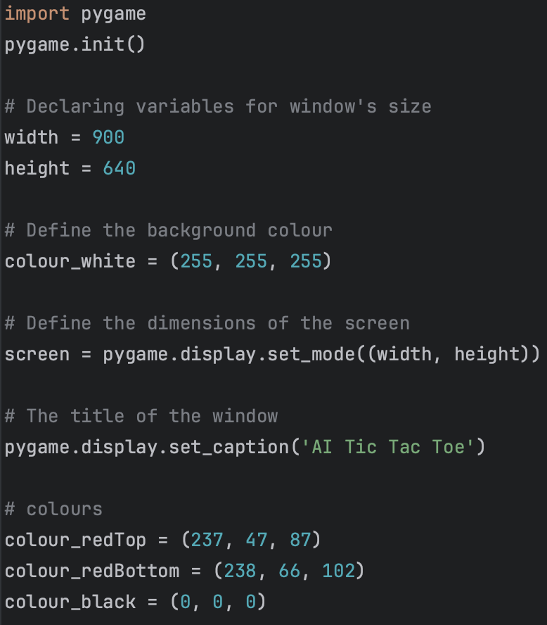

This code imports the Pygame library. Sets up the game window with specified dimensions and title. Defines colour variables, which will be used for all the screens to keep the same colour scheme

At this point I defined a function which will be used as more screens are added and display the game screen when called – game_screen(). Created a global variable current_screen, which will keep track of the current screen and by changing it another screen will be displayed. Filled the screen with white colour

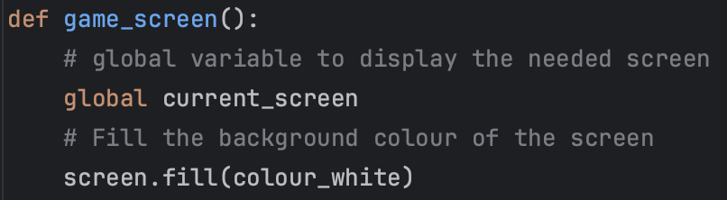

I have initialised three different fonts to be used for different parts of the game screen, these fonts have different sizes. After initializing the fonts, they were used to render specific text elements in a particular style, so the game interface had a consistent look, making it easier for players to interact with the game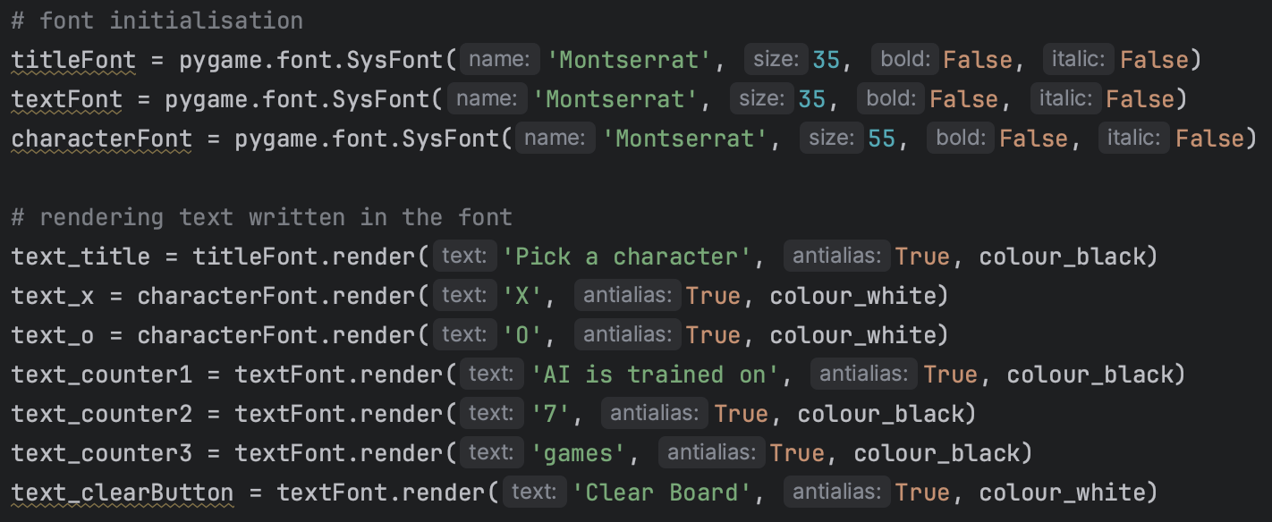

In this section of the code, I'm tracking the current (x, y) coordinates of the mouse pointer on the game screen by using the mouse variable to store the current mouse coordinates, using the function pygame.mouse.get_pos(). Next, I'm checking if the mouse is hovering over specific buttons that have also been created such as the 'X' button, the 'O' button, and the 'Clear Board' button. When I hover the mouse over a button, it changes to a darker shade to provide visual feedback.

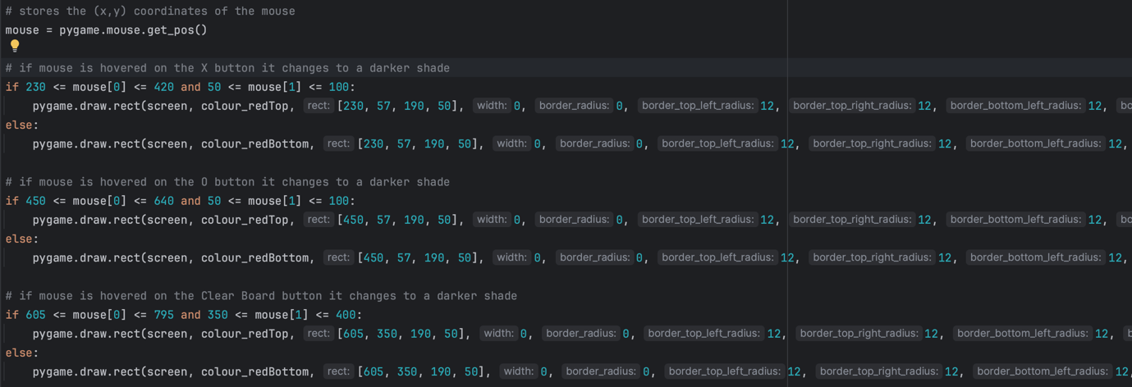

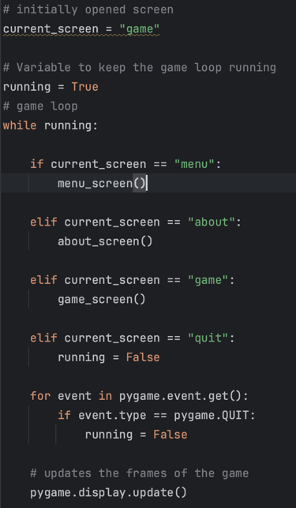

In this bit of code, I'm setting up the initial screen to be displayed and starting a game loop to manage different screens. current_screen is set to "game" for now, but as I add menu, it will be changed. Inside the game loop, I'm managing different screens based on the value of current_screen: if it's "game," I call the game_screen() function to display the game screen and so on. If it's "quit," I set running to False to exit the game loop. I also call the display update function, to show all the changes

The provided code defines a function named grid, which is called from the game_screen function, to create and draw a 3x3 grid on the screen. I set up variables for cell dimensions, spacing, and line styles, in case I want to change the location, I don’t need to do it for every square. Additionally, I added visual separators in both horizontal and vertical directions as it was shown in the design. For now, the squares are black, to make them noticeable, but then I will make them white

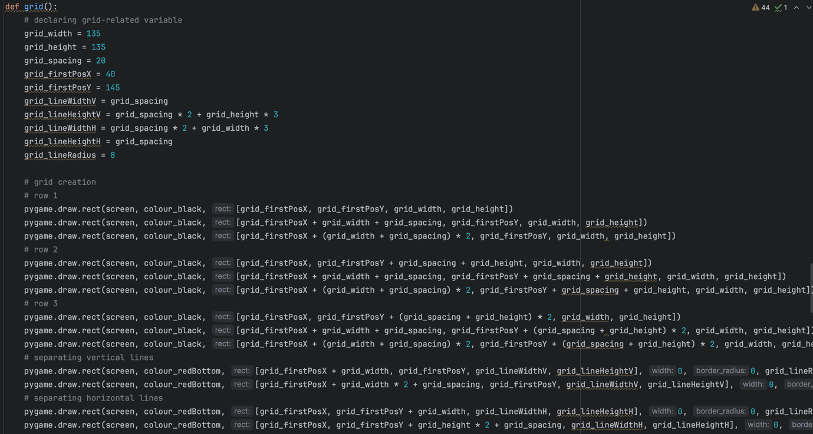

Text elements are positioned and displayed on the game screen. The grid function is called to draw the Tic Tac Toe game grid. Event handling is implemented to detect when the user closes the game window and to change the current_screen variable to "quit” and exit the game.

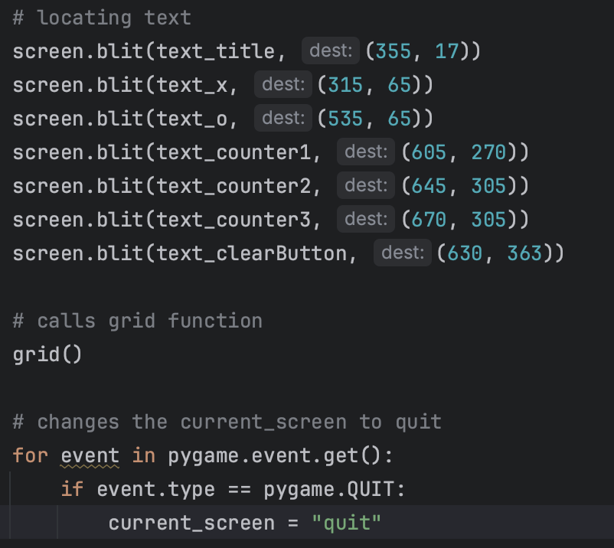

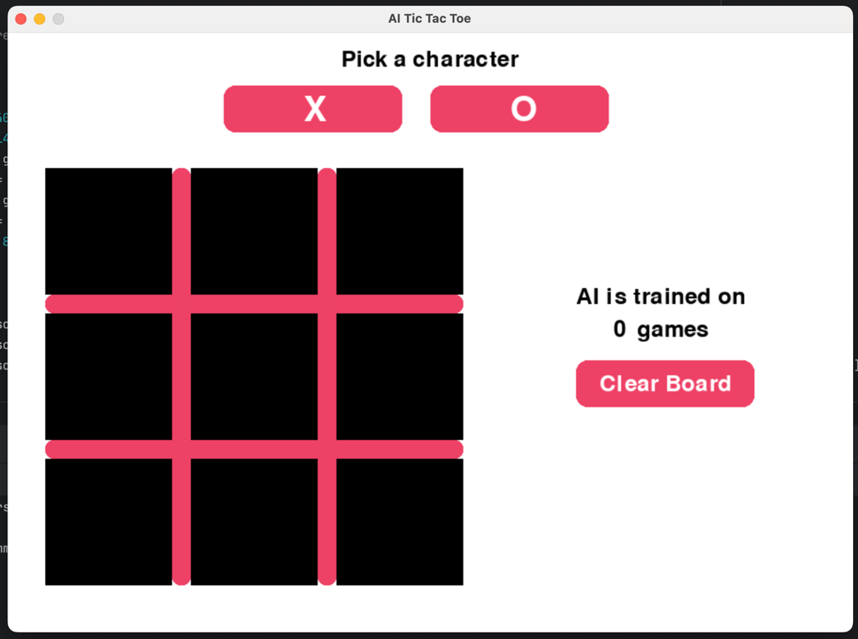

In this screenshot, all the above-mentioned can be seen.

UPD: the title was changed from “Pick a character” to “Choose your side”

Screenshot 1.8

### Bug Fixes:

In the bug fixes stage, there were no significant bugs that disrupted the overall development process. However, when I developed the grid, I didn’t think that I might need to change its location and size, so I used the numbers as parameters for each square, which was a mistake. (In the screenshot only three squares were located correctly, for the test purposes, and they were coloured in black to make them noticeable when the game screen is being displayed)

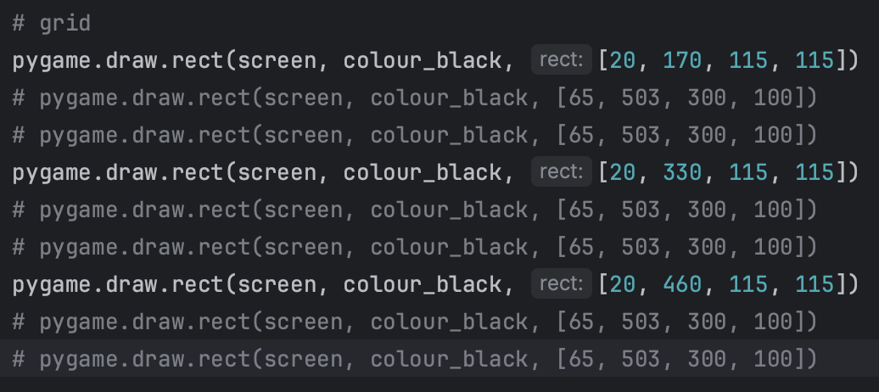

When I realised my mistake, I declared new variables and used them instead of the numbers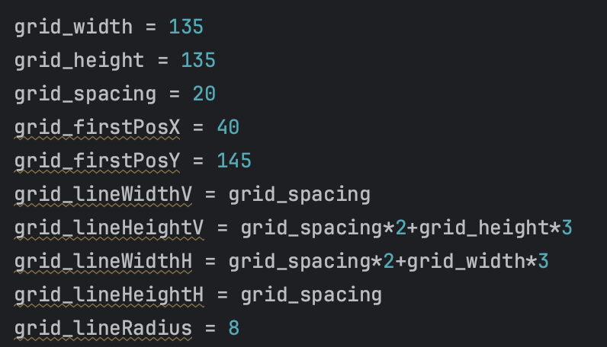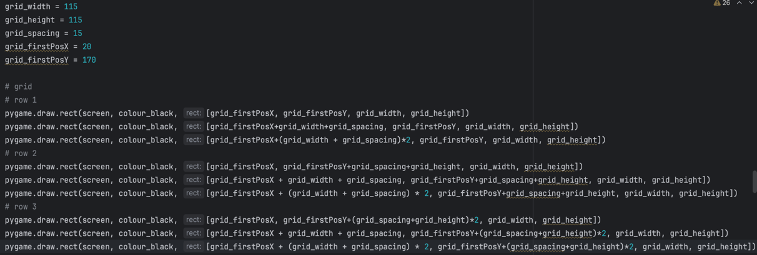

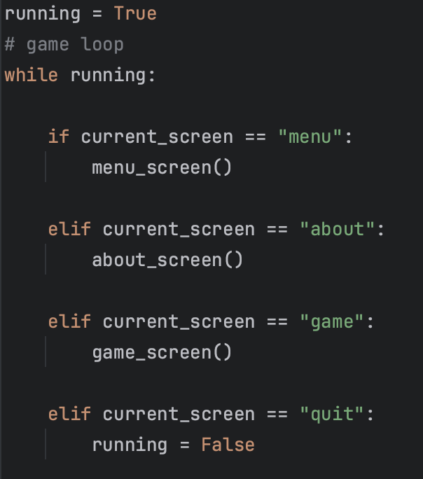In addition, as the game_screen function was called from the main while true loop, it has never actually returned to the loop, so the function of quitting by pressing the window’s close button, which was written in the while true loop, wasn’t working, so I had to add an imaginary screen “quit” that would be called from any screen by pressing the window’s close button and end the loop (stop the program) by changing running to False

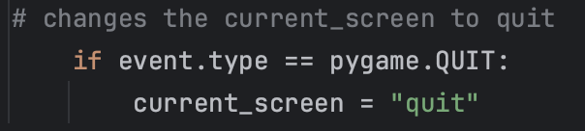

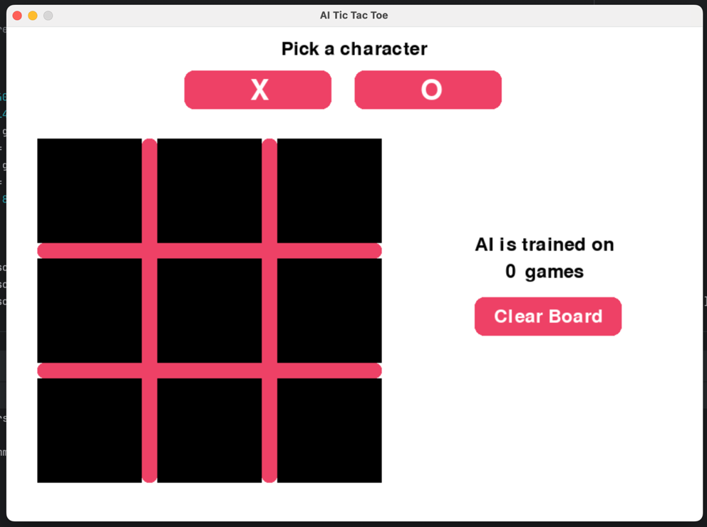

Moreover, it was decided not to add the score counter, as I thought that first several hundred games AI would just lose and the score would be, for instance, 430 : 0, which had no point in displaying, so only the counter of the number of games AI has learnt on was left.

**Tests Table:**

|  |  |  |  |  |  |
| --- | --- | --- | --- | --- | --- |
| Test No. | Description | Type of test | Test data | Expected Result | Actual Result |
| 1 | Does a correctly sized game window generate? | Valid | Run the program (Game Menu) | Game window opens | Correctly sized game window opens  Evidence:  Screenshot 1.8 |
| 2 | Does the grid generate? | Valid | Run the program (Game Menu) | A correctly sized grid generates | Grid generates in the right place and in the needed size  Evidence:  Screenshot 1.8 |
| 3 | Does the game counter AI have learnt on generate? | Valid | Run the program (Game Menu) | The counter generates at the right middle of the screen | The counter is displayed in the right place  Evidence:  Screenshot 1.8 |
| 4 | Does change character “X” button generate? | Valid | Run the program (Game Menu) | A button with the text “X” is displayed | The “X” button is displayed in the right spot.  Evidence:  Screenshot 1.8 |
| 5 | Does change character “O” button generate? | Valid | Run the program (Game Menu) | A button with the text “O” is displayed | The “O” button is displayed in the right spot.  Evidence:  Screenshot 1.8 |
| 6 | Does the “Clear Board” button generate? | Valid | Run the program (Game Menu) | The “Clear Board” button is generated | The clear board button is displayed in the right spot.  Evidence:  Screenshot 1.8 |
| 7 | Does the text “Pick a character” generate? | Valid | Run the program (Game Menu) | The text “Pick a character” is generated at the top middle of the screen. | The text is displayed in the correct place.  Evidence:  Screenshot 1.8 |

## Stage 1 Review

In this stage, I added the layout and visual elements of the game screen. As I had a concept done for this stage, it made things easier, but doing the coding part was a bit tricky. While the implementation went relatively smoothly, understanding how to work with the PyGame library took a while. However, I managed to get all the knowledge needed which will make it easier to develop other menus in the next stages.

## Stage 2 – Functionality of the Screens

### Substage – Game Screen

**Summary:**

This stage is created to make the Game Screen functional. As to play the game – the grid, counter, and all the buttons must be functional.

**Requirements met in this stage:**

|  |  |
| --- | --- |
| Requirement number and name | Test No. checking this requirement |
| 3f. A character appearing on the grid when the user clicks | 1a, 1b, 2a, 2b |
| 3h. Number of games played | 3 (Will be completed in the next stage) |
| 3i. Clear Board button | 4 |

**Has to be implemented:**

|  |  |
| --- | --- |
| Functionality | Justification |
| Clickable grid | By using the design of the grid developed in the stage 1, it should be made clickable, hence it has to display characters as soon as the player clicks or when AI makes its choice |
| Counter | A functional counter, which was designed in the stage 1, has to count the number of games AI has learn on. |
| Buttons | By using previously designed buttons (stage 1) add functionality to them |

**Example Tests Table:**

|  |  |  |  |  |  |
| --- | --- | --- | --- | --- | --- |
| Test No. | Description | Type of test | Test data | Expected Result | Actual Result |
| 1a | Does pressing button “X” update user’s character? | Valid | Click on the “X” button | The variable storing user’s character should store “X” |  |
| 1b | Does the grid display user’s character when clicked? | Valid | Click on one of the empty grid squares | The “X” character should appear on the grid |  |
| 2a | Does pressing button “O” update user’s character? | Valid | Click on the “O” button | The variable storing user’s character should store “O” |  |
| 2b | Does the grid display user’s character when clicked? | Valid | Click on one of the empty grid squares | The “O” character should appear on the grid |  |
| 3 | Does the counter increment once the game is finished?  CHANGED: This test was not added to the actual test table because, the victory and tie detection algorithms have not been implemented yet, so it is impossible to update the counter | Valid | Play the game till it finishes | The game counter is incremented |  |
| 4 | Does the “Clear Board” button clear the board when clicked? | Valid | Click on the “Clear Board” button | The grid is cleared when the button is pressed |  |

**Data Dictionary:**

|  |  |  |  |
| --- | --- | --- | --- |
| Name | Data Type | Description | Validation |
| square1, …, square9 | Boolean | Used to store whether the character stored in that square must be displayed. Basically, works as a flag. |  |
| userCharacter | String | Stores user’s character | “x”, “o”, or “ ” (empty) |

## Stage 2 Flowchart

### Summary:

The Python code, implemented using Pygame, transforms the flowchart's logic into a graphical user interface for playing Tic Tac Toe. This flowchart displays the process of user interactions with the game screen, including character selection, grid interactions, and additional actions.

### Justification:

When the game screen is displayed, the elements should have the following functionality:

Character Selection - players pick their character ('X' or 'O') by clicking on the respective buttons, and the choice is stored in a variable.

Game Grid - the code renders a grid on the game screen, providing a visual representation of the Tic Tac Toe game board.

Clear Board Button - a button is implemented to reset the game board, clearing moves, and allowing to start a new game upon clicking.

There’s no information about the counter in the flowchart due to a plan change (see DPC – Development Plan Changes, Change 1)

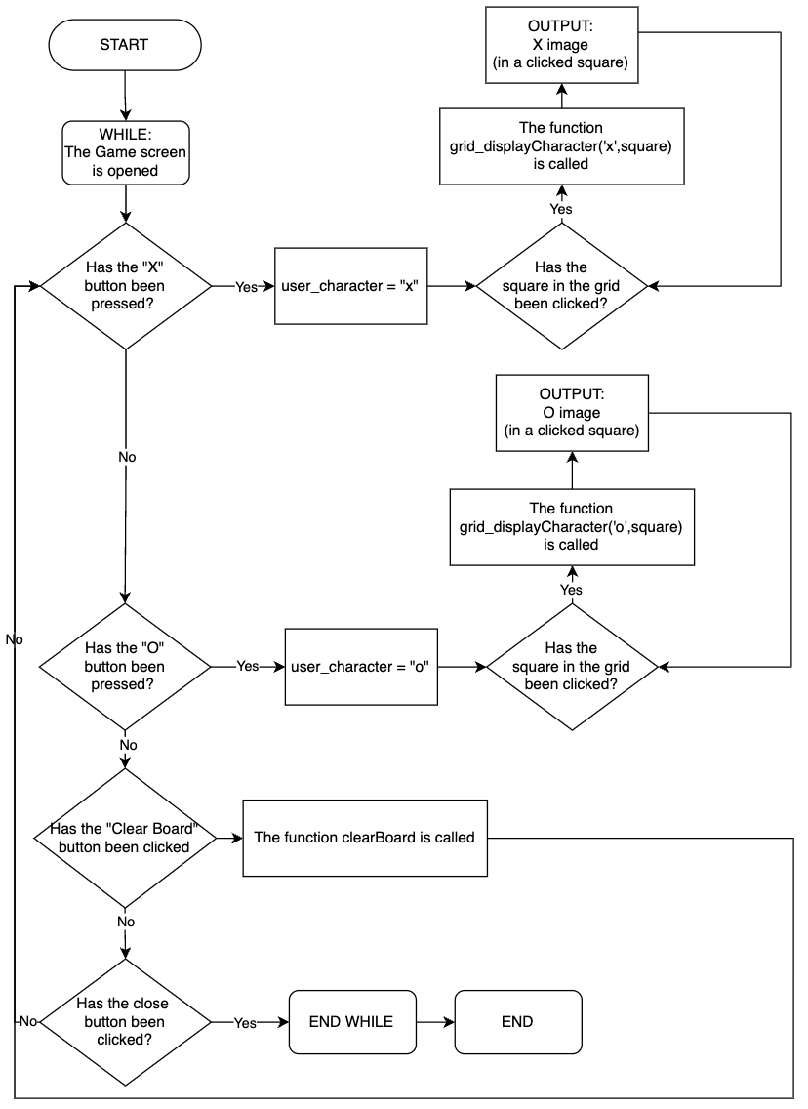

## Stage 2 Development

### Summary:

In the table below the development of the game screen can be seen. Functionality that allows the user to play the game, without an opponent for now, has been implemented. As it was mentioned in the summary of the “Stage 1 Development”, the screenshots presented in this table are of the finished code that fulfils all the requirements for the current stage and the actual development process and the bugs that have been found and fixed can be seen in the Bug Fixes section.

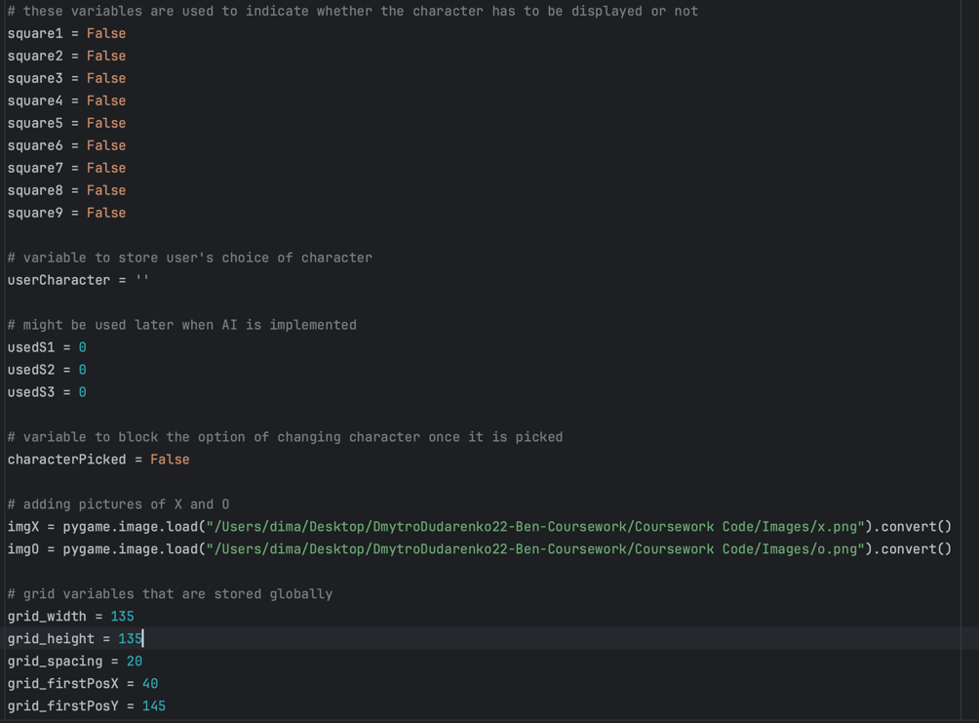

This block of code initialises several variables that are used in a game. Like boolean variables for squares, which will detect whether the square is used or not by changing the variable to true or false respectively. userCharacter - a variable to store the user's choice of character ('X' or 'O'). characterPicked - a boolean variable that blocks the option of changing the character once it is picked, it helps control the user's choice throughout the game. globally as well.

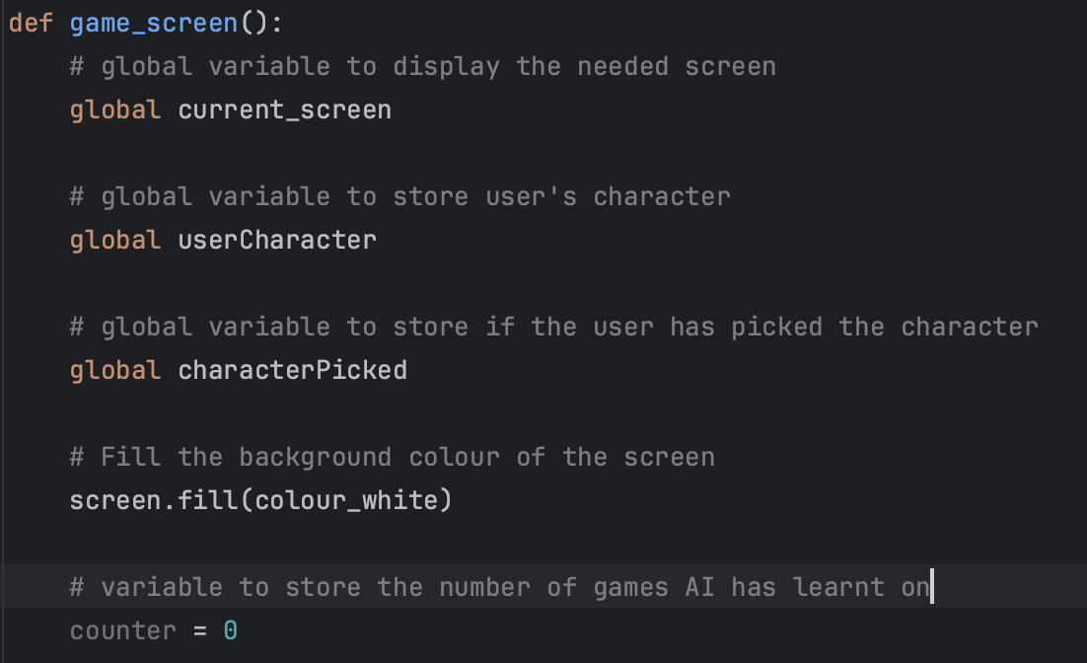

In this screenshot, I called global variables and initialised the counter variable which will be used later. Because I realised that I cannot code the counter till I finish stage 3. (see DPC – Development Plan Change, change 1)

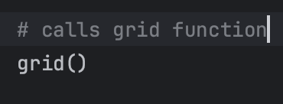

In the previous stage, the grid was initialised in the game screen subroutine, but to make the code seem clearer and modularised I moved it to a different subroutine.

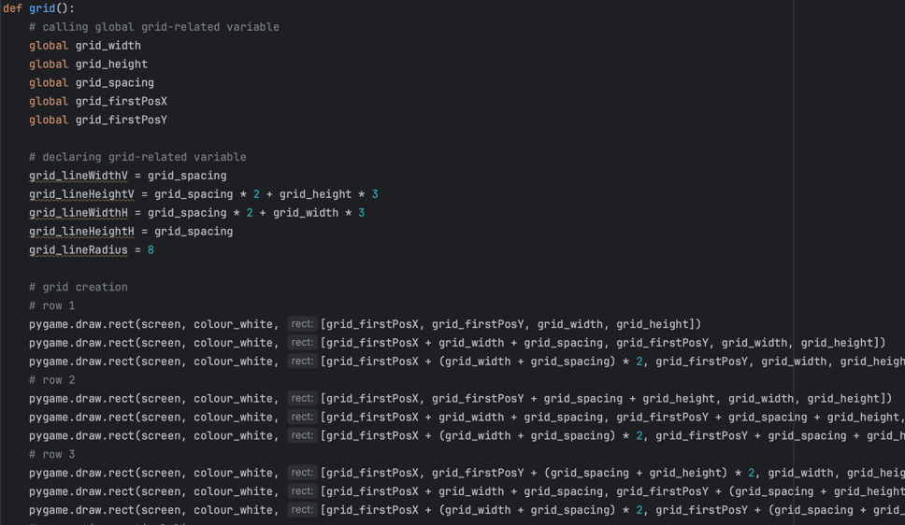

It can be seen how the code looks inside the grid subroutine and no significant changes have been done to this bit since Stage 1.

The bit of code below checks if a mouse button is clicked on one of the buttons. If the user clicks within a specified region for the Clear Board button, the clearBoard() function is called. In addition, if the user clicks on either X or O button, its character, which is stored in the userCharacter variable, is updated to X or O respectively.

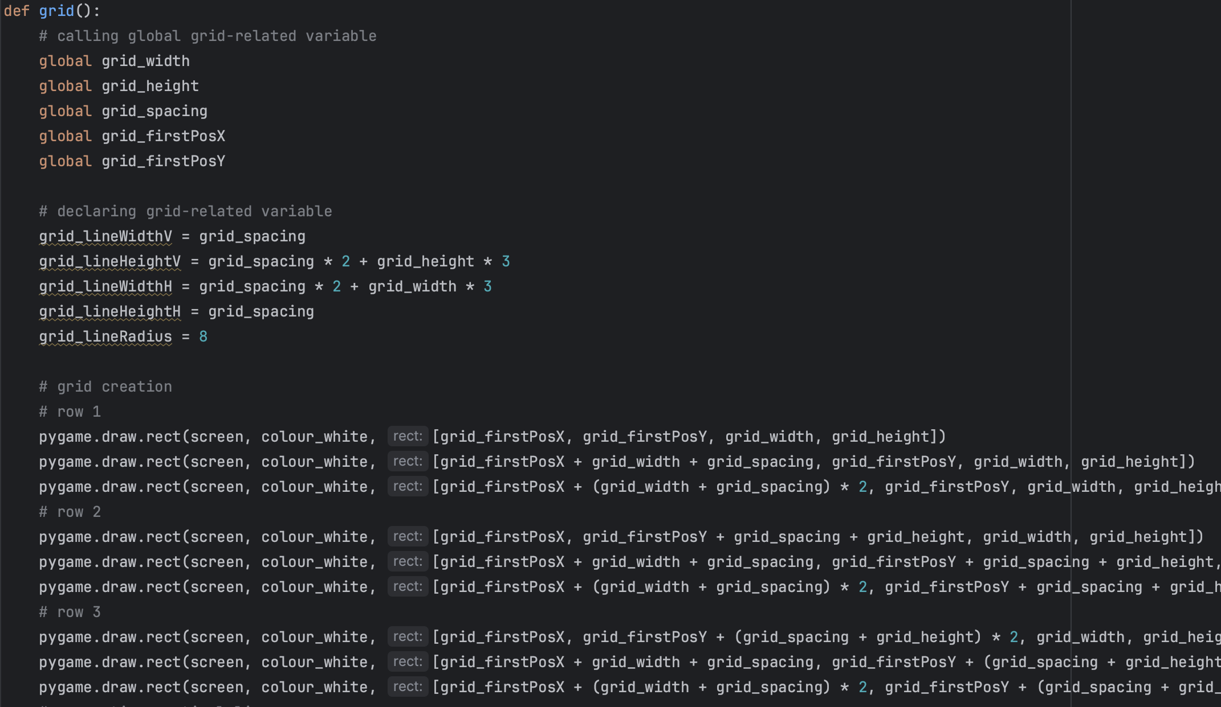

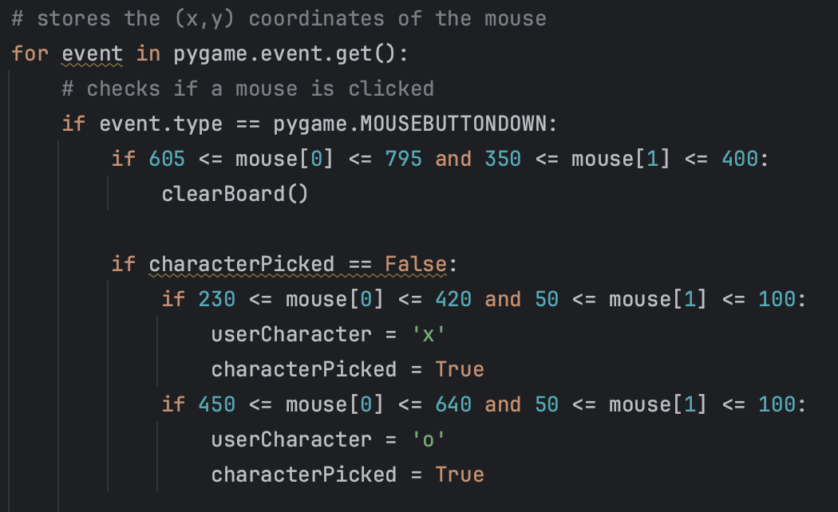

This block of code checks if the user’s choice of character is X and then waits for the player to click on a square to display the X image by calling a function grid_displayCharacter(). The code repeats this pattern for each row and column in the grid, ensuring that the 'X' character is displayed in the correct square based on the user's mouse click.

In this screenshot the same bit of code as in screenshot above is displayed, but for the user who picks O instead of X.

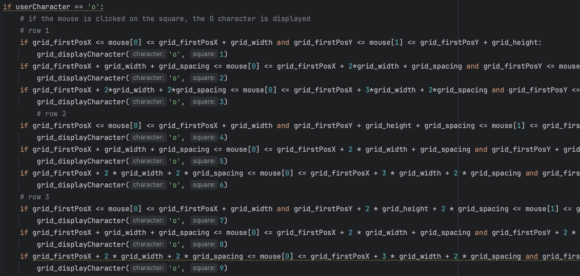

This code shows the grid_displayCharacter () function, the parameters it receives, and initialises a set of global boolean variables, representing the state (True/False) of individual squares. Additionally, there are some global variables that are marked as "not used," as they are currently not used in the program.

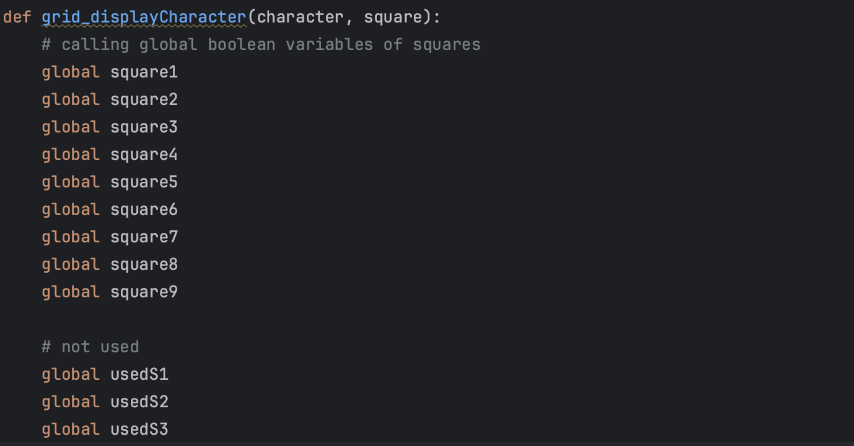

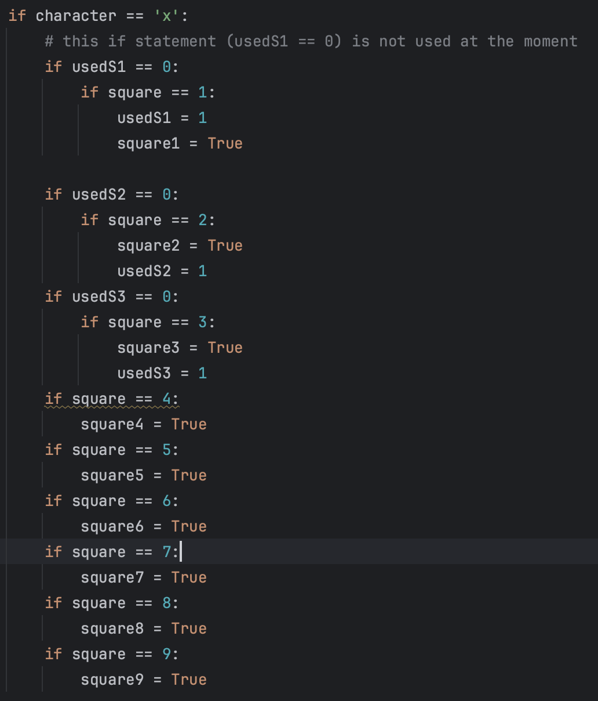

In this screenshot the same bit of code as in screenshot above is written, but for the user who picks O instead of X.

It checks if the current player's character is 'X', then changes the state of each square based on the player's move (square) and the character ('x'). For example, if the player character is 'x' and the move is on square 1 (square == 1), it sets square1 to True, which basically blocks this square from future use, till the board is cleared. Similar logic is applied for other squares.

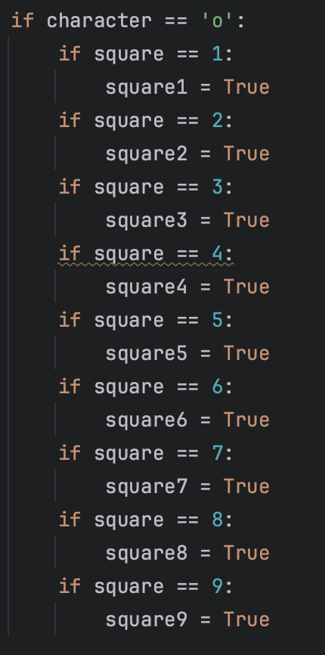

This code is written in the main while loop that runs till the program is stopped. It handles the rendering of the 'X' image on the screen based on the state of each square. As soon as the state of the square becomes true, the image displays.

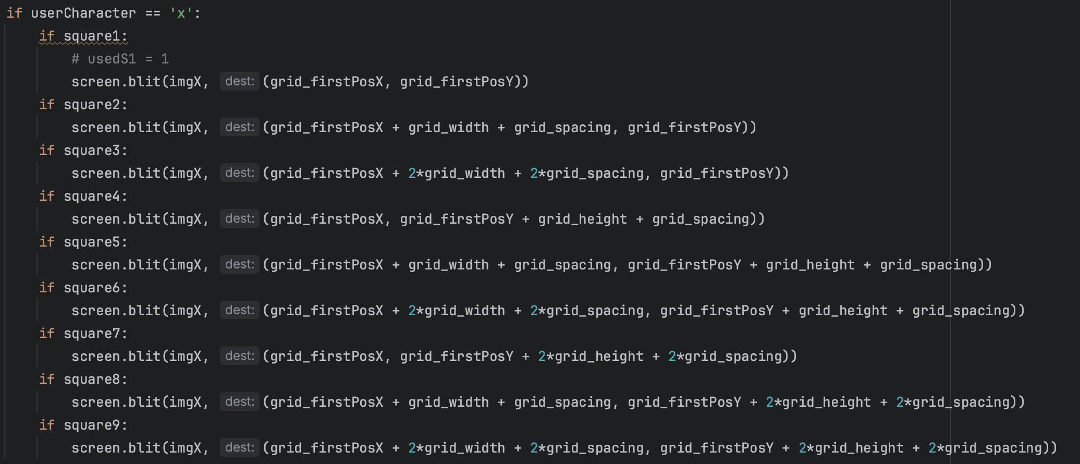

The same bit of code as in screenshot above is written, but for the user whose userCharacter == ‘o’

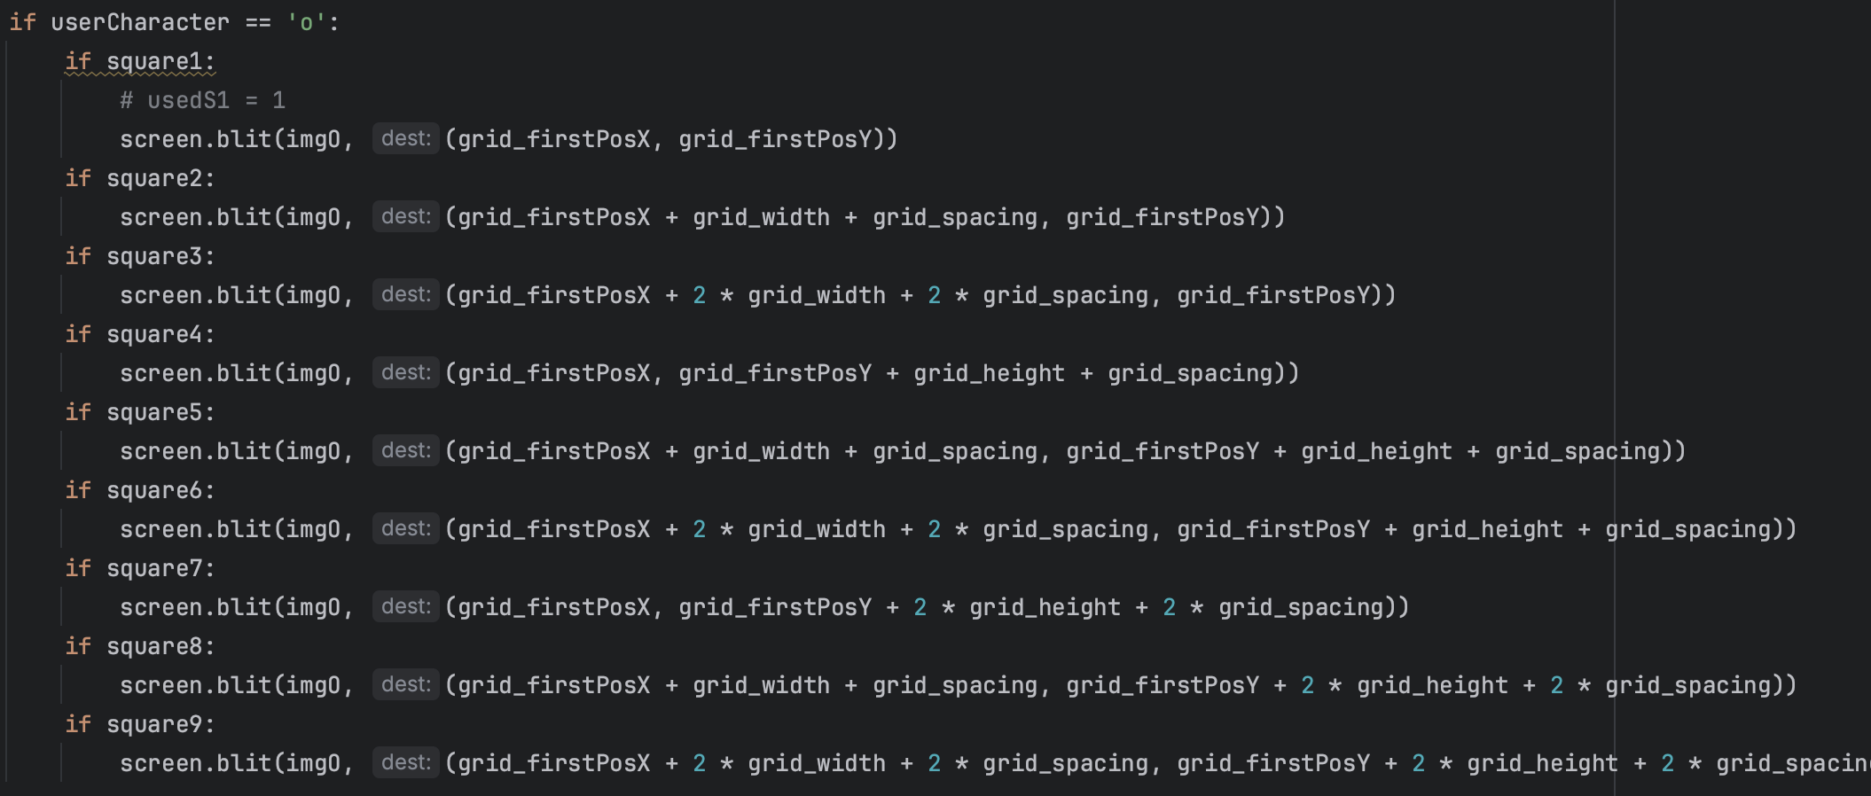

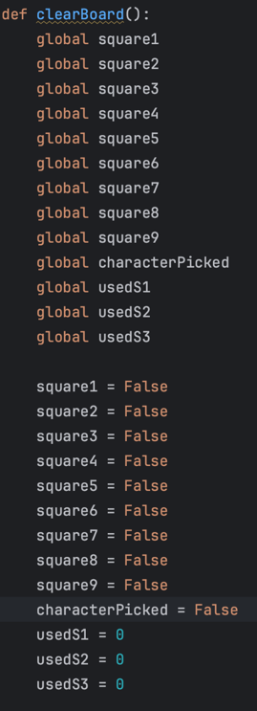

In this screenshot, the clearBoard() function is shown and it resets the state of various global variables, essentially clearing the game board and allowing a new game to be played

### Bug Fixes:

At this stage, there were loads of bugs that I did not expect at all and spent quite a while on fixing them. The first one is that when I made squares clickable, I added a function to display the image straight into the if statement that checked whether the square was clicked. As I realised later, the PyGame updates the screen after a certain amount of time, which means that one click on the square would only make a picture appear till the next screen update and then it would disappear.

That is what it was:



Video 2.18 illustrates the issue.

The fix was to create a function called grid_displayCharacter() and move the function displaying the image to the main while loop which would constantly display the image.

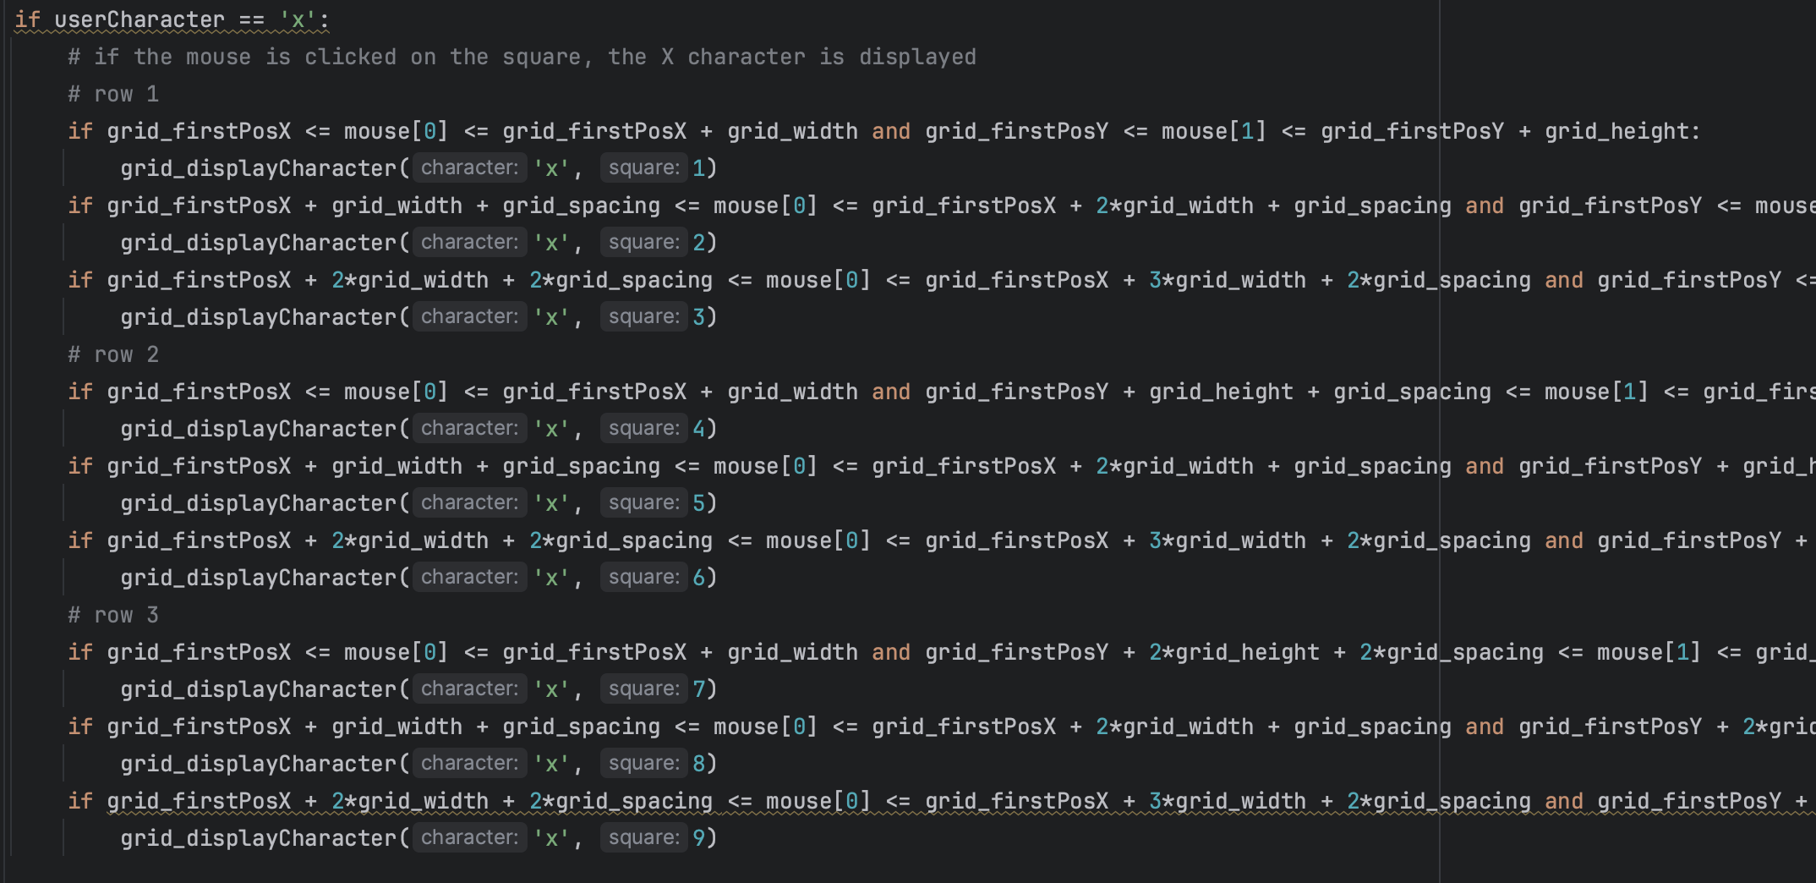

Screenshot of the grid_displayCharacter() function



Screenshot of the code inside the while loop



Video 2.18(2) shows how it works after implementing these changes.

Another issue was that a character could be changed by another character when the character change button was pressed. (Video 2.19)

The fix that was to create a boolean variable called characterPicked and change it to True when it is picked, so the button would become blocked and remain in this state till the clear board button was pressed.

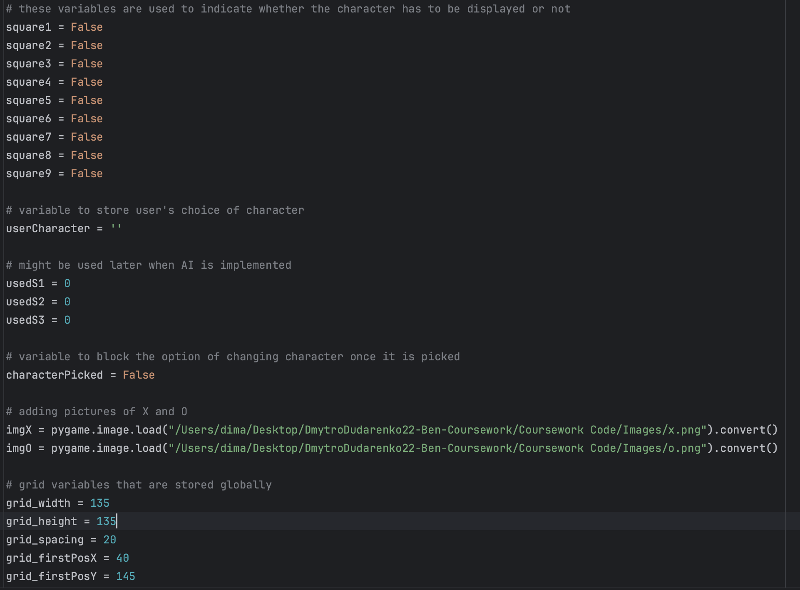



The fixed version is shown in video 2.20

Sometime later I realised that in the clear board function, I forgot to reset userCharacter. (Video 2.21)

The characterPicked variable is reset when the clear button is pressed. So, the user has an opportunity to change the character in a new game. But the variable userCharacter still contains the character from the previous game (screenshot on the left), so I added one more variable to be reset

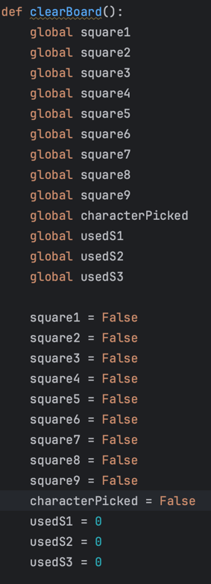 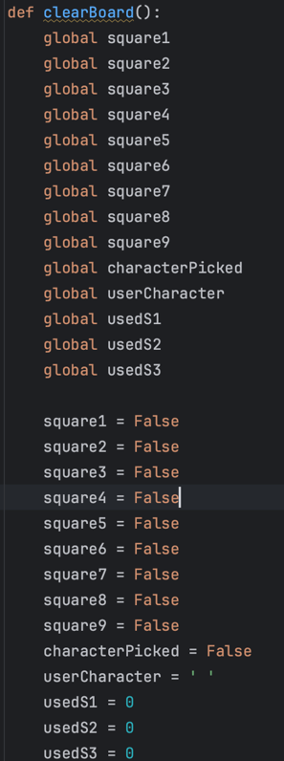

Video 2.22 shows how it works when fixed.

**Tests Table:**

|  |  |  |  |  |  |
| --- | --- | --- | --- | --- | --- |
| Test No. | Description | Type of test | Test data | Expected Result | Actual Result |
| 1a | Does pressing button “X” update user’s character? | Valid | Click on the “X” button | The variable storing user’s character should store “X” | The variable storing user’s character is updated.  Evidence:  Video 2.18(2) |
| 1b | Does the grid display user’s character when clicked? | Valid | Pick a character and click on one of the empty grid squares | The “X” character should appear on the grid | The character is displayed on the grid  Evidence:  Video 2.24 |
| 2a | Does pressing button “O” update user’s character? | Valid | Click on the “O” button | The variable storing user’s character should store “O” | The variable storing user’s character is updated.  Evidence:  Video 2.23 |
| 2b | Does the grid display user’s character when clicked? | Valid | Pick a character and click on one of the empty grid squares | The “O” character should appear on the grid | The character is displayed on the grid  Evidence:  Video 2.25 |
| 4 | Does the “Clear Board” button clear the board when clicked? | Valid | Click on the “Clear Board” button | The grid is cleared when the button is pressed | The board is cleared once the button is pressed.  Evidence:  Video 2.26 |
| 5 | Does anything display on the grid if the character is not picked? | Invalid | Click on the grid without picking a character | Nothing should be displayed | Nothing is displayed.  Evidence:  Video 2.26 |

## Stage 2 Review

Stage 2 was about making the game screen functional. It was good to see the game start to function as intended with each new feature I added. Sure, there were a few problems along the way, but they all were fixed and the requirements for this stage were met.

## Stage 3 – Result Detection

### Substage – A win

**Summary:**

This stage is made to create a winning detection algorithm, create a line that will show the winning set, and implement a function to block the grid. The victory detection algorithm is a critical component in the overall functionality of the system, as without accurate and timely recognition of game outcomes, nothing will work.

**Requirements met in this stage:**

|  |  |
| --- | --- |
| Requirement number and name | Test No. checking this requirement |
| 3g. Line crossing winning combination | 1a, 1b, 1c |
| 3h. Games played number | 2a, 2b, 2c |

**Has to be implemented:**

|  |  |
| --- | --- |
| Functionality | Justification |
| A line crossing winning combination | This line will work with the “Detection of the victory” algorithm and when it finds a winning set, the line will be displayed crossing the combination |
| Blocked grid | This function means that after the winning set is found access to the grid has to be restricted - no more characters could be added. |

|  |  |
| --- | --- |
| Algorithm | Justification |
| Detection of the victory | After each move algorithm will go through all the possible winning combinations to check whether someone has won. It also will be optimised by implementing additional conditions, like only start checking if it’s the fifth move, or if there are the same characters in 2 corners |

**Example Tests Table:**

|  |  |  |  |  |  |
| --- | --- | --- | --- | --- | --- |
| Test No. | Description | Type of test | Test data | Expected Result | Actual Result |
| 1a | Does the line appear on the grid when the winning combination is found? | Valid | Play the game till either side builds a winning set | The line appears on the grid when the winning combination is found |  |
| 1b | Does the line cross the winning combination? | Valid | Play the game till either side builds a winning set | The line crosses exactly the main set when the winning combination is found |  |
| 1c | Does the line cross the combination of different characters?  CHANGED: This test could not be run due to having one player as AI has not been implemented yet | Invalid | Build a line of X and O characters in a mix | The algorithms should not detect a winning combination as the characters are different |  |
| 2a | Does the counter’s score increase when either side wins? | Valid | Play the game till either side builds a winning set | The counter’s score increases |  |
| 2b | Does it increase by 1? | Valid | Play the game till either side builds a winning set | The counter’s score increases by 1 |  |
| 2c | Is the counter’s score reset once the clear board button is pressed? | Invalid | Play the game till either side builds a winning set and press the clear board button | The score should not be reset |  |
| 3 | Does the grid allow to put new characters after the winning line is drawn? | Invalid | Play the game till either side builds a winning set and try to click on the empty cell of the grid | The grid is blocked; therefore nothing should happen |  |

**Data Dictionary:**

|  |  |  |  |
| --- | --- | --- | --- |
| Name | Data Type | Description | Validation |
| scoreCounter | Integer | Stores the number of games played | >= 0 |
| victoryCombX1,  …,  victoryCombX8 | Boolean | These variables are used as flags for character X to show that one of the combinations has been detected and hence a line crossing it should be displayed |  |
| victoryCombO1,  …,  victoryCombO8 | Boolean | These variables are used as flag for character O to show that one of the combinations has been detected and hence a line crossing it should be displayed |  |
| charSquare1,  …,  charSquare9 | String | These variables keep track of which characters are displayed in which squares. Because using the logic created in the stage 2, it would be impossible to track what each square contains. |  |
| moveCounter | Integer | Stores the number of moves made | >= 0 and <= 9 |
| victoryDetected | Boolean | Is set to True when winning set is found to block the grid |  |

## Stage 3 Flowchart

### Substage – A win

### Summary:

The flowchart shows the logic of the victory detection algorithm. It checks if the game screen is open and, if the move counter is between 5 and 8 inclusive (See Development Plan Changes, Change 5), the victoryDetection function starts to consistently check for the game result.

The victory detection flowchart shows how the algorithm goes through all possible winning combinations in the game. Upon identifying a winning scenario, it sets the variable `victoryDetected` (See DPC, Change 6) to true and displays a line crossing the winning set.

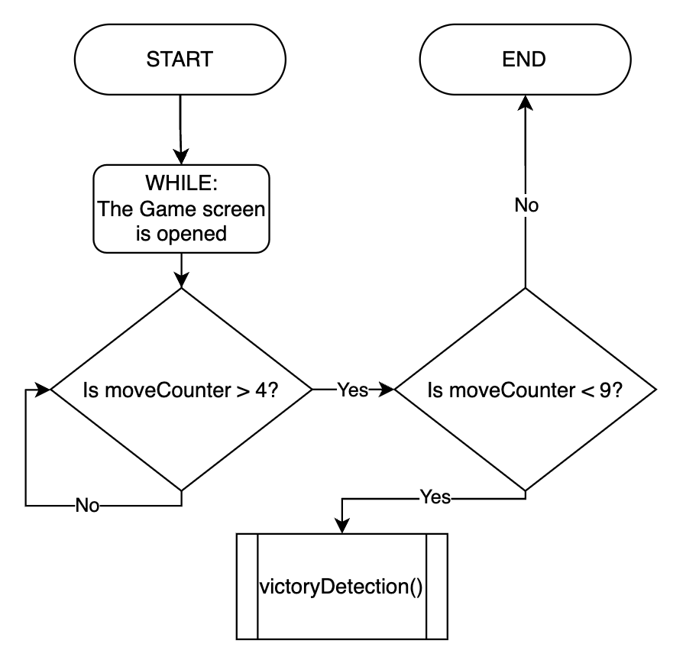

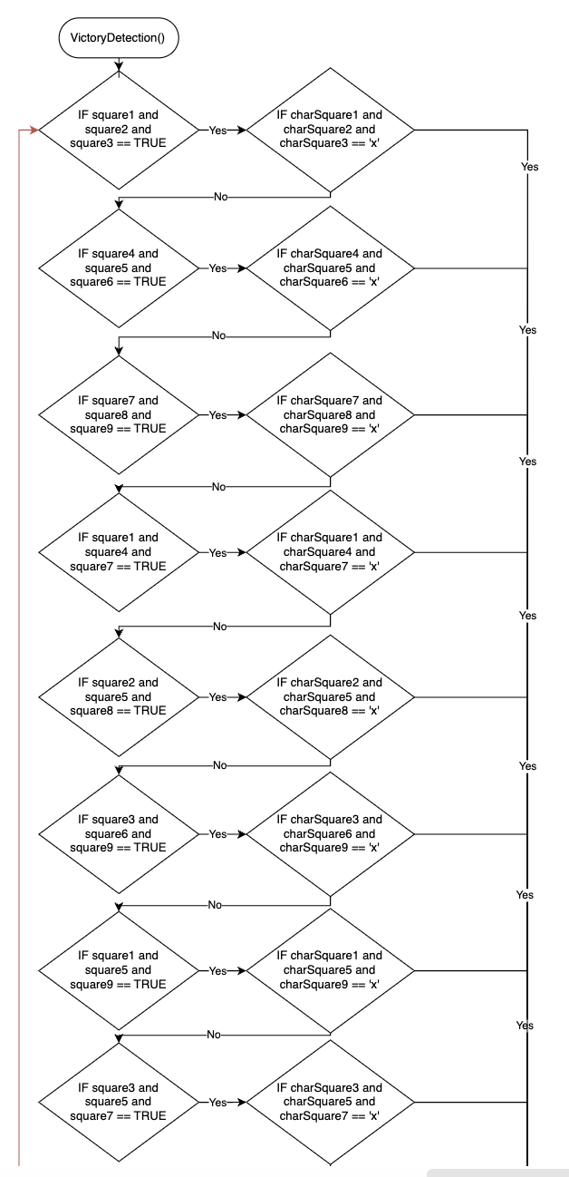

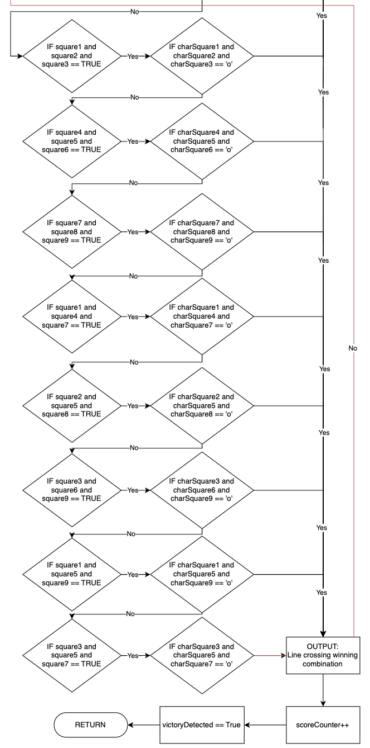

## Stage 3 Development

### Substage – A win

### Summary:

In the section the development of the victory detection algorithm is illustrated, the focus is on showing the implementation for identifying game victories. The screenshots demonstrate key steps in the algorithm, such as checking for winning patterns.

This screenshot shows initialisation of the scoreCounter which keeps track of the number of games played and accessing images of the lines that will cross the winning sets.

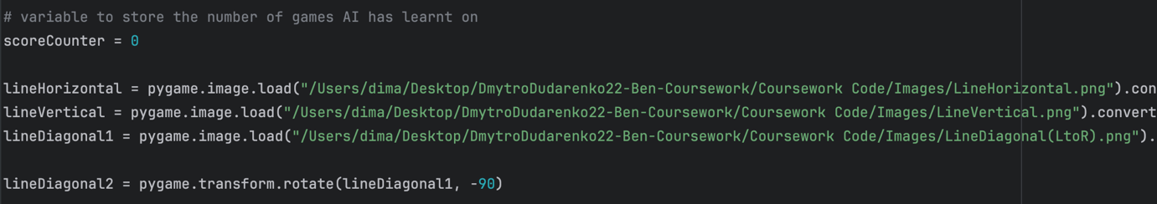

The code defines a function named victoryDetection() and calls certain global variables.

- victoryCombX1 to victoryCombO8 - variables storing different combinations of winning patterns for both 'X' and 'O'.

- charSquare1 to charSquare9 - variables representing the characters ('X', 'O', or empty) in each square of the board.

- victoryDetected - a flag indicating whether a victory condition has been detected.

- moveCounter - keeps track of the total number of moves made during the game.

- scoreCounter - counts the number of games played.

- scoreAdded - a flag indicating whether the current game has already been added to the score.

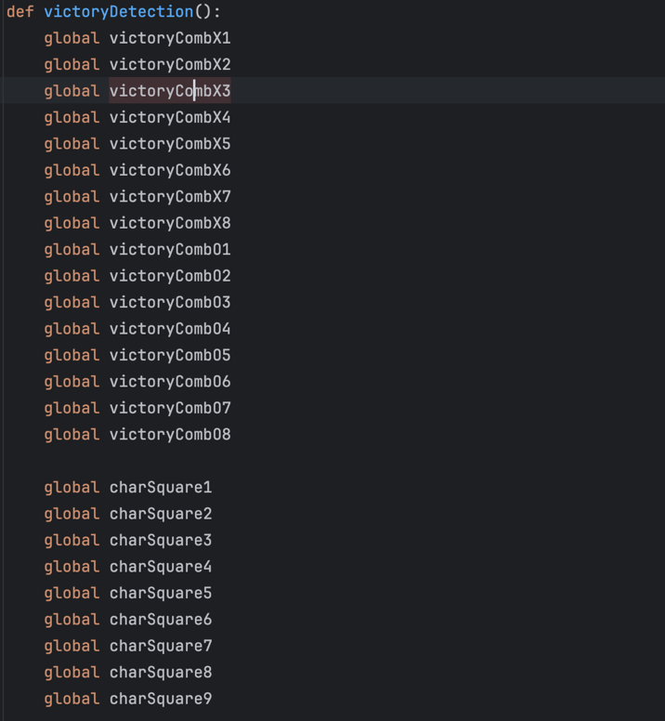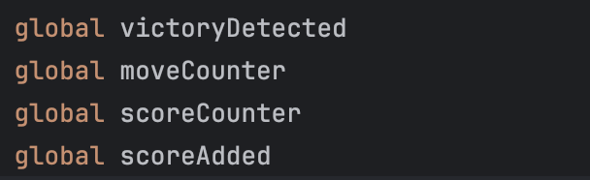

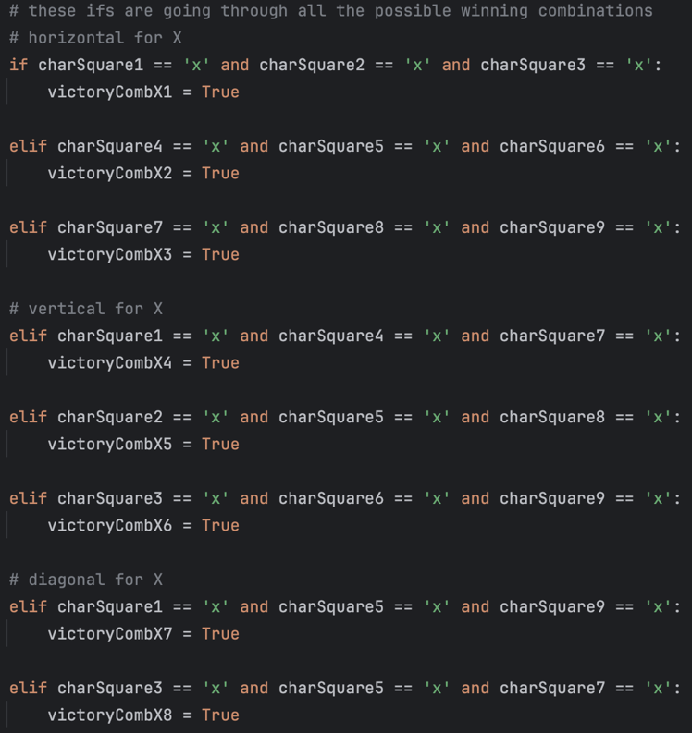

This code snippet checks for victory conditions for the 'X' player. It uses a series of `if` and `elif` statements to examine all possible winning combinations, both horizontally, vertically, and diagonally. If any of these conditions are satisfied, the corresponding `victoryCombX1` to `victoryCombX8` variables are set to `True`, indicating that a victory combination for 'X' has been detected.

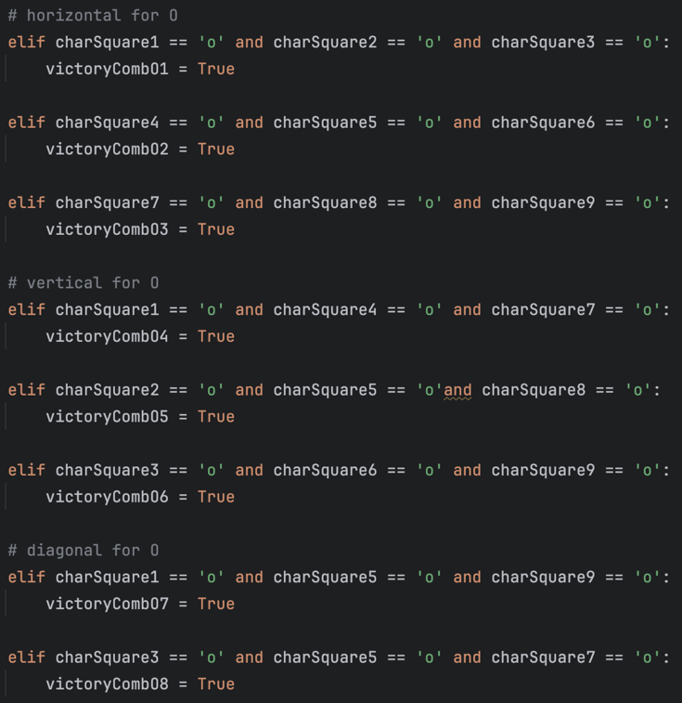

This block of the code extends the victory condition checks for the 'O' player. Similar to the 'X' player's conditions, it checks all possible winning combinations, including horizontal, vertical, and diagonal sets. If any of these conditions are met, the corresponding `victoryCombO1` to `victoryCombO8` variables are set to `True`, indicating a victory combination for 'O' has been detected.

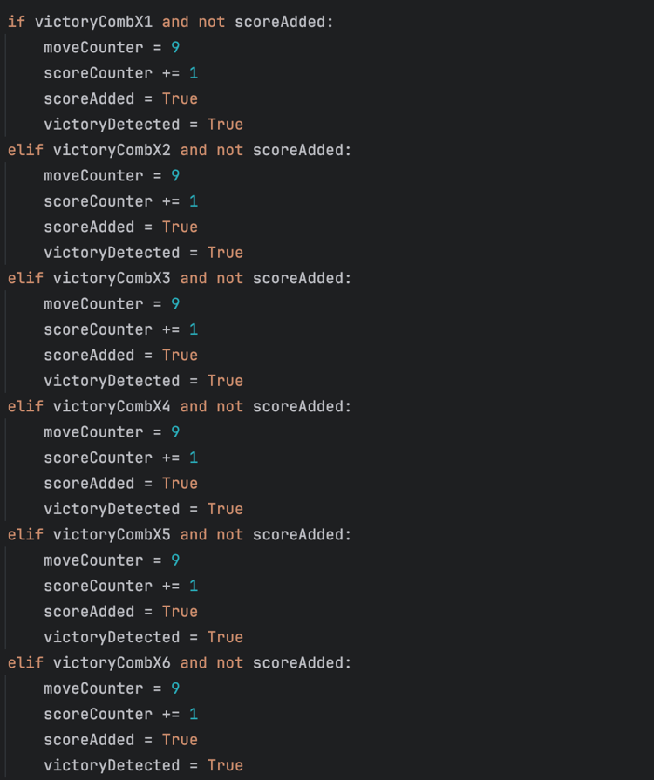

This part of the code handles the situation when a victory for the 'X' player is detected. It checks each of the previously identified victory combinations (`victoryCombX1` to `victoryCombX8`). If a victory is detected and the score has not been added yet (`not scoreAdded`), it performs the following actions:

- Sets `moveCounter` to 9, indicating that no more moves can be made.

- Increments `scoreCounter` showing that one more game has been played.

- Sets `scoreAdded` to True, preventing duplicate score increments.

- Sets `victoryDetected` to True, indicating that a victory has been detected.

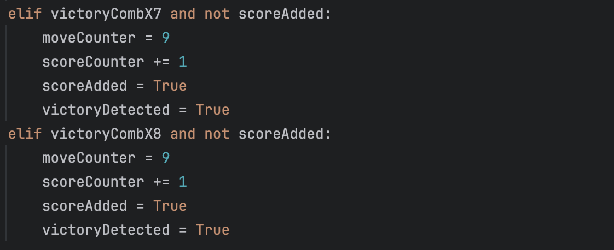

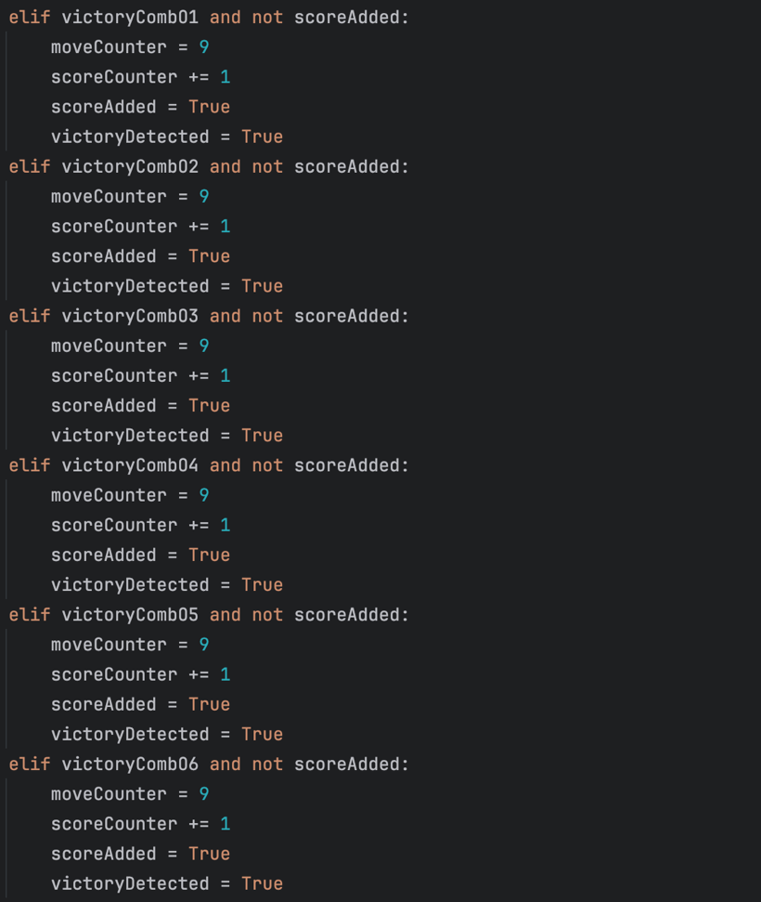

This bit of code checks each of the identified victory combinations for 'O' (`victoryCombO1` to `victoryCombO8`). If a victory is detected and the score has not been added yet (`not scoreAdded`), it performs the following actions:

- Sets `moveCounter` to 9, indicating that no more moves can be made.

- Increments `scoreCounter` showing that one more game has been played.

- Sets `scoreAdded` to True, preventing duplicate score increments.

- Sets `victoryDetected` to True, indicating that a victory has been detected.

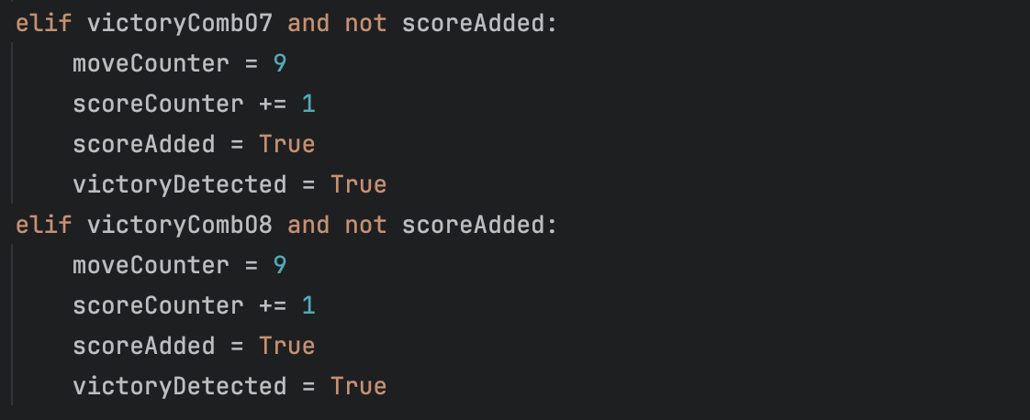

If none of the previous conditions for detecting a victory for 'X' or 'O' are met, it sets `victoryDetected` to False. This means that there is no victory detected in the current state and the game should continue.

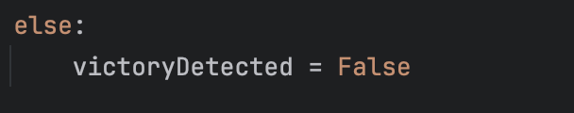

This part of the code is responsible for displaying the winning combination on the board, in case either 'X' or 'O' wins. Specific line images (`lineHorizontal`, `lineVertical`, `lineDiagonal1`, `lineDiagonal2`) are drawn at positions corresponding to the winning combinations. Here is an explanation for some cases:

if victoryCombX1 or victoryCombO1 is True, it draws a horizontal line image at the top row of the grid.

If victoryCombX4 or victoryCombO4 is True, it draws a vertical line image at the leftmost column of the grid.

If victoryCombX7 or victoryCombO7 is True, it draws a diagonal line image from the top-left to bottom-right.

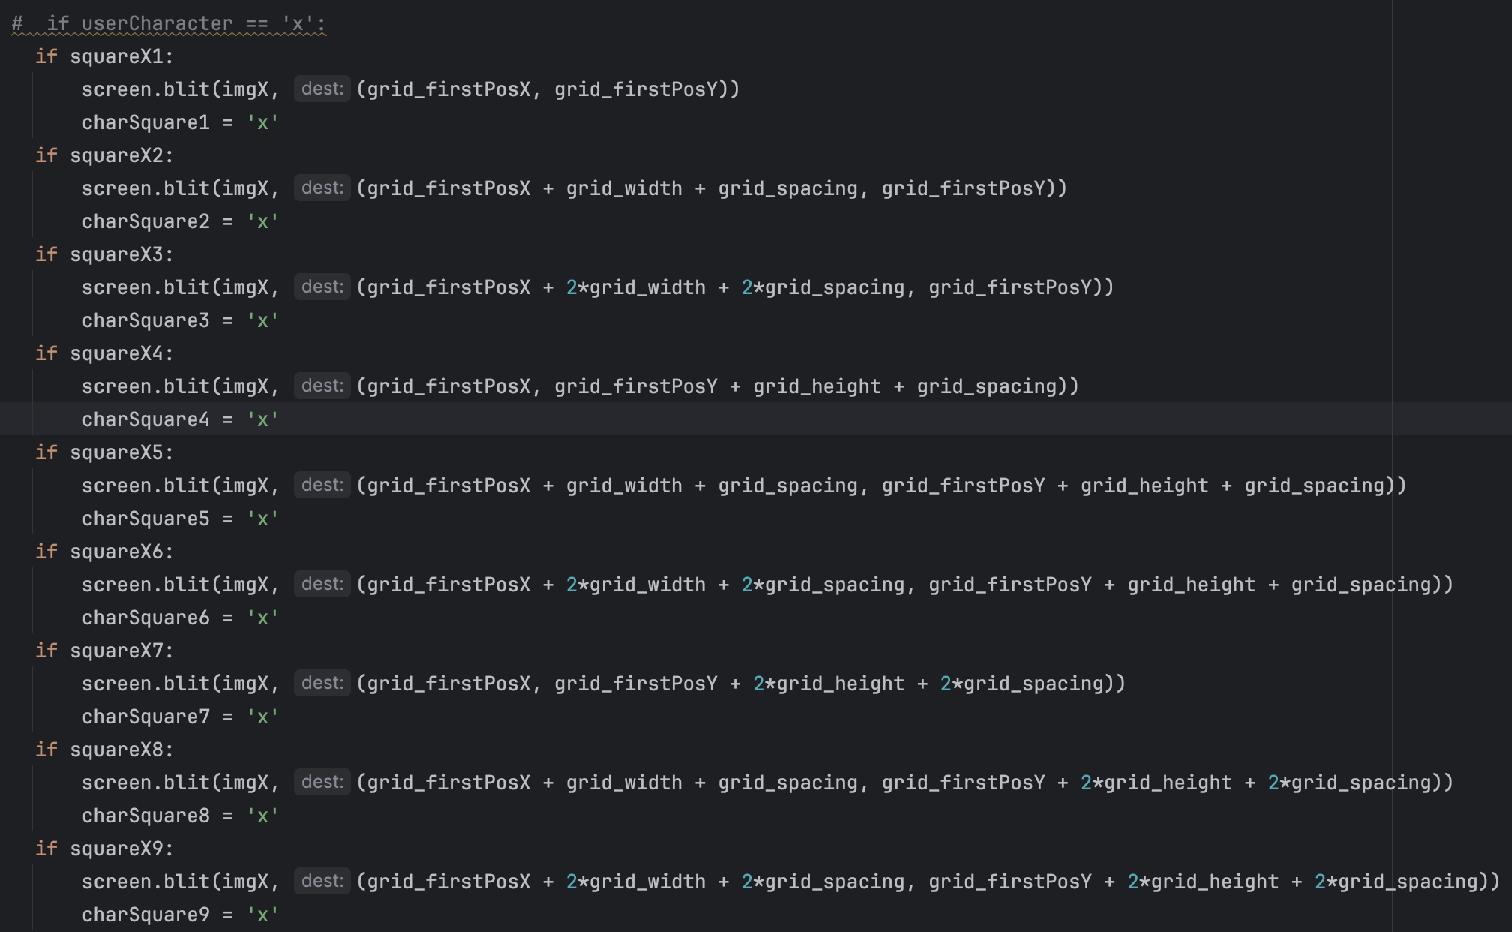

### Bug Fixes:

While I was testing the program, I discovered a bug which appeared when two winning sets were found simultaneously (Video - 3.13) – the score was added twice to the counter.

This bug appeared because the victoryDetection function would go through all the possible winning sets even if they had already been found. So, I coded an additional check – if not victoryDetected, before each if statement to interrupt the function. Video - 3.14

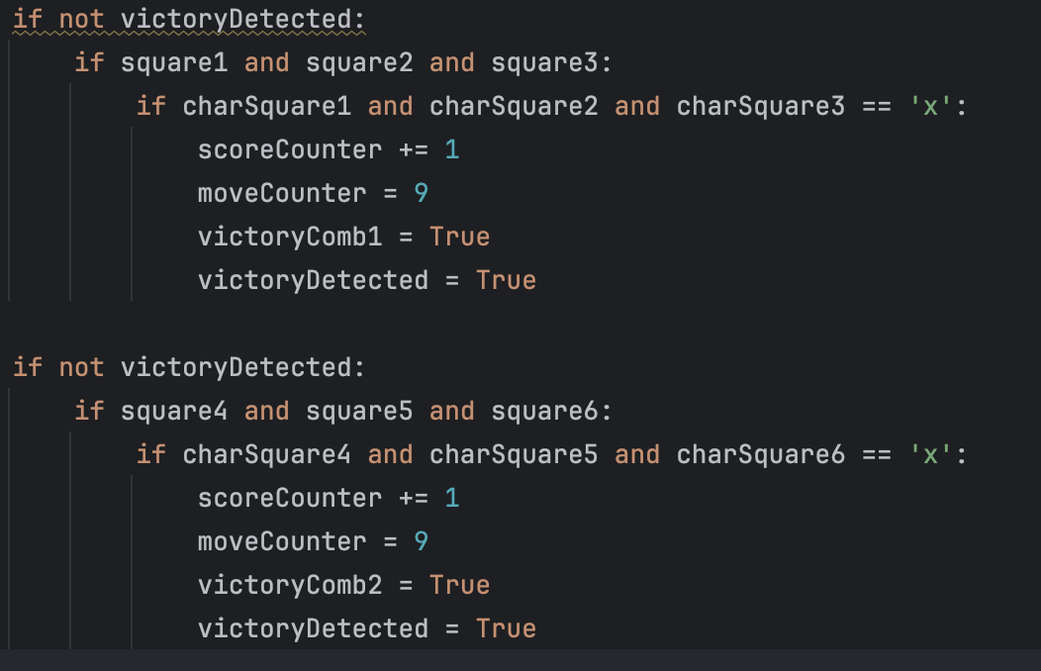

After that, I understood that in the first place, the function should not be called if the victory is detected and that there is no point in the line below (if square1 and square2 and square3) as if there is a character in a square, the boolean representing it will be True so lines 2 and 3 are duplicates. Moreover, I remembered that I could use “elif” instead of adding extra conditions to sort this problem out.

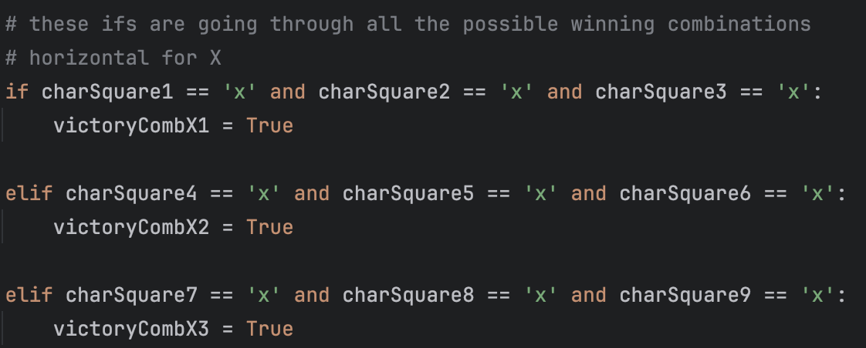

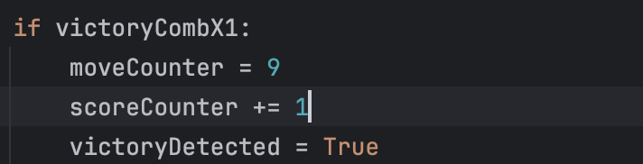

This change made the code look more organised and understandable and created a new bug (Video -3.15). I quickly realised that I needed to create another variable which would be a flag showing that the score had been added. The video – 3.16, shows the fixed version.

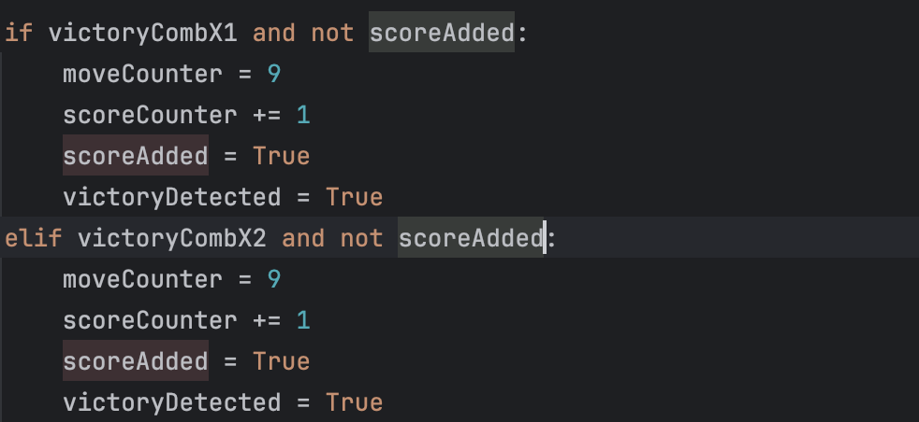

The first step I did was to check if the lines crossing winning combinations were displayed correctly in all the cases. Unfortunately, they were not. That what would be displayed when diagonal line was shown.

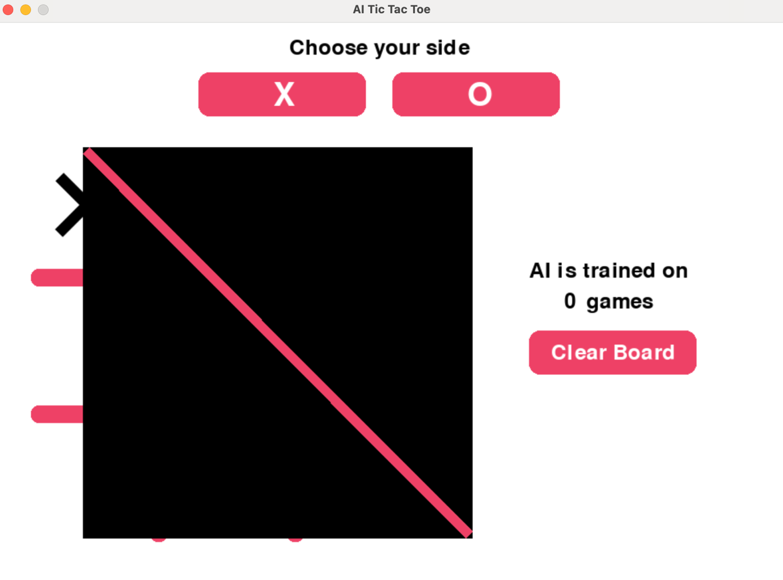

I saved the picture without a background, but its container was still rectangular which the computer was trying to fill with the colour.

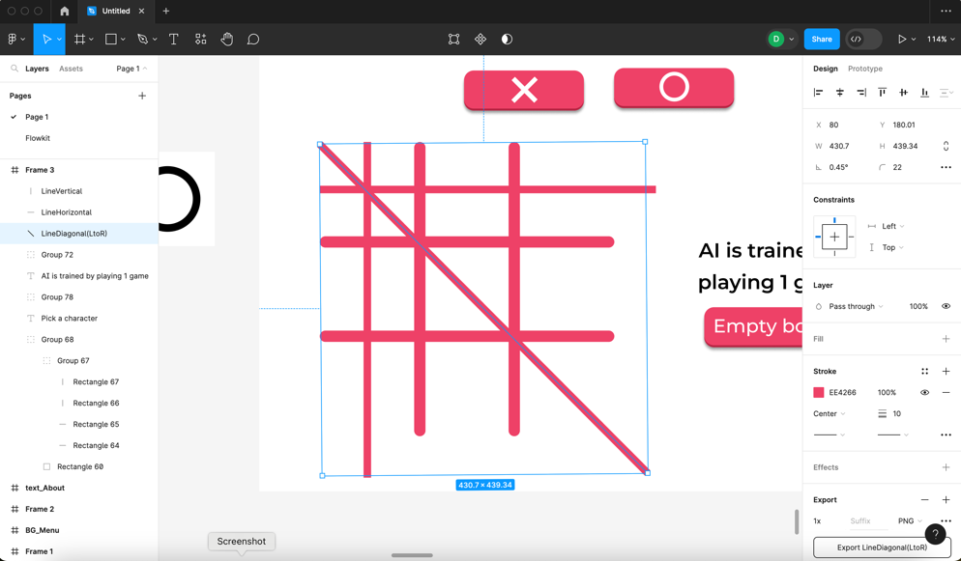

I tried rotating a horizontal line instead of using a picture of a diagonal line, unfortunately, it did not work (Video – 3.17) and I had to come up with a solution. I spent some time doing research and found this:



Unexpectedly, this small word “alpha” fixed the bug. Video – 3.18 shows how it works when fixed

**Tests Table:**

|  |  |  |  |  |  |
| --- | --- | --- | --- | --- | --- |
| Test No. | Description | Type of test | Test data | Expected Result | Actual Result |
| 1a | Does the line appear on the grid when the winning combination is found? | Valid | Play the game till either side builds a winning set | The line appears on the grid when the winning combination is found | Pass  Evidence:  Videos – 3.14, 3.16, 3.18. |
| 1b | Does the line cross the winning combination? | Valid | Play the game till either side builds a winning set | The line crosses exactly the main set when the winning combination is found | Pass  Evidence:  Videos – 3.14, 3.16, 3.18. |
| 2a | Does the counter’s score increase when either side wins? | Valid | Play the game till either side builds a winning set | The counter’s score increases | Pass  Evidence:  Videos – 3.14, 3.16, 3.18. |
| 2b | Does it increase by 1? | Valid | Play the game till either side builds a winning set | The counter’s score increases by 1 | Pass  Evidence:  Videos – 3.14, 3.16, 3.18. |
| 2c | Is the counter’s score reset once the clear board button is pressed? | Invalid | Play the game till either side builds a winning set and press the clear board button | The score should not be reset | Pass  Evidence:  Videos – 3.14, 3.16, 3.18. |
| 3 | Does the grid allow to put new characters after the winning line is drawn? | Invalid | Play the game till either side builds a winning set and try to click on the empty cell of the grid | The grid is blocked, therefore, nothing should happen | Pass  Evidence:  Videos – 3.22 |

## Stage 3 – Result Detection

### Substage – A tie

**Summary:**

In this substage, an algorithm checking for a tie will be added to the function detecting victory.

**Has to be implemented:**

|  |  |
| --- | --- |
| Functionality | Justification |
| Update counter | Whenever the draw is detected, the game counter should be updated by adding 1 to the current value |
| Block grid | After getting a signal of detecting the draw, the grid should be blocked, so the characters that have already been put, can’t be changed |

|  |  |
| --- | --- |
| Algorithm | Justification |
| Draw detection | An algorithm that will detect the draw and give a signal to other functions |

**Example Tests Table:**

|  |  |  |  |  |  |
| --- | --- | --- | --- | --- | --- |
| Test No. | Description | Type of test | Test data | Expected Result | Actual Result |
| 1 | Does the grid get blocked when the draw is detected? | Valid | Play the game till the draw and try to put a character on the grid | Nothing should happen – the character won’t be changed |  |
| 2 | Does the counter update when the draw is detected? | Valid | Play the game till the draw | The counter’s value should be changed by +1 |  |

## Stage 3 Flowchart

### Substage – A tie

### Summary:

This flowchart shows a small change that has been made to the victory detection algorithm to detect a draw. From now on, when moveCounter reaches 9, victoryDetected is set to True, which blocks the grid, in this case functions making moves cannot be accessed, and the scoreCounter is updated.

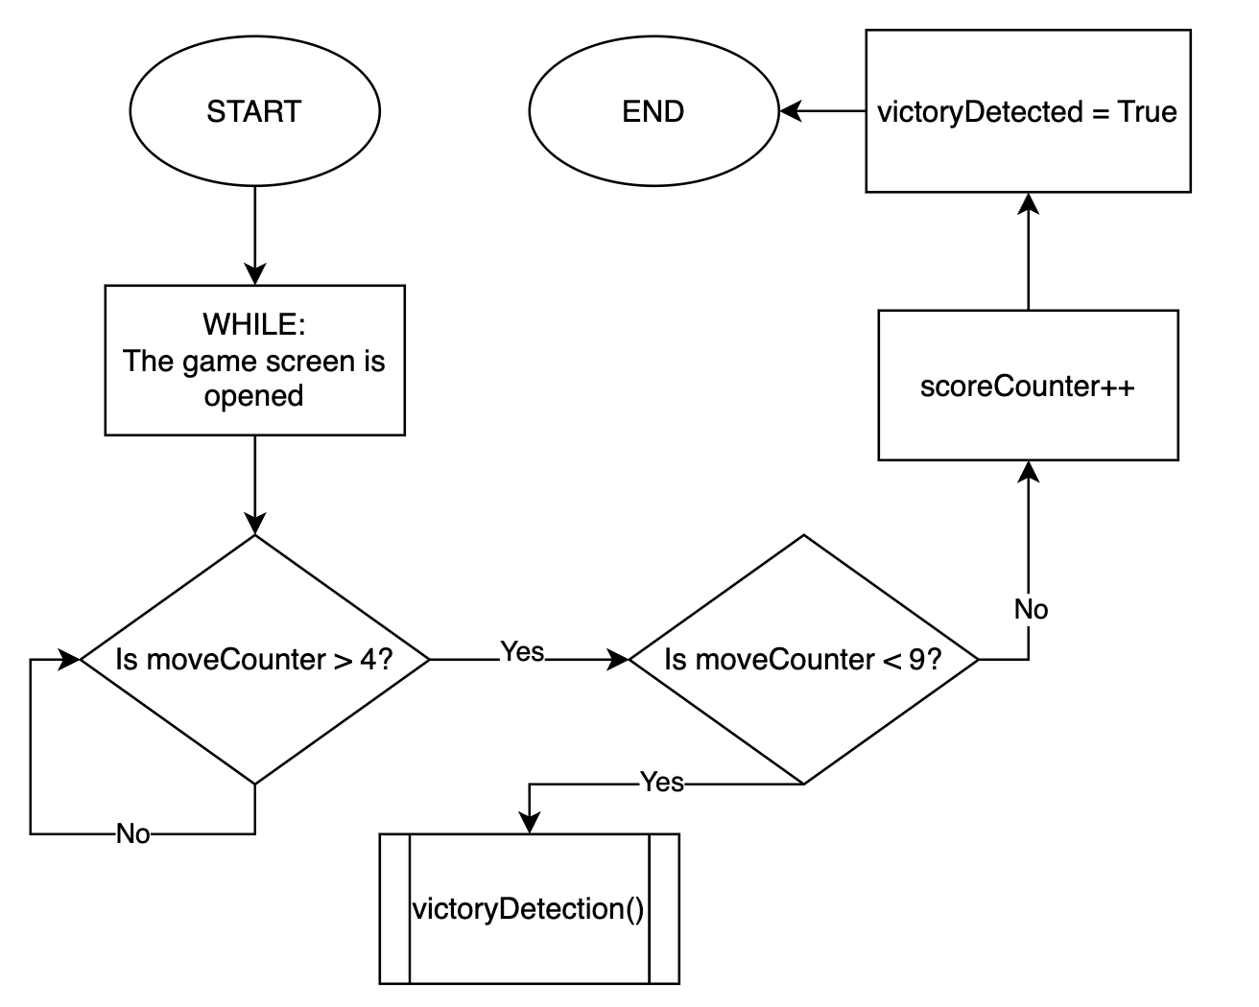

## Stage 3 Development

### Substage – A tie

### Summary:

In this section screenshot of an addition to the victory detection algorithm is shown. It illustrates the changes made to the existing algorithm to identify ties.

This bit of code illustrates what happens when the game results in a draw.

If `moveCounter` equals 9 (indicating that all squares on the Tic Tac Toe board are used) and the score has not been added yet (`not scoreAdded`), it performs the following actions:

- Increments `scoreCounter`  to update the score.

- Sets `scoreAdded` to True, preventing duplicate score increments.

- Sets `victoryDetected` to True, indicating that the game has ended.

The `else` statement sets `victoryDetected` to False if none of the specified conditions for victory or draw are met, therefore the game continues.

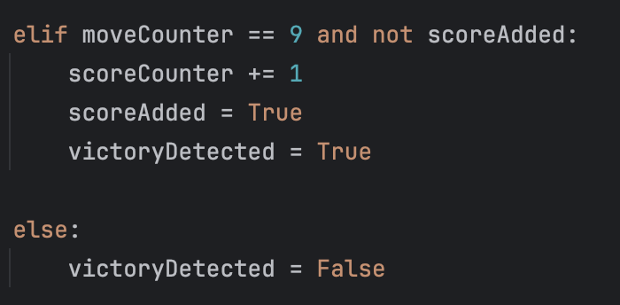

### Bug Fixes:

The implementation of the tie detection feature involved a minor change to the code, and it was seamlessly integrated hence it did not create any new bugs or issues.

However, to test if it works a second player that only makes moves that lead to a draw has been created. Important to say, it is a temporary function which will be deleted as soon as AI is implemented.

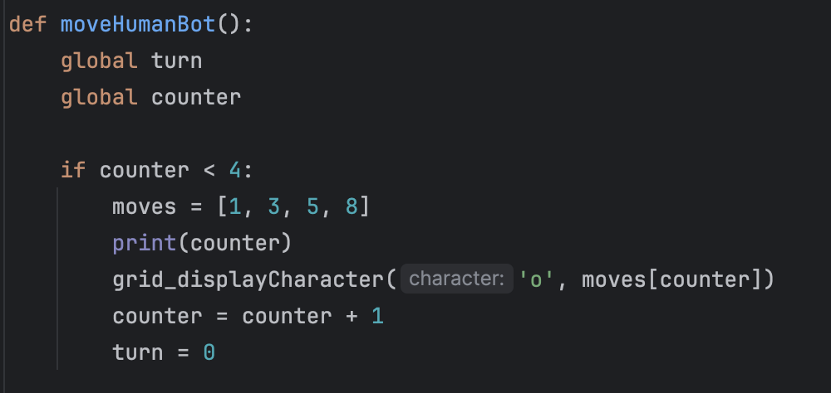

The list called moves was created to make a bot make specific moves which led to a draw. Video 3.25 shows that tie detection works as the grid is blocked and the score is added.

**Tests Table:**

|  |  |  |  |  |  |
| --- | --- | --- | --- | --- | --- |
| Test No. | Description | Type of test | Test data | Expected Result | Actual Result |
| 1 | Does the grid get blocked when the draw is detected? | Valid | Play the game till the draw and try to put a character on the grid | Nothing will happen – the character won’t be changed | The grid is blocked.  Evidence:  Video 3.25 |
| 2 | Does the counter update when the draw is detected? | Valid | Play the game till the draw | The counter’s value should be changed by +1 | The counter is incremented  Evidence:  Video 3.25 |

## Stage 3 Review

In this stage, I focused on making sure the game could correctly identify wins and ties. Getting these detection algorithms just right was trickier than expected, especially displaying the diagonal lines when victory is detected. But with a bit of perseverance, I managed to get everything working smoothly.

To summarise, all the test required have been passed and the requirements fulfilled, so the development of the stage was successful.

## Stage 4 – AI Functionality

### Substage – Game Screen

**Summary:**

This is the main stage in which I will develop AI and implement it using a machine learning approach that enables a model to iteratively learn and improve over time by taking the correct action. The one that I will use is called Q learning. In addition, this is the most time-consuming stage and that is it is the reason why I want to do it before developing “Menu” and “About” screens.

**Requirements met in this stage:**

|  |  |
| --- | --- |
| Requirement number and name | Test No. checking this requirement |
| 4a. AI Development | 1, 2, 3, 4, 5, 6, 7, 8, 9, 10, 11, 12, 13, 14 |
| 4b. Second AI | 9, 10, 11 |

**Has to be implemented:**

|  |  |
| --- | --- |
| Functionality | Justification |
| Getting a character (see DPC, Change 3) | User will have an opportunity to choose the character to play, so depending on the player’s choice AI should pick an opposite character before making a move |
| Making a move | By using the experience of previous games, unless it is a first game, it should analyse the grid, which characters have already been put, and find the best move to make using Q-values for the current state. |
| Analysing the game | After the game finished with any result, it should measure the reward, unless the clear board button had been clicked before the game ended (see DPC, Change 4) |

|  |  |
| --- | --- |
| Algorithm | Justification |
| Q learning | This is the main algorithm that will be used to develop AI. It can be split into 5 stages:   1. Q-Table initialisation 2. Get an action 3. Make a move 4. Get reward 5. Update Q-Table   And then steps 2-5 repeat. |

**Example Tests Table:**

|  |  |  |  |  |  |
| --- | --- | --- | --- | --- | --- |
| Test No. | Description | Type of test | Test data | Expected Result | Actual Result |
| 1 | Does AI make the move first using “X” character if the user picks “O” ?  CHANGED: There is no opportunity for the user to pick “O” | Valid | Pick “O” and wait for AI to make a move | AI will make the move first as “X” |  |
| 2 | Does AI make the move second using “O” character if the user picks “X” ? | Valid | Pick “X” and make a move | AI will wait for a player to make a move and then make its own using “O” |  |
| 3 | Does AI stop making moves when the game end with a win for either side? | Valid | Play the game for either character till a win of any side | AI will stop making moves when the game finishes |  |
| 4 | Does AI stop making moves when the game end with a draw? | Valid | Play the game for either character till a draw | AI will stop making moves when the game finishes |  |
| 5 | Does AI develop after playing a certain number of games? | Valid | Play 1000 games, then 2000, 5000, and 10000. | AI will make more educated moves as the user plays more games |  |
| 6 | Does AI measure a reward if the “Clear” button was pressed before the end of the game? | Valid | Make several moves and press the “Clear” button | In the output window it shouldn’t print out the reward |  |
| 7 | Does it correctly analyse the game and, therefore, measure the reward when it loses? | Valid | Play the game and make AI lose | In the output window it will print out the reward that AI got and it should be negative |  |
| 8 | Does it correctly analyse the game and, therefore, measure the reward when it wins? | Valid | Play the game and let AI win | In the output window it will print out the reward that AI got and it should be zero |  |
| 9 | Does it correctly analyse the game and, therefore, measure the reward when it is a draw? | Valid | Play the game and make it a draw | In the output window it will print out the reward that AI got and it should be positive |  |

**Data Dictionary:**

|  |  |  |  |
| --- | --- | --- | --- |
| Name | Data Type | Description | Validation |
| num_states,  num_actions | integer | These variables will be used as parameters to declare arrays size |  |
| q_values[num_states]  [num_actions] | compound | This 2D array will be storing Q-values for each action of each state | First parameter:  >= 0 and <= 8532  Second parameter:  >= 0 and <= 9 |
| learning_rate | floating point | The value of this variable determines to what extent newly acquired information overrides the old one | >= 0.0 and <= 1.0 |
| discount_factor | floating point | Determines the trade-off between immediate and future rewards | >= 0.0 and <= 1.0 |
| decay_rate | floating point | The rate at which epsilon will decrease | >= 0.0 and <= 1.0 |
| min_epsilon | floating point | Sets a value to which epsilon can be decreased | >= 0.0 and <= 1.0 |
| current_epsilon | floating point | The probability of choosing between exploitation and exploration | >= 0.0 and <= 1.0 |
| current_episode | integer | Keeps track of current learning episode | >= 0 |
| reward | integer | Will be given when the result is detected to teach AI |  |

**Q Table:**

This image is a visual representation of the Q Table that stores Q-values for each square on the grid for respective states (starting from 0 and going up to 8532). It is seen that the table is prefilled with zeroes. Importantly, the column indexed 0 which is coloured in red just takes memory space without being functional at all. This is due to the logic of the function displaying characters on the board (gridDisplayCharacter()), which takes the square number as a parameter and the square numbers are assigned starting from one, in other words, square number 0 does not exist, therefore the data in this column is redundant.

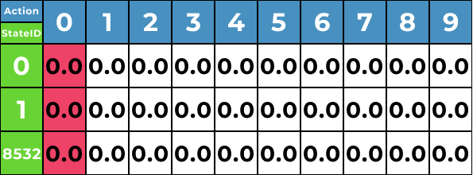

## Stage 4 Flowchart

### Summary:

The flowchart depicts the iterative process of the game with Q-learning implemented. It begins with checking which mode is turned on, followed by the move selection and Q-value updates. After detecting the game result, Q-values are updated, the board is cleared, and the loop repeats.

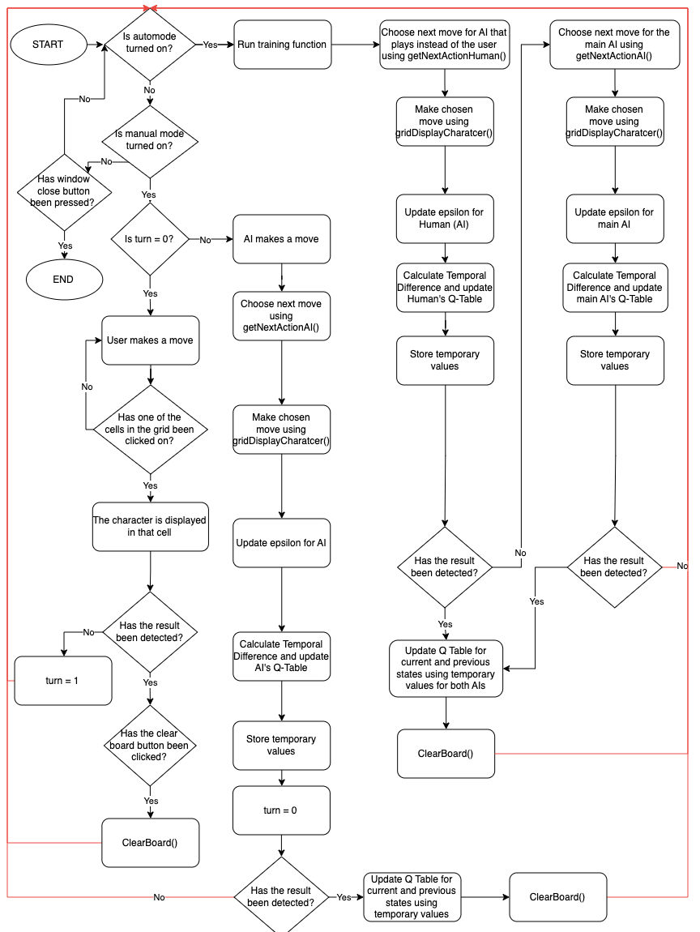

## Stage 4 Development

### Summary:

At this stage, the AI has been developed using Q-learning. The system initialises necessary parameters, Q-tables, and global variables. Training processes for both the primary AI and a secondary AI (called Human, which is used when playing in auto mode) are detailed, highlighting move selection, state tracking, and Q-value updates. Key functions, such as getNextActionHuman for move determination and getCurrentState for state representation, are explained. Additionally, the getStateID function assigns unique identifiers to states, and a function lists available actions on the game board.

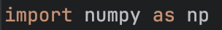

In order to make the Q learning algorithm work, a library called numpy had to be imported

In this screenshot all the parameters needed for AI to function, and Q-Tables were initialised. num_actions is set to 10, although it means that there is an extra column as array starts at 0, on the other hand, it makes it easier to comprehend that if column 1 (which is in fact the second one as it is an array) has the highest q-value for some state and AI picks it, the character will appear in square 1

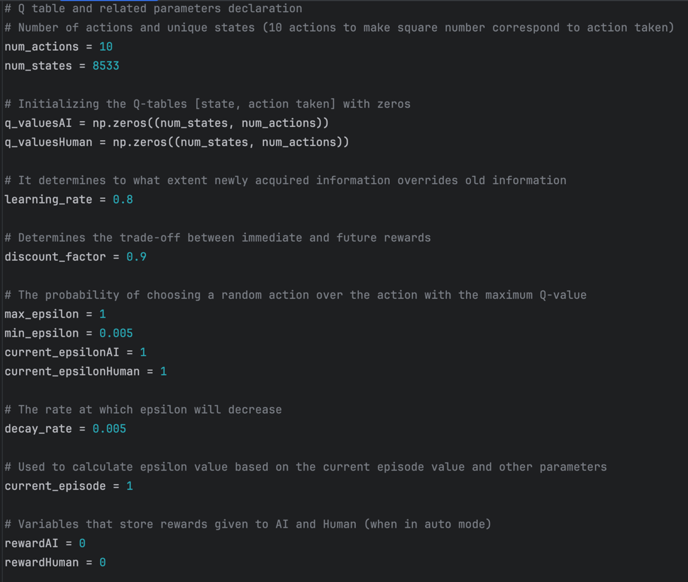

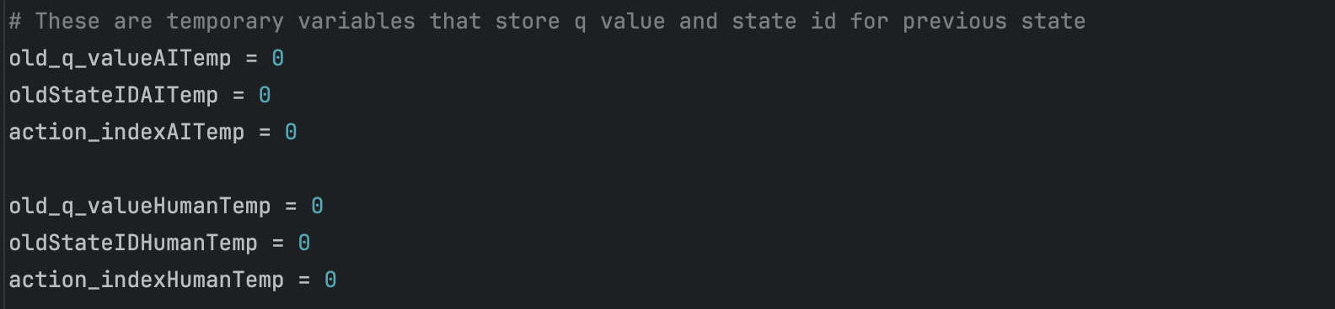

Dictionary and stateID have been initialised, which will then be used to store q-values in the array at a certain address (state)

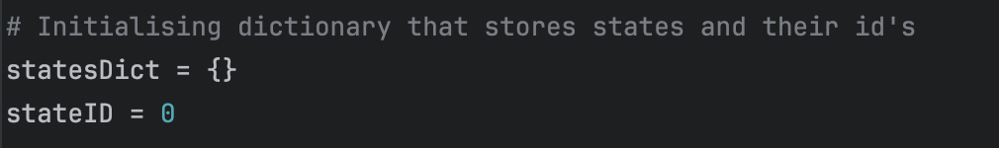

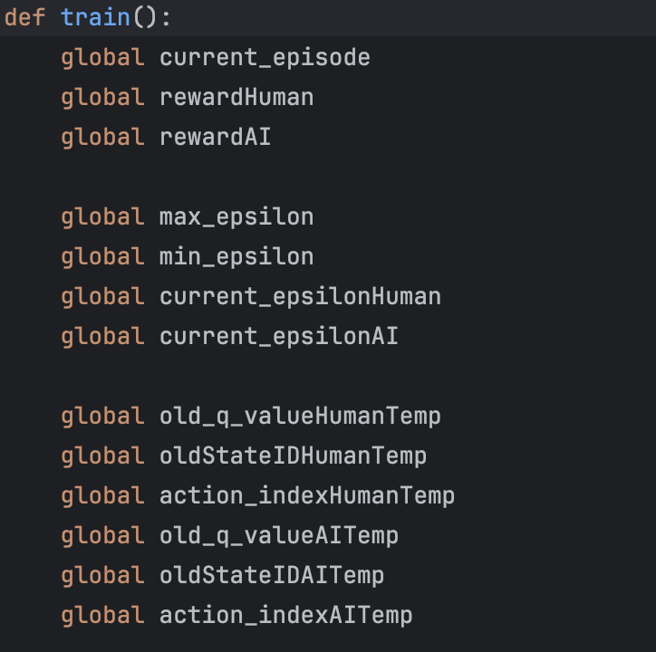

All variables needed related to the Q-learning algorithm and used for tracking various parameters during the training process are accessed globally

In this screenshot, the training process of the first AI (that plays instead of user when in auto mode, so its name is human) is done by following these steps:

1. Checking if the game result has not been detected.
2. Choosing a move by calling getNextActionHuman function.
3. Saving the state ID before making a move.
4. Making the move on the game board.
5. Updating the exploration rate (current_epsilonHuman) based on the current episode.
6. Calculating the temporal difference for the Q-learning update.
7. Updating the Q-value for the previous state and action pair for the human AI.

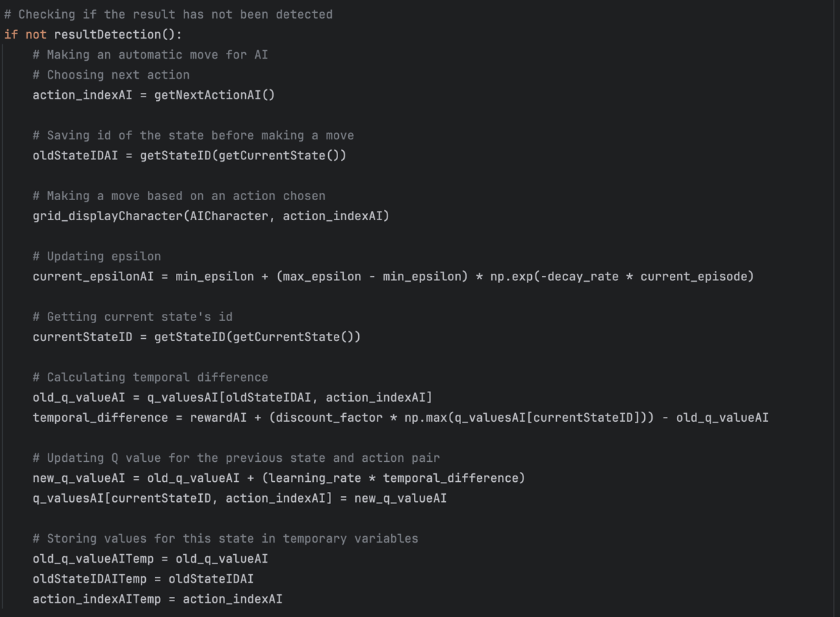

This block of code is similar to the one in screenshot above as it is also training AI, but now it is the main AI which plays against the user when in manual mode. There are difference it variable names as this AI has got its own q table and parameters, although the logic is kept the same.

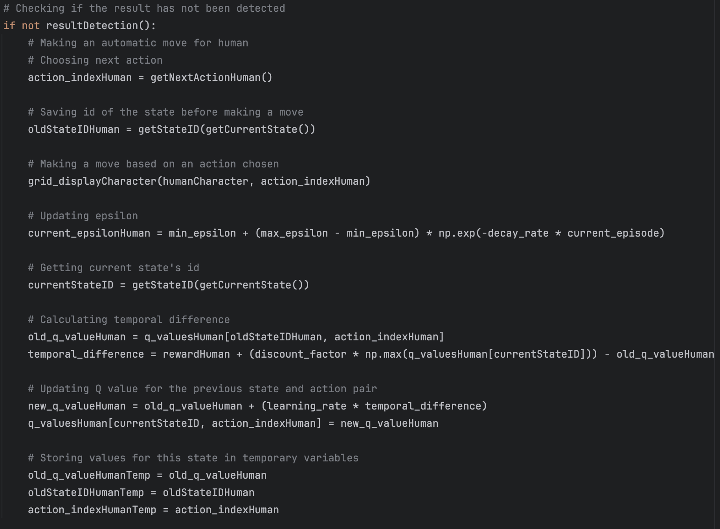

This code snippet handles the Q-learning update process when the result has been detected. It calculates temporal differences for both the human and AI players and updates their respective Q-values based on the values from the previous state and action pairs. After the updates, it clears the game board for a new game.

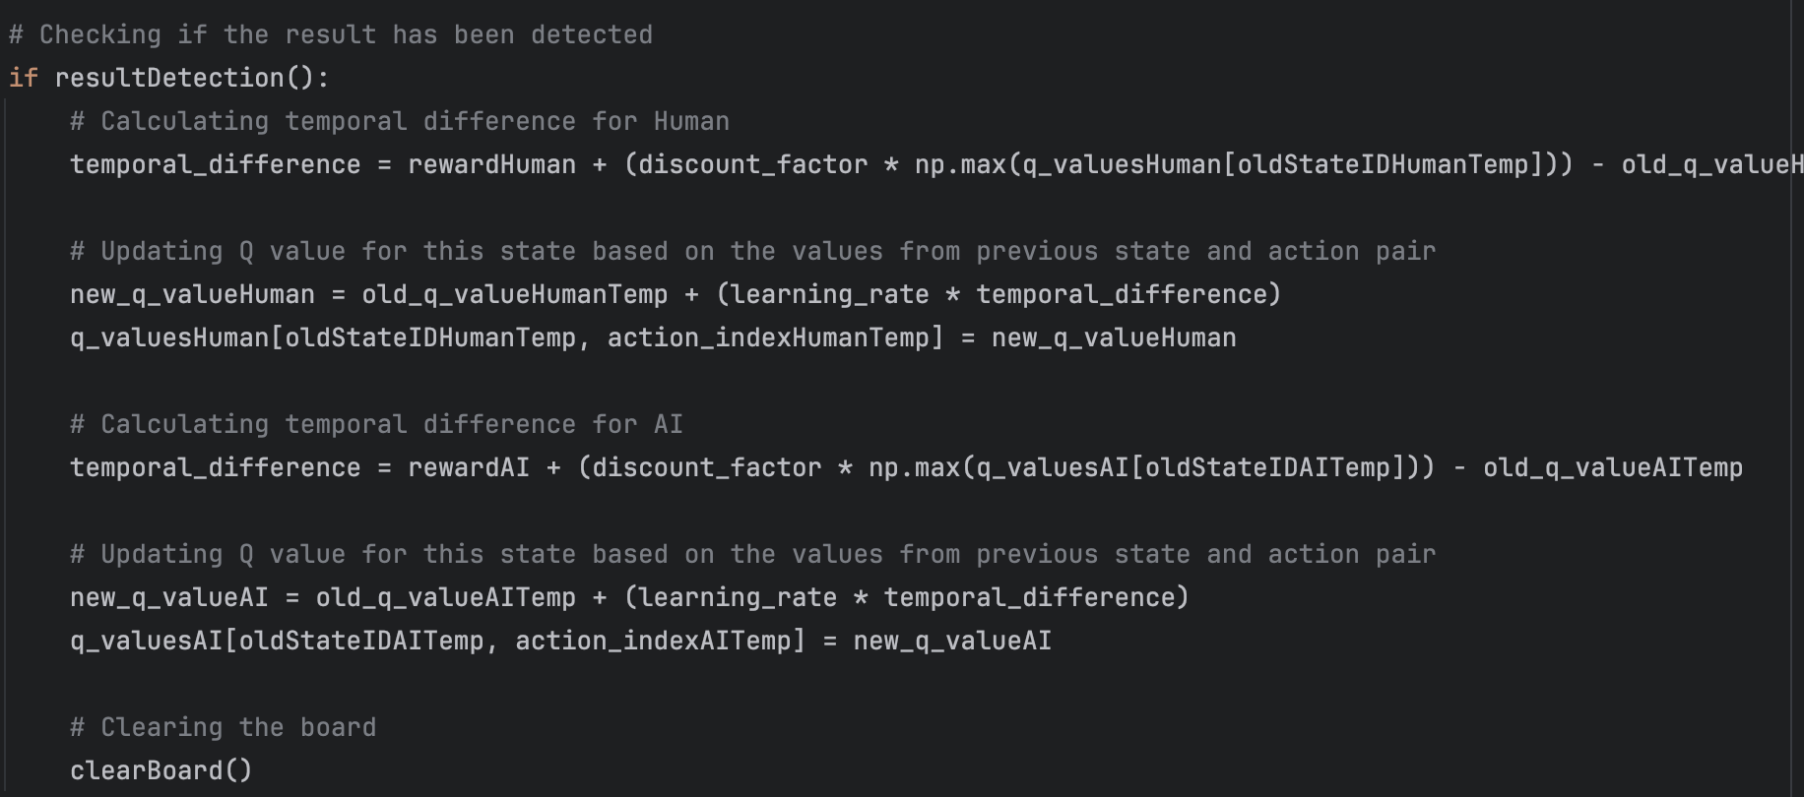

This screenshot shows the getNextActionHuman function which determines the next move for the first AI (called Human) based on the epsilon-greedy strategy by

generating a random number between 0.0 and 1.0 and then if randomNumber is greater than current_epsilonHuman, the function exploits the learned information by choosing the action (move) with the highest Q-value for the current state. If the highest Q-value is 0 (indicating the AI has not developed enough for that state), it explores by choosing a random move.

If randomNumber is less than or equal to current_epsilonHuman, the function explores by choosing a random move. If no positions are available, it sets moveCounter to 9 to signal the end of the game.

The function returns the chosen move back to the train(). This is Screenshot 4.8

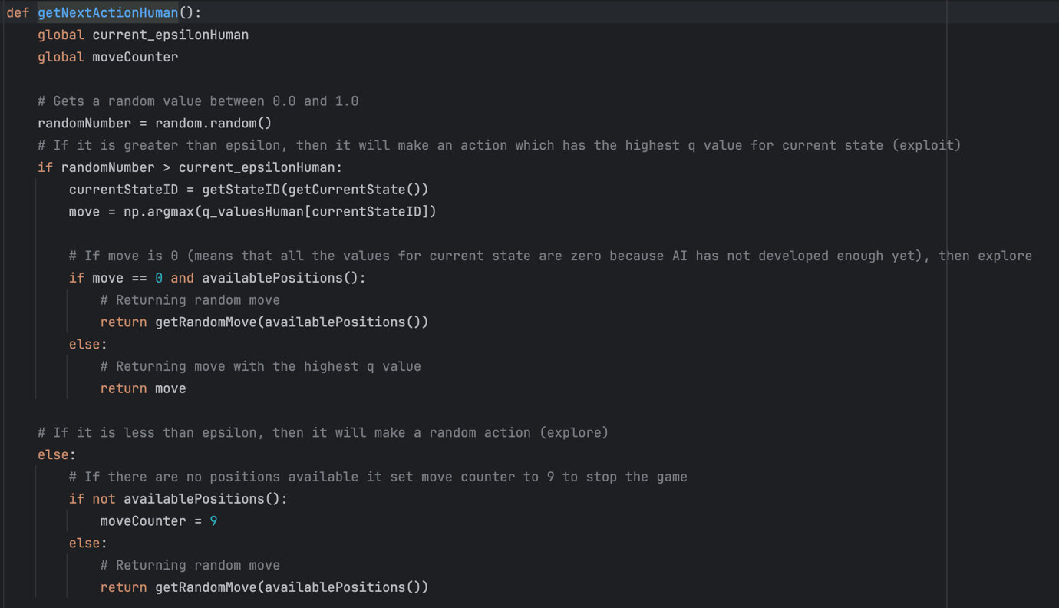

This screenshot illustrates how getCurrentState() function works (which is used in getNextActionHuman(), screenshot above). So, basically, what it does is generates a string representing current state. It relies on several global variables (usedS1 to usedS9 and squareX1 to squareX9) that track the state of each cell on the board.

Screenshot 4.9

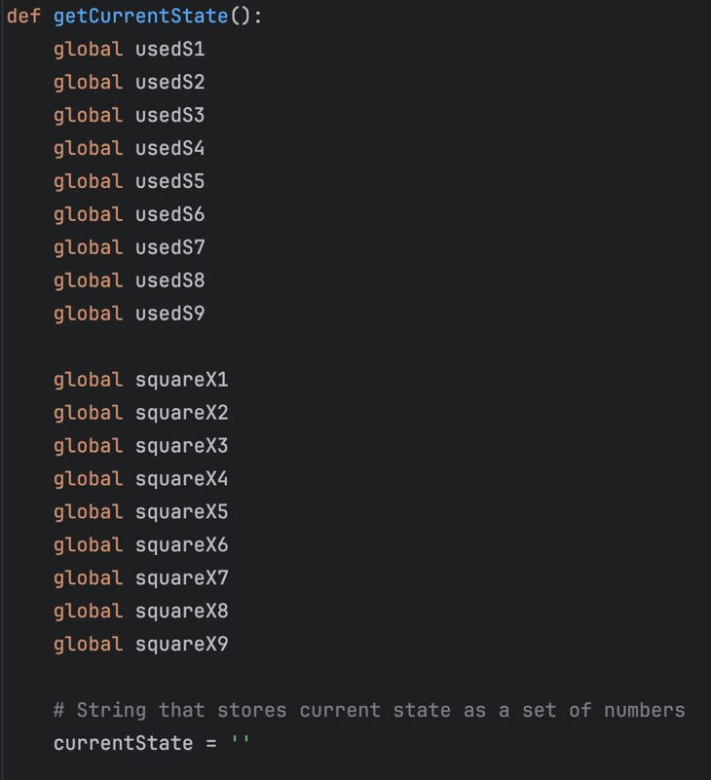

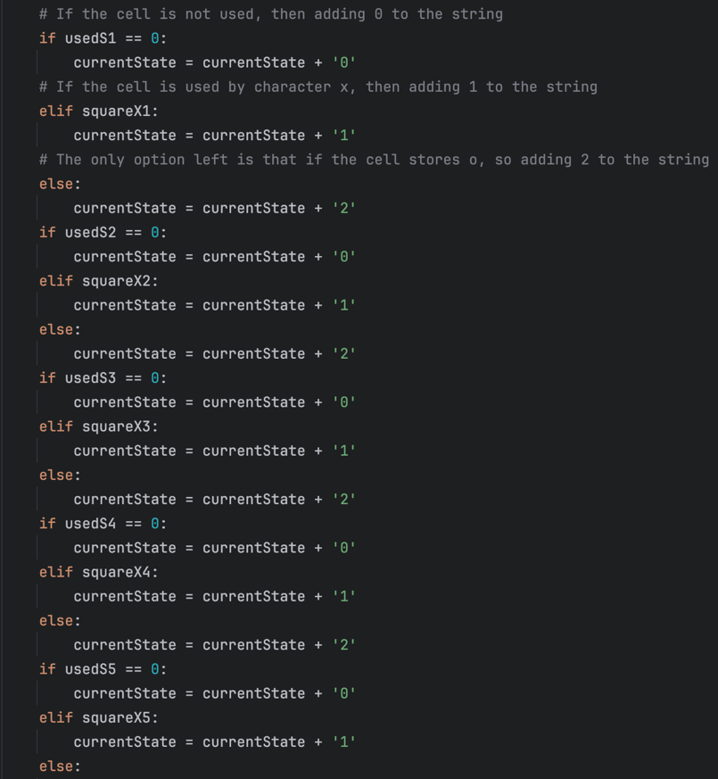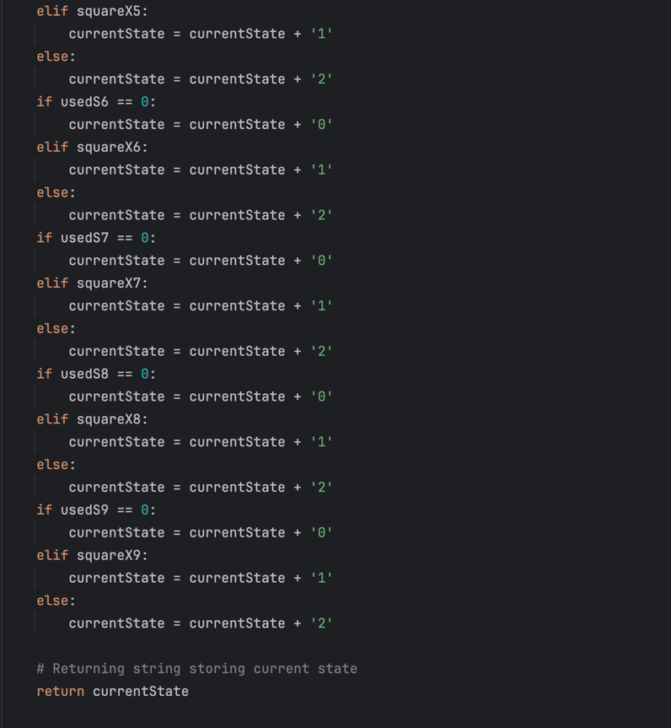

The string is constructed by checking each cell, if it is unused, used by 'X', or used by 'O', and appends the corresponding digit to the currentState string.

'0': Cell is not used.

'1': Cell is used by character 'X'.

'2': Cell is used by character 'O'.

The function then returns the constructed string.

Screenshots 4.10 and 4.11

This block of code below represents the getStateID() function that is responsible for assigning and returning a unique identifier (ID) for a given state. The way it works is as follows:

1. It uses two global variables - `statesDict` and `stateID`, to maintain a dictionary of states and their corresponding IDs.
2. It iterates through the existing state IDs in the dictionary (for i in range(stateID + 1)).
3. If the state passed as a parameter (it is created in getCurrentState(), screenshot 4.9, 4.10, 4.11) already exists in the dictionary, it returns the existing ID associated with that state.
4. If the state does not exist in the dictionary, it assigns a new ID (`stateID + 1`) to the state, updates the dictionary, and returns the newly assigned ID.

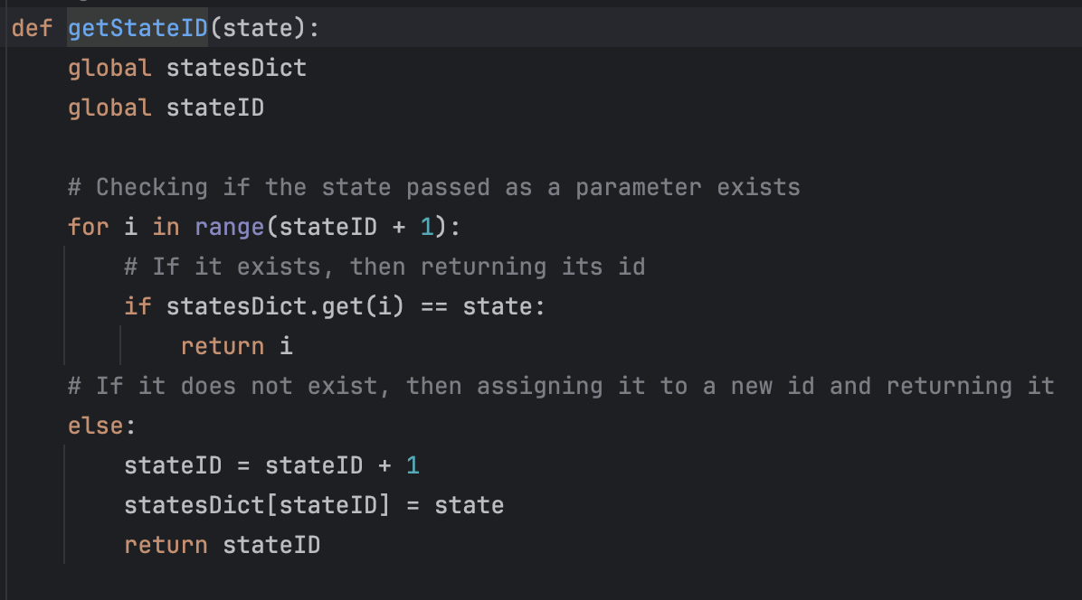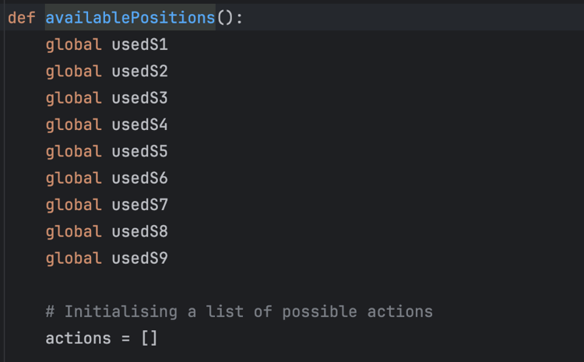

This block of code represents the getStateID() function that is responsible for assigning and returning a unique identifier (ID) for a given state. The way it works is as follows:

1. It uses two global variables - `statesDict` and `stateID`, to maintain a dictionary of states and their corresponding IDs.
2. It iterates through the existing state IDs in the dictionary (for i in range(stateID + 1)).
3. If the state passed as a parameter (it is created in getCurrentState(), screenshot 4.9, 4.10, 4.11) already exists in the dictionary, it returns the existing ID associated with that state.
4. If the state does not exist in the dictionary, it assigns a new ID (`stateID + 1`) to the state, updates the dictionary, and returns the newly assigned ID.

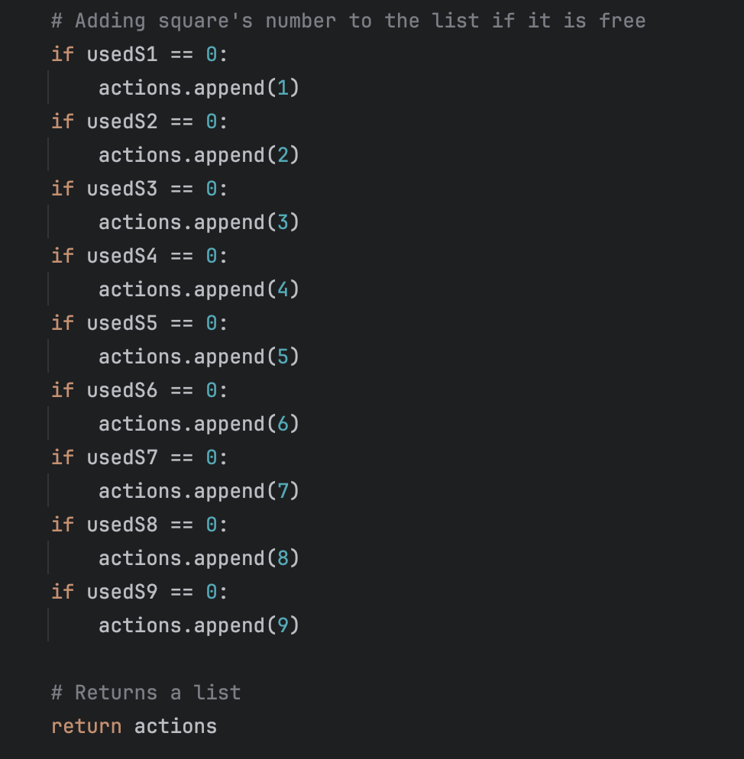

This piece of code is almost the same as in screenshot 4.8 but now it for the main AI which plays against the user when in manual mode. There are difference it variable names as this AI has got its own q table and parameters, although the logic is kept the same.

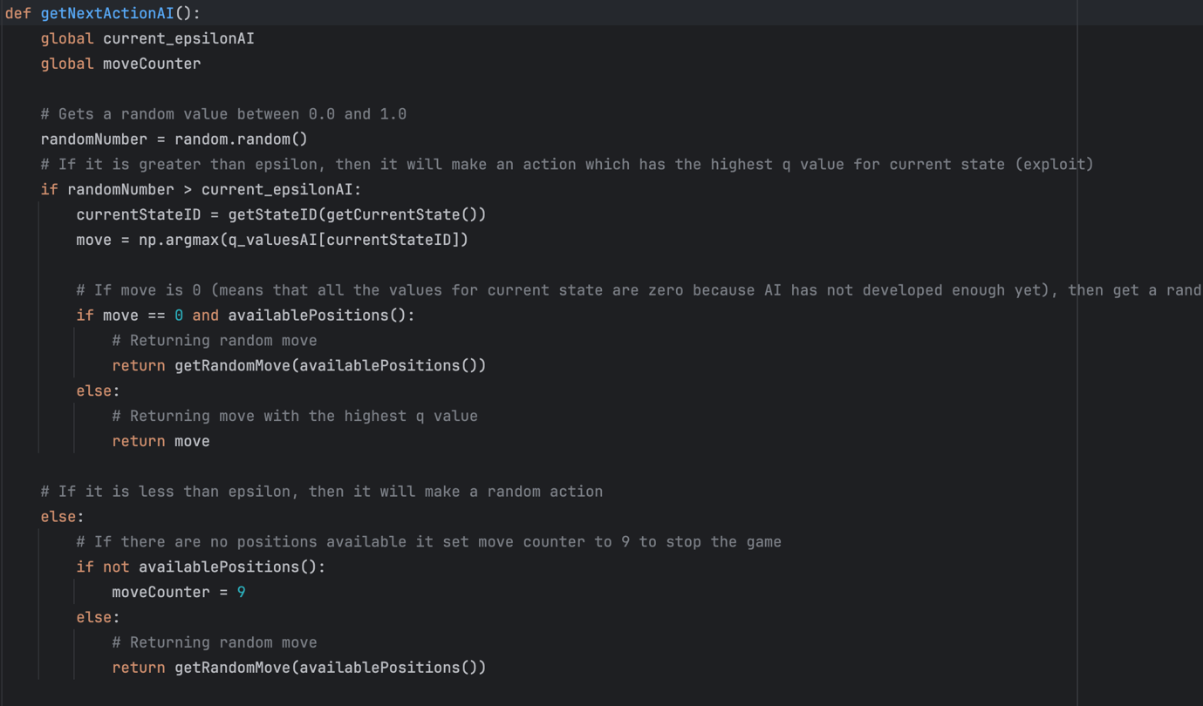

### Q Learning Algorithm:

### Summary:

The section covers the initialisation of the Q-table and parameters set. Explains the training process, outlining steps such as move selection, state tracking, and Q-value updates based on the temporal difference for both AIs.

The first step involves the initialization of the Q-table, a data structure for storing Q-values corresponding to state-action pairs. In this step, an array is created where each row represents a distinct state, and columns correspond to possible actions. The Q-values for all state-action pairs are initially set to zero. As the algorithm interacts with the environment and receives rewards, these Q-values will be updated, allowing the system to learn and make more educated moves over time.

The next step is identifying the state. This involves using the getCurrentState function, which constructs a string - representation of the current game state using 9 digits. In this representation, 0 is used for empty cells, 1 represents 'X,' and 2 - 'O.' After that, a unique identifier (ID) is assigned to each state, and these IDs are stored in an array along with the corresponding Q-values. This approach is used for the efficient tracking and management of states.

The action selection process involves using a function called getNextAction. This function determines whether to explore or exploit the learnt information and then make a move based on this decision.

Within the getNextAction function, an epsilon-greedy strategy is used. This strategy involves generating a random number between 0.0 and 1.0. If this random number is greater than the exploration rate (epsilon), the algorithm exploits the learned information by choosing the action with the highest Q-value for the current state. In case the highest Q-value is 0 (indicating insufficient learning for that state), it explores, and a random move is selected. The chosen move is then returned by the function.

The next important step in this algorithm is measuring and assigning rewards. Basically, a reward is feedback, which is represented by a number, that the system receives after taking an action in a specific state. This value tells the algorithm whether the action is beneficial to the victory or not. Rewards influence the learning process, encouraging the algorithm to optimise decision-making for maximizing cumulative rewards over time. After each action, the Q-value must be updated for the current state based on the reward received.

The last step is connecting all the functions and parameters mentioned into one training loop which will run whenever AI has to make a move.

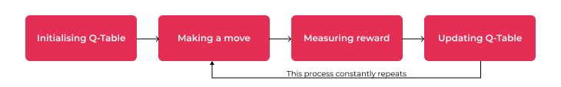

### Bug fixes:

The development process encountered significant challenges with numerous minor and critical bugs, influencing the functionality of the AI and the game in general. Loads of effort and time were dedicated to identifying and resolving these issues.

Before Implementing AI, I had to fix all the bugs that influenced the gameplay, as, otherwise, the Q Table would not be updated correctly. The issue was that even after the game had finished and a line crossing the winning set had appeared, one more move would still be made, so an extra character would appear and only then the grid would be blocked (Video – 4.16). My first thoughts were that the victoryDetection function, which was later renamed to resultDetection, was not working correctly or that the block of code that was responsible for making a move for AI could be accessed without checking for the game result. I decided to print the boolean that was returned by the victoryDetection function and found out that it would only return True when an extra character appeared on the board. I was thoroughly looking through the victoryDetection function but could not find any bugs in it, so I decided to rewrite it, which is the reason why I changed its name to resultDetection and noticed that I have two variables which allow to display line crossing winning sets.



So, I changed that to:

And saw that I was updating the variables storing which characters are in which squares only after displaying them, which resulted in a slight delay of result detection, which allowed the move to be made, hence extra characters appeared.



Therefore, I started updating them in the gridDisplayCharacter function, which fixed the bug, video - 4.18

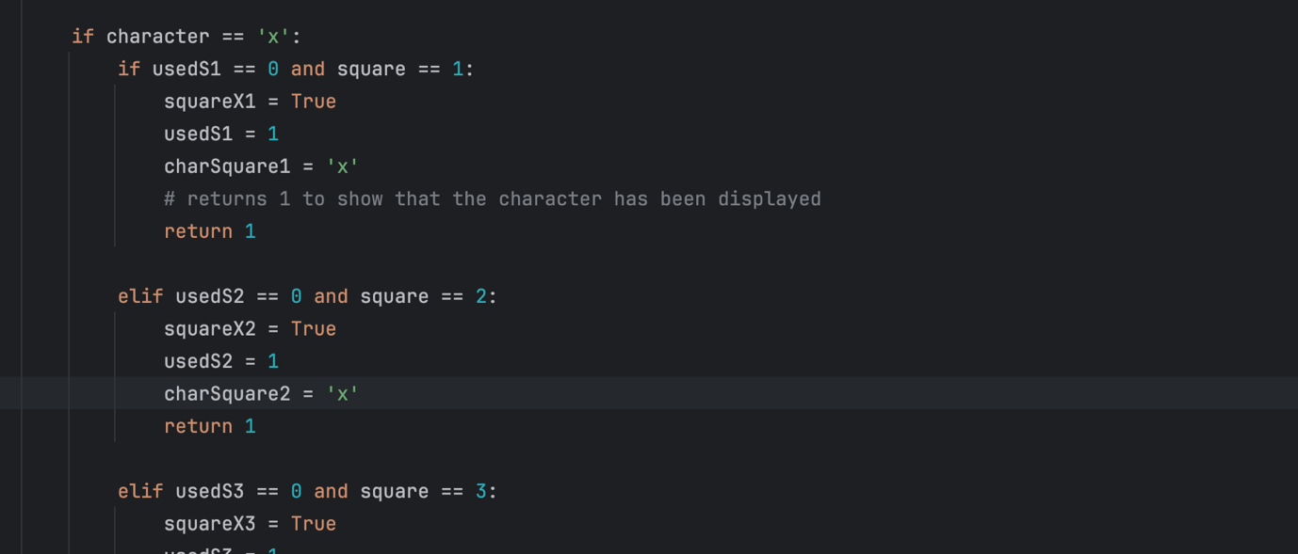

At this point, I was finally able to start implementing AI, so I started adding helper functions like getNextAction, which required access to the Q Table to find the best move for the current state. Initially, I passed to the array current state (string) as the first parameter and action_index as the second parameter, which resulted in this error:

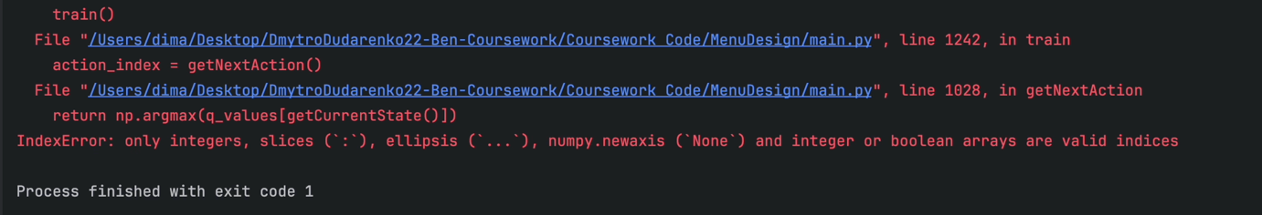

After doing some research I understood that the solution would be, basically, to give a unique ID to each state and then pass the ID as the first parameter. For this purpose, I initialised a dictionary and added one more function – getStateID, which would assign IDs to the new states or return the state’s ID if it has already been assigned.

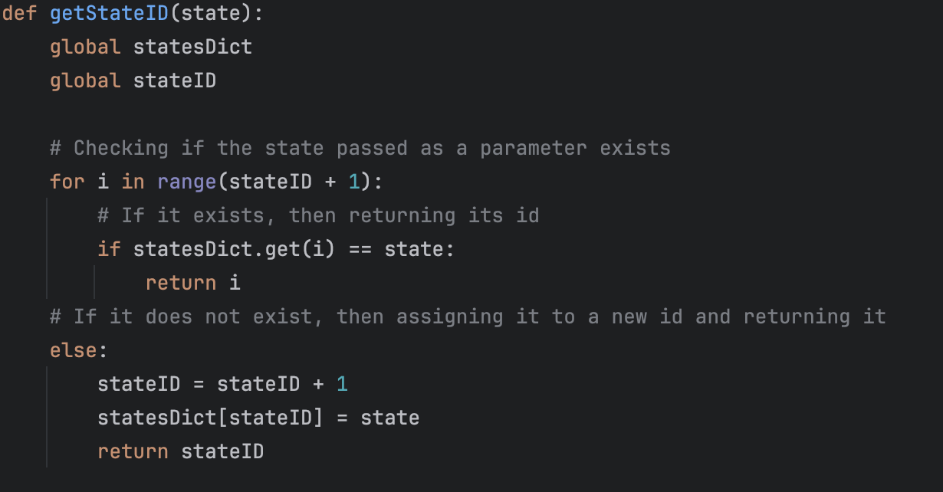

Hence, there was a slight change in the train() function, particularly in the variables storing states. From this:

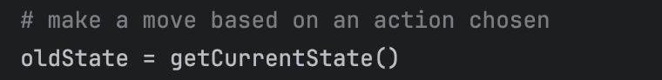

To this:



Another bug was serious as the game would crash, but it was easy to get rid of it. The problem appeared when the game result was a draw, but AI would still try to make a move, by choosing a square number from the list of available positions, which was empty, therefore the game crashed, as there was nothing to choose from.

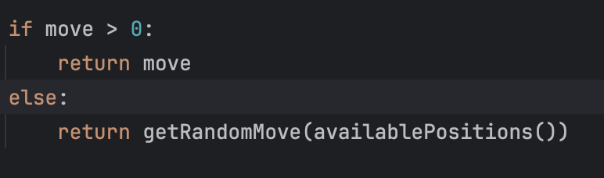

So, in every place where I had this line of code – getRandomMove(availablePositions()), I implemented additional checks using Python’s feature that lists return False when they are empty.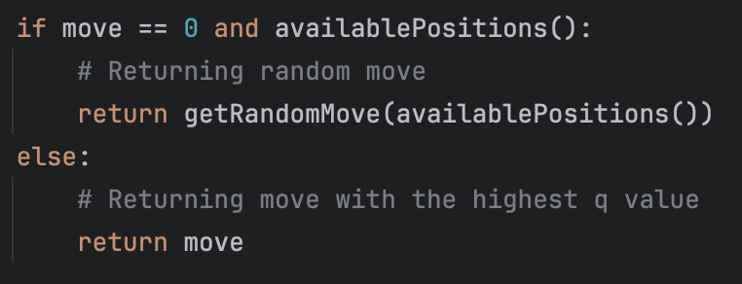

Since there were no more bugs, AI had to start developing but it did not. For this reason, I started looking through its training process trying to understand the issue. I could not find it and I decided to do more research to broaden my knowledge about the Q learning algorithm and that was the key to the solution. The problem was that I did not update the Q Table once the terminal state had been reached.

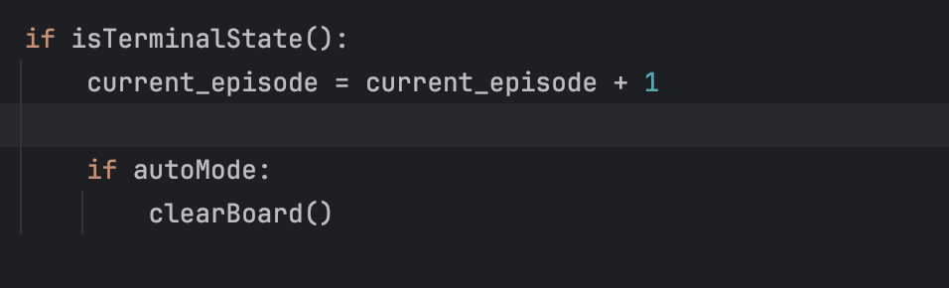

And changed it to this:

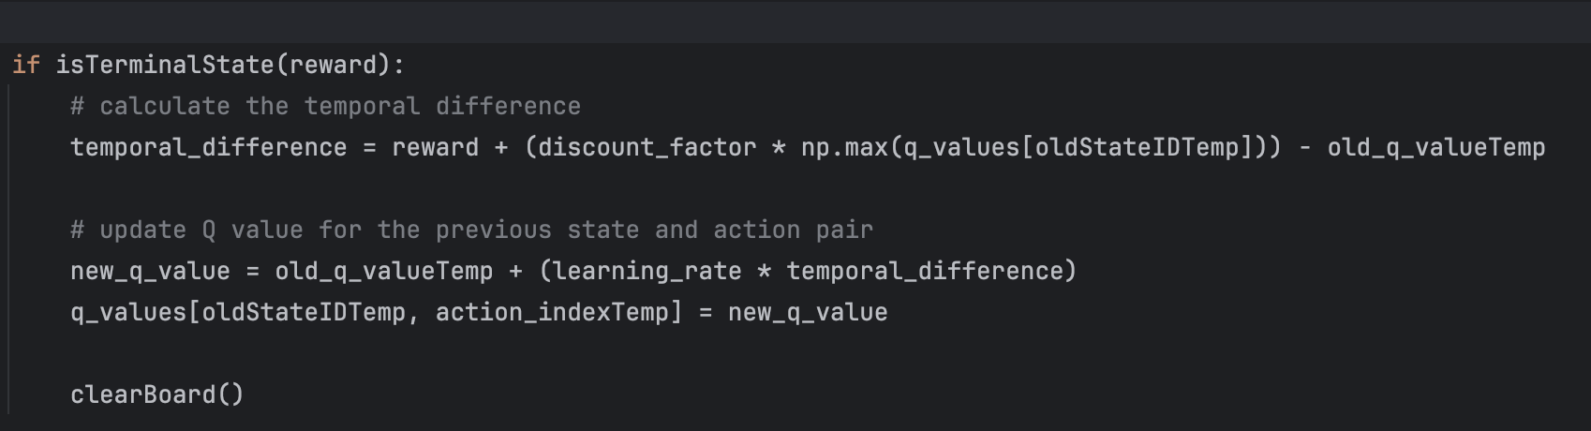

Finally, I saw that AI started learning and making educated moves, which was a huge win for me. Later I noticed that it took ages for AI to learn how to play as its opponent, when the game was in auto mode, was a function making random moves. Because of this I decided to add a second AI called Human, which was planned initially as unessential due to being time and effort consuming but it was the only way to increase the AI’s learning rate. Every line of code that was responsible for AI training was duplicated and one more Q Table was created together with helper functions.

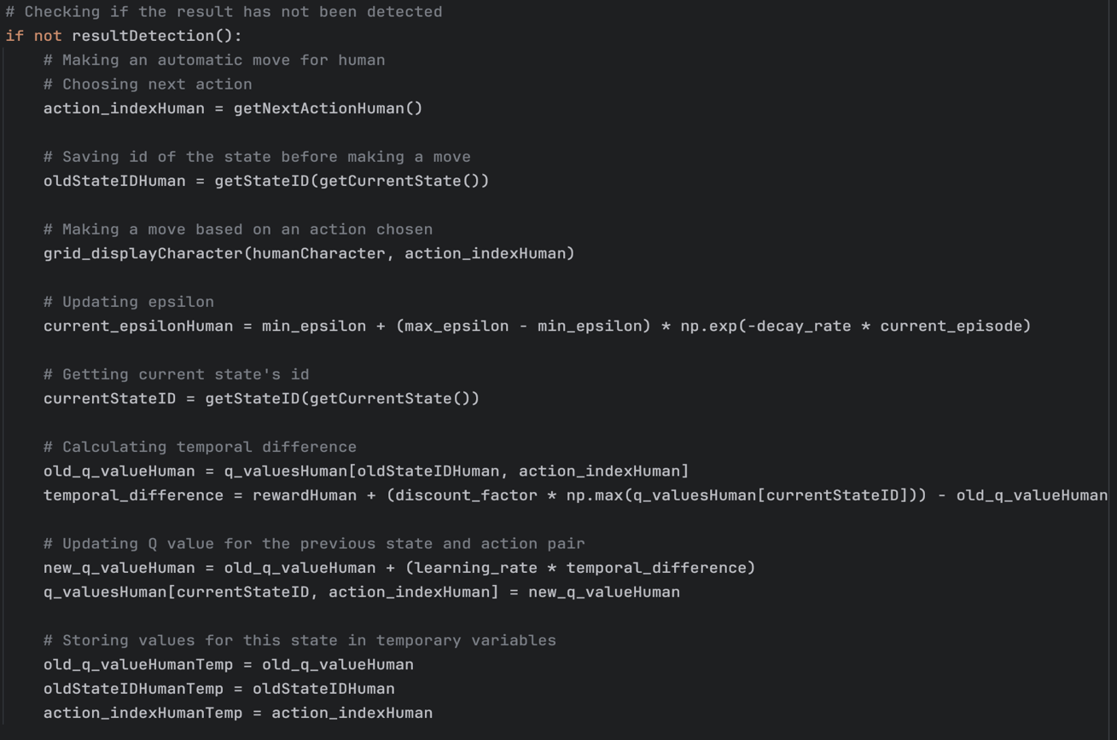

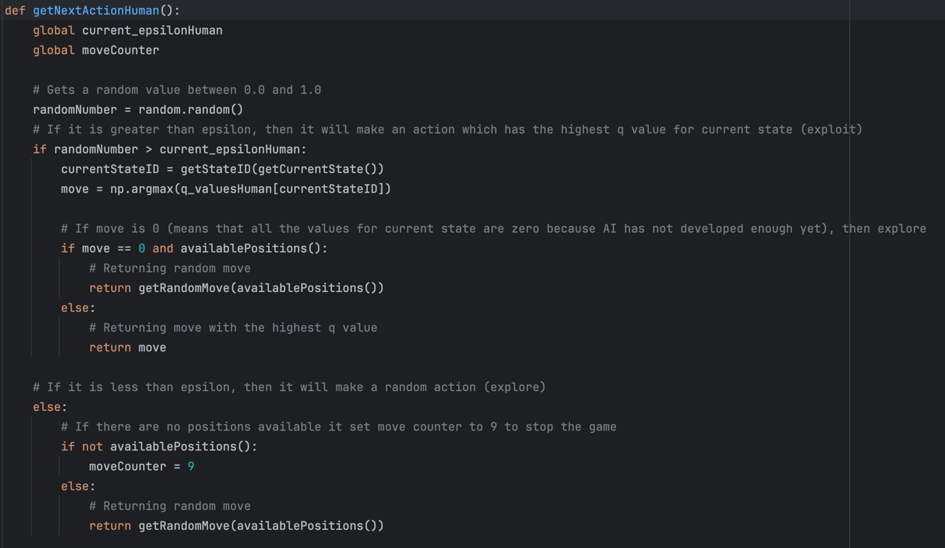

Another issue that was found occurred when the clear board was pressed before the end of the game. This resulted in an unfinished training episode which negatively affected AI’s development. To fix that I added another if statement that would check if the game had finished and only then the board would be reset. However, it was not obvious to the user that the game had to be finished before pressing the button, so I added a warning message. Video 4.20 shows the warning message

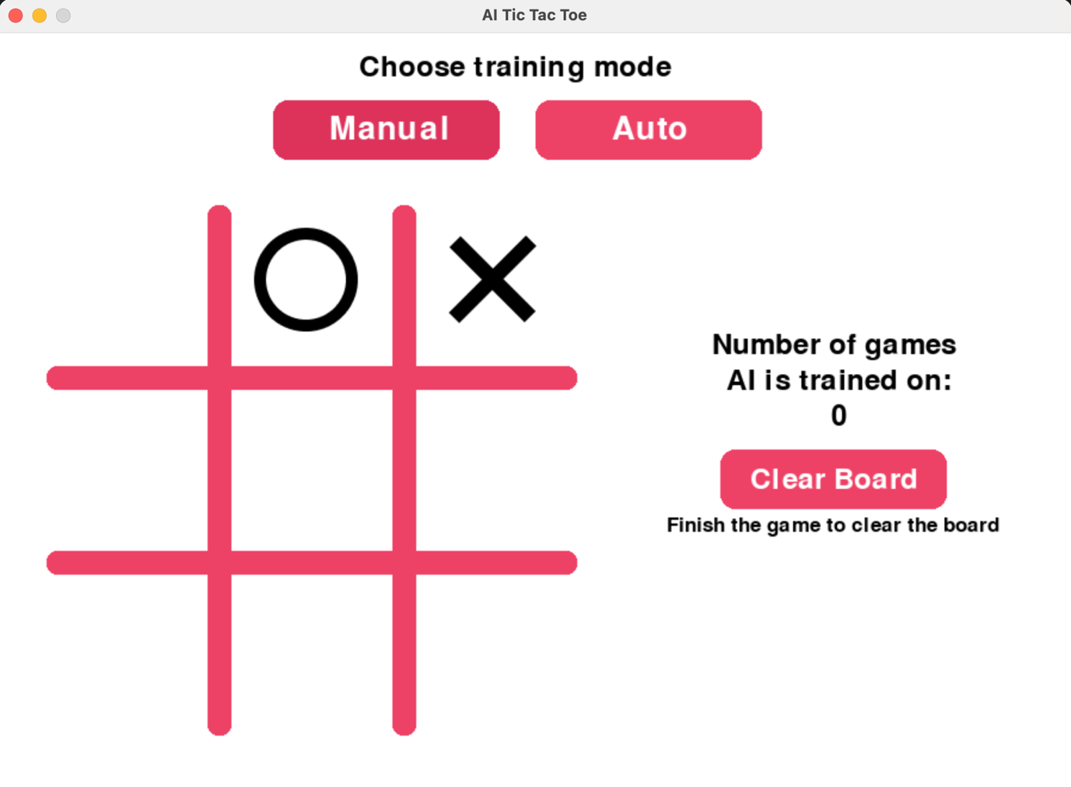

Another thing that I discovered was that AI was trying to build a winning set completely ignoring the user, as the reward for winning was 10 and for a draw 5. To be fair that was not a bug, as it worked, but not the way I thought it would. Therefore, I changed the rewards from 10 – win, 5 – draw, -10 – lose to 5 – win, 10 – draw, and -10 – lose. This sorted the problem as AI started paying more attention to the user and tried to block human from winning.

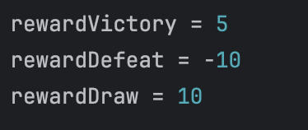

The next bug was discovered when the tests were run. When the game is in manual mode AI still develops and updates its Q Table after each move. To show a piece of evidence for test #7 I printed out the reward which is used to update the Q Table when the result is detected.

This screenshot shows a block of code of the moveAI function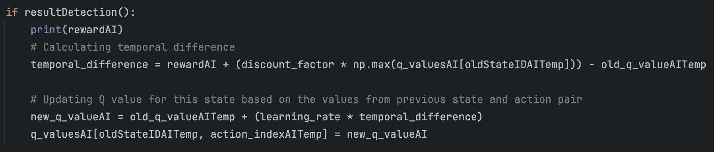

In video 4.36, it can be seen that the reward is only given when AI wins as that is the only case when it manages to access this function and then the Q Table is updated.

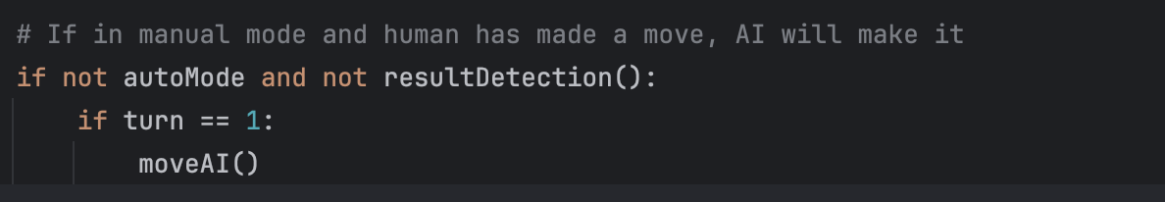

The whole problem was in this bit – “and not resultDetection()”, so it was deleted and the reward from that moment was measured correctly.

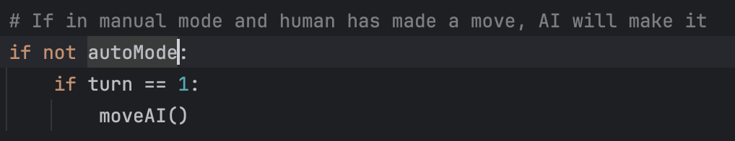

Video 4.39 shows which reward it assigns to each of the game outcomes.

**Tests Table:**

|  |  |  |  |  |  |
| --- | --- | --- | --- | --- | --- |
| Test No. | Description | Type of test | Test data | Expected Result | Actual Result |
| 1 | Does AI make the move second using “O” character if the user picks “X” ? | Valid | Pick “X” and make a move | AI will wait for a player to make a move and then make its own using “O” | Pass  Evidence:  Video 4.18 |
| 2 | Does AI stop making moves when the game end with a win for either side? | Valid | Play the game for either character till a win of any side | AI will stop making moves when the game finishes | Pass  Evidence:  Video 4.18 |
| 3 | Does AI stop making moves when the game end with a draw? | Valid | Play the game for either character till a draw | AI will stop making moves when the game finishes | Pass  Evidence:  Video 4.33 |
| 4 | Is the board cleared automatically when in automatic mode? | Valid | Press Auto button | The board should be cleared, and the game should continue | Pass  Evidence:  Video 4.34 |
| 5 | Does AI measure a reward if the “Clear” button was pressed before the end of the game? | Valid | Make several moves and press the “Clear” button | In the output window it shouldn’t print out the reward | As the board cannot be cleared before the result is detected, hence the reward is not measured till the end of the game  Evidence:  Video 4.20 |
| 6 | Does it correctly analyse the game and, therefore, measure the reward when it loses? | Valid | Play the game and make AI lose | In the output window it will print out the reward that AI got, and it should be -10 | Fail (4.36). The bug and the fix are shown in the bug fixes section above.  Evidence of pass:  Video 4.39 |
| 7 | Does it correctly analyse the game and, therefore, measure the reward when it wins? | Valid | Play the game and let AI win | In the output window it will print out the reward that AI got, and it should be 5 | Pass  Evidence:  Video 4.39 |
| 8 | Does it correctly analyse the game and, therefore, measure the reward when it is a draw? | Valid | Play the game and make it a draw | In the output window it will print out the reward that AI got and it should be 10 | Pass  Evidence:  Video 4.39 |
| 9 | Does AI develop after playing 1000 games? | Valid | Play 1000 games | AI will make more educated moves as the user plays more games, also epsilon has to significantly decrease to get rid of random moves. | As mentioned in expected results it developed slightly but still makes random moves.  Evidence:  Video 4.40 |
| 10 | Does AI noticeably develop more after playing 2000 games? | Valid | Play 2000 games | There is not an easily noticeable difference, however, it develops, so it is a pass  Evidence:  Video 4.41 |
| 11 | Does AI noticeably develop more after playing 5000 games? | Valid | Play 5000 games | It can be seen that AI makes more educated moves than when it was trained on 2000 games.  Evidence:  Video 4.42 |
| 12 | Is it possible to turn auto mode on if the board is not empty? | Valid | Put a character on the grid in manual mode and press auto mode button | There should not be a difference whether the board is empty or not for the auto mode functionality | Pass  Evidence:  Video 4.44 |
| 13 | Is it possible to make moves in manual mode if the board is not empty because the game was in auto mode? | Valid | Press auto mode button, stop it during the game, and put a character on the board | It should work as normal | Pass  Evidence:  Video 4.44 |

## Stage 4 Review

Stage 4 was perhaps the most challenging part of the project. Developing the AI involved loads of research, coding, and testing.

There were moments of frustration when things did not work, especially that moment when I could not fix the bug with result detection algorithm, as it would not give any errors that IDE could detect, the problem was in logic, and I was just lucky to spot that mistake. But seeing the AI start to learn and improve was incredibly rewarding. I guess a good description for this stage will be to say it has been a rollercoaster of emotions, but ultimately, seeing the AI working made all the effort worth it.

In summary, I am definitely satisfied with the result, and I could not expect it to be better.

**Tutorials used in this stage:**

Explains the concept of Q learning:

[Q learning explained (tutorial)](https://www.youtube.com/watch?v=aCEvtRtNO-M&t=10s)

[Q-Learning: A Complete Example in Python](https://www.youtube.com/watch?v=iKdlKYG78j4&t=815s)

[What is Q-Learning (back to basics)](https://www.youtube.com/watch?v=nOBm4aYEYR4&t=1552s)

This video was particularly useful as it explained the logic that should be done to implement Q learning into Tic Tac Toe:

[Reinforcement learning: Tic Tac Toe](https://www.youtube.com/watch?v=KEQhaBIZ9yk&t=685s)

I also watched videos about reinforcement learning in general:

[An introduction to Reinforcement Learning](https://www.youtube.com/watch?v=JgvyzIkgxF0&t=68s)

[Reinforcement Learning Basics](https://www.youtube.com/watch?v=2xATEwcRpy8)

[Q Learning Intro/Table - Reinforcement Learning p.1](https://www.youtube.com/watch?v=yMk_XtIEzH8), also watched parts 2, 3, 4, 5

Loads of other websites were accessed as well to broaden my knowledge

## Stage 5 – Design of the Screens

### Substage – Menu Screen

**Summary:**

The design of the menu screen is essential to improve the user experience when playing the game. At this stage, all the text, images, and background elements will be added, however, buttons will not have any functionality, as this will be done in the next stages.

**Requirements met in this stage:**

|  |  |
| --- | --- |
| Requirement number and name | Test No. checking this requirement |
| 1a. Title | 2 |
| 1b. Sub-title | 2 |
| 1c. Robot image | 5 |
| 1d. Background image | 5 |
| 1e. Play button | 3 |
| 2a. “?” (About) button | 4 |

**Has to be implemented:**

|  |  |
| --- | --- |
| Feature | Justification |
| Menu window | This is initial and the only window that will be opened, as PyGame doesn’t allow to have multiple windows, hence it’s significant to make sure this window opens correctly sized and fully functional (will be done in the stage 6) |
| Text | Title and sub-title have to be displayed on the screen |
| Buttons | For now, buttons - “Play” and “?” will only be designed and allocated according to the designed pattern |
| Background design | Robot image and red curved shape will be added as the background design in this stage |

**Example Tests Table:**

|  |  |  |  |  |  |
| --- | --- | --- | --- | --- | --- |
| Test No. | Description | Type of test | Test data | Expected Result | Actual Result |
| 1 | Does a correctly sized game window generate? | Valid | Run the program | The main menu window is opened |  |
| 2 | Does text display? | Valid | Run the program | The text is displayed when the main menu window is opened |  |
| 3 | Does the “Play” button display? | Valid | Run the program | Displays a Play button |  |
| 4 | Does the “?” (About) button display? | Valid | Run the program | The “?” button is displayed |  |
| 5 | Does the background design display? | Valid | Run the program | Robot image and red curved shape are displayed in the right position and correctly sized |  |

**Data Dictionary:**

|  |  |  |  |
| --- | --- | --- | --- |
| Name | Data Type | Description | Validation |
| font | Font | There will be several variables storing different fonts that will be applied to certain texts |  |
| text | Text | A few variables storing the text with the font parameters applied. |  |

## Stage 5 Flowchart

### Summary:

The menu screen flowchart shows the design process of the screen. It firstly checks if the menu screen is opened, proceeding to display background images, text, play button, and “?” (about the project) button.

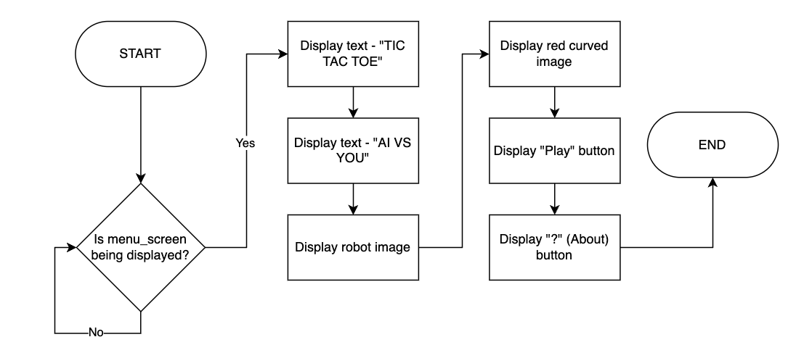

## Stage 5 Development

### Summary:

In the section the process of creating a GUI using Pygame for the menu screen can be seen, the focus is on the visual design and implementation of the graphical user interface. This stage is a significant aspect of the development, as it demonstrates the integration of interactive elements, and buttons, that enhance the user experience.

This bit code defines a function `menu_screen`. The function fills the screen with a white background colour and displays a background image (`BG_Menu.png`).

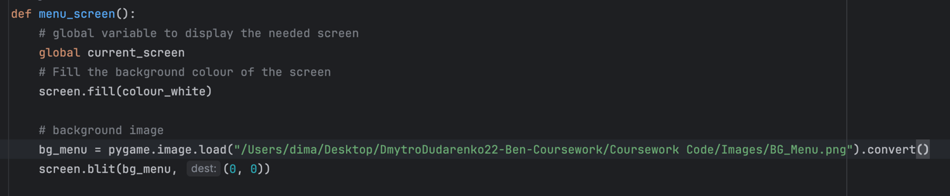

This code segment initialises fonts - `buttonFont`, `titleFont`, and `subtitleFont`, and renders text. These rendered texts are intended for buttons, titles, and subtitles.

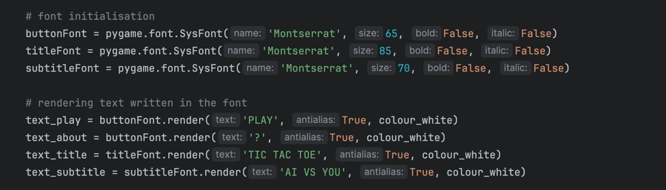

This screenshot shows how the buttons are created and located on the screen



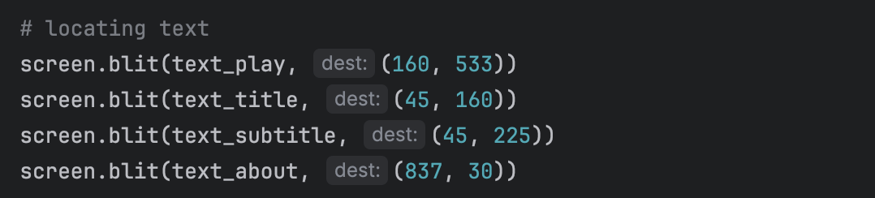

This part of the code positions previously rendered text onto the screen.

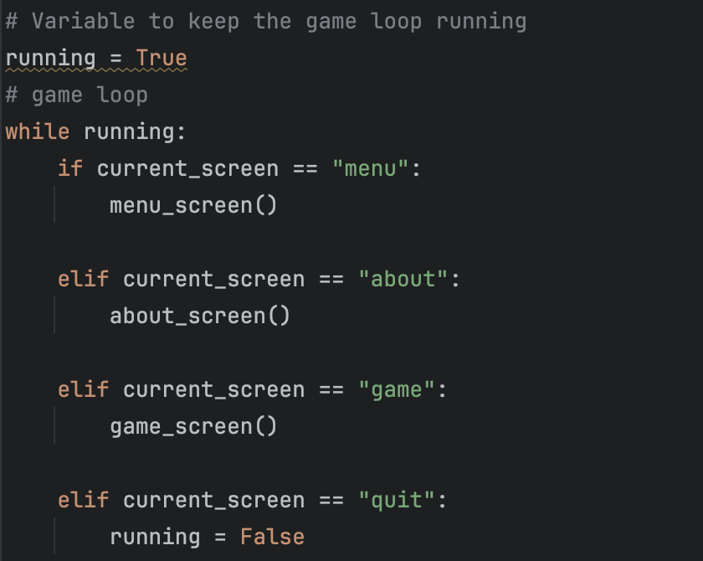

This code snippet illustrates a game loop that runs while the variable `running` is set to `True`. Within the loop, the code checks the value of the `current_screen` variable and calls different functions based on its value. That is how the game navigates in between the screens.

Bug Fixes:

During the Menu Screen Design stage, the development process was smoothly done with no significant bugs. This was due to earlier experience in creating a graphical user interface for the game screen.

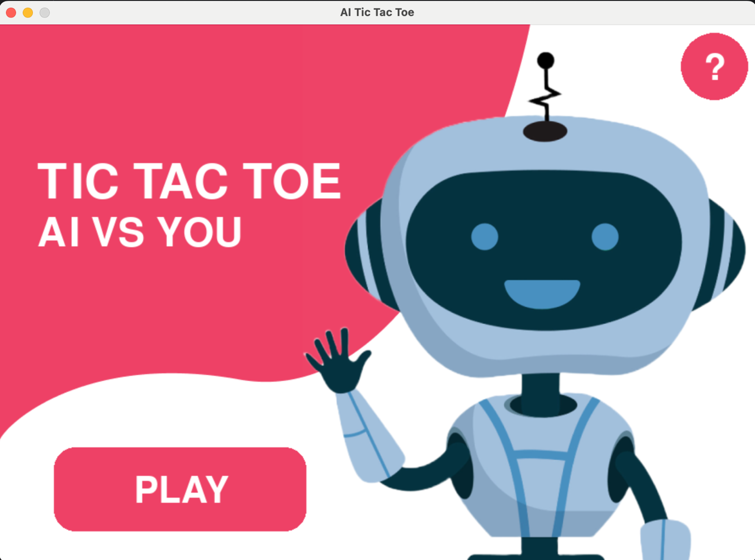

As the buttons are not functional at the moment, hence the screens are not connected, so the current_screen variable was set to “menu”, to make the menu screen appear when the program is run

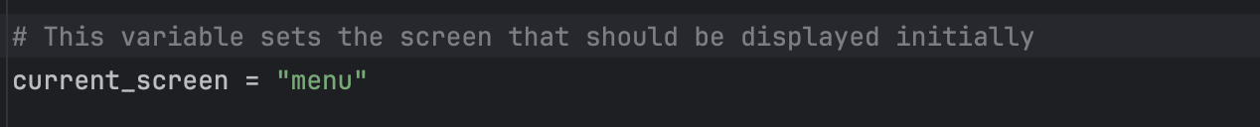

**Tests Table:**

|  |  |  |  |  |  |
| --- | --- | --- | --- | --- | --- |
| Test No. | Description | Type of test | Test data | Expected Result | Actual Result |
| 1 | Does a correctly sized game window generate? | Valid | Run the program | The main menu window is opened | Pass  Evidence:  Video 5.11 |
| 2 | Does text display? | Valid | Run the program | The text is displayed when the main menu window is opened | Pass  Evidence:  Video 5.11 |
| 3 | Does the “Play” button display? | Valid | Run the program | Displays a Play button | Pass  Evidence:  Video 5.11 |
| 4 | Does the “?” (About) button display? | Valid | Run the program | The “?” button is displayed | Pass  Evidence:  Video 5.11 |
| 5 | Does the background design display? | Valid | Run the program | Robot image and red curved shape are displayed in the right position and correctly sized | Pass  Evidence:  Video 5.11 |

## Stage 5 – Design of the Screens

### Substage – About Screen

**Summary:**

This stage’s main point is to convert the design of the “About” screen into code, which will help user to understand, what the project is about, and how to interact with it. It is not an extremely essential feature, but the time allows to add it and it will improve the overall user experience.

**Requirements met in this stage:**

|  |  |
| --- | --- |
| Requirement number and name | Test No. checking this requirement |
| 2b. Title | 1 |
| 2c. Description | 1 |
| 2d. Background design | 3 |
| 2e. Close button | 2 |

**Has to be implemented:**

|  |  |
| --- | --- |
| Feature | Justification |
| Text | Title and description have to be displayed on this screen |
| Buttons | Close button should be designed and put in the right place (right top corner), then functionality will be added in the stage 6 |
| Background design | The point is to make it look like a pop-up window, although PyGame doesn’t allow to have multiple windows. So, the design will show the Menu screen in the background and a container with text in the middle |

**Example Tests Table:**

|  |  |  |  |  |  |
| --- | --- | --- | --- | --- | --- |
| Test No. | Description | Type of test | Test data | Expected Result | Actual Result |
| 1 | Does text display? | Valid | Open “About” screen | The text – title and description, are displayed on the About screen |  |
| 2 | Does the close button display? | Valid | Open “About” screen | The button is displayed in the right top corner |  |
| 3 | Does the background design display? | Valid | Open “About” screen | Displays the background design as shown in the actual prototype (see page 20, GUI Design) |  |

**Data Dictionary:**

|  |  |  |  |
| --- | --- | --- | --- |
| Name | Data Type | Description | Validation |
| font | Font | There will be several variables storing different fonts that will be applied to certain texts |  |
| text | Text | A few variables storing the text with the font parameters applied. |  |

## Stage 5 Flowchart

### Summary:

The About screen flowchart illustrates the design process of the screen. It initially checks if the “?” button has been clicked on and if so, displays a background image, text, and a close button.

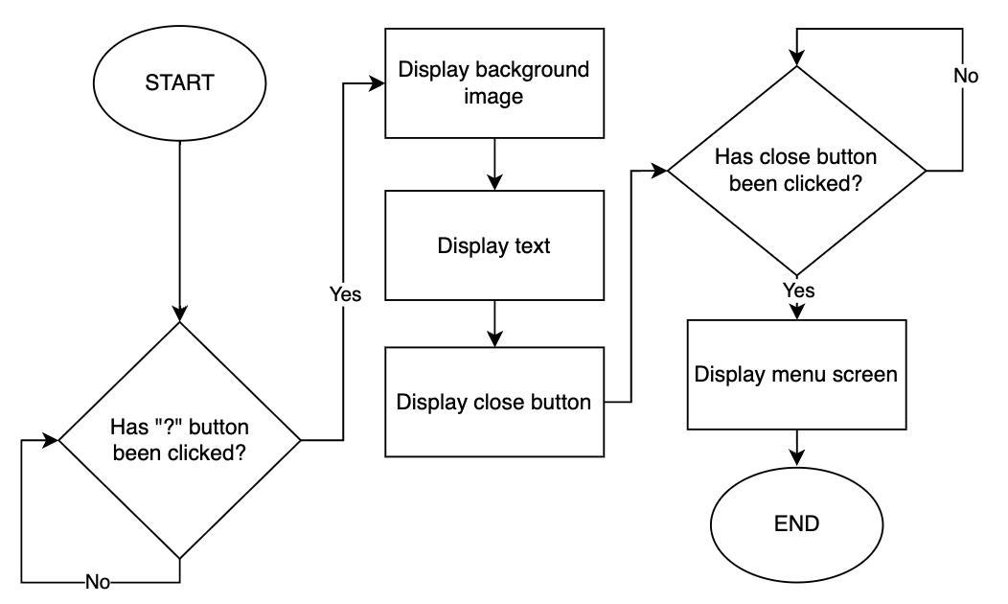

## Stage 5 Development

### Summary:

In the "about" screen, the program provides information about the project. The implementation of this stage involves displaying text, images, and buttons.

This part of the code sets fills the screen with a white colour to clear any previous content. Then, it loads a background image (BG_About), which makes it look like about screen is a pop up and not a completely different screen.

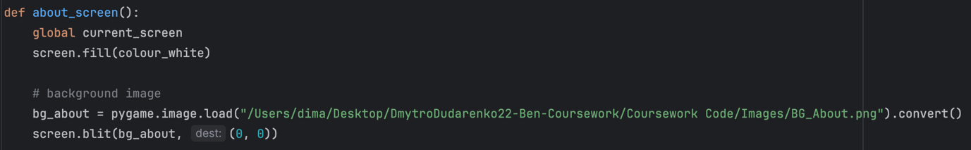

This portion of the code draws a rounded rectangle on the screen and displays a text image within that rectangle. This is because displaying actual text would require creating 11 different bits of the text, rendering them, and then displaying, to make them appear in different lines.

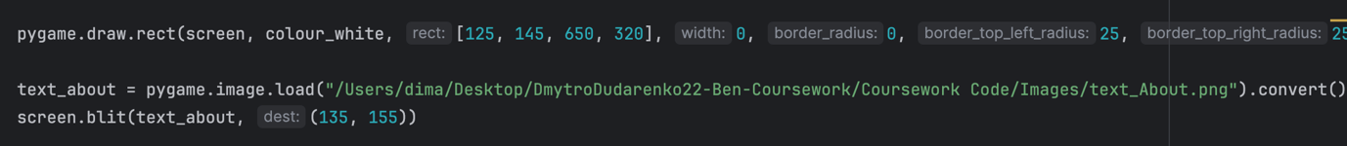

This block of code prepares a font for rendering text and then renders the character 'X' using that font in white colour. The rendered text is later used for the close button.

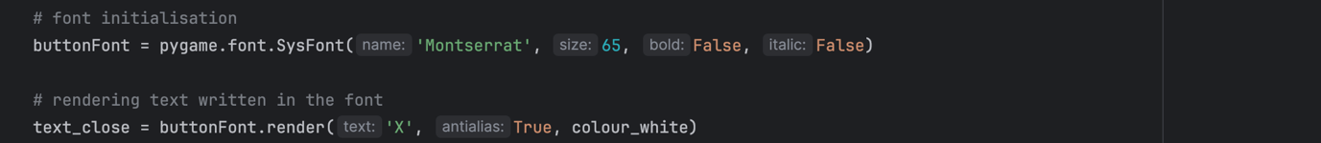

This part of the code draws a circle that represents a close button and then displays previously rendered text ('X') onto the screen, so it appears above the circle.

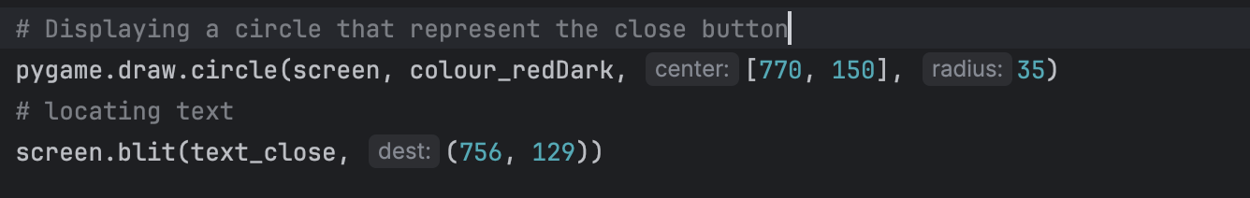

Bug Fixes:

The About Screen Design stage proceeded seamlessly, without any noteworthy bugs or issues.

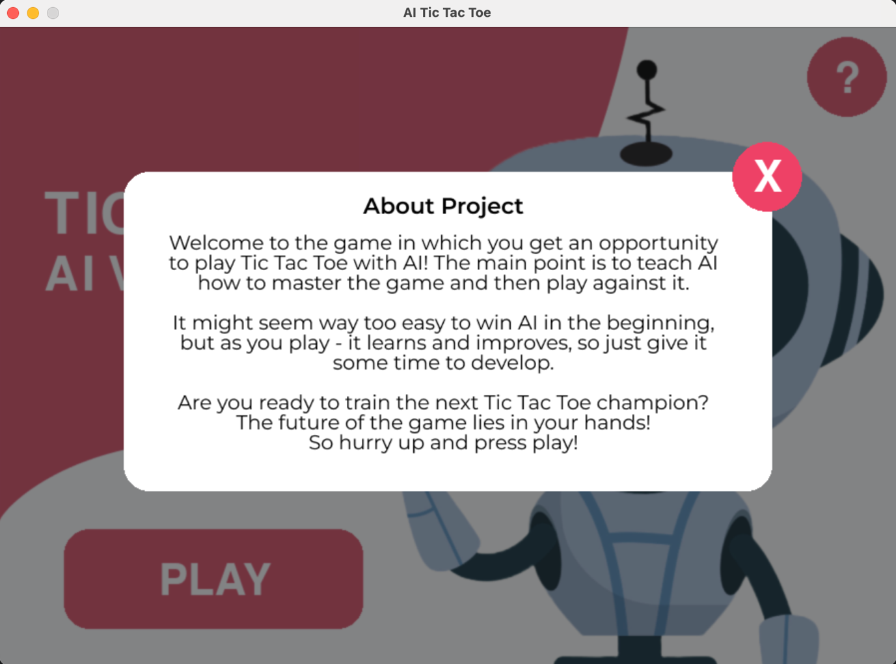

The only thing that is worth mentioning is that in order to access the about screen, the current_screen variable is set to “about”.

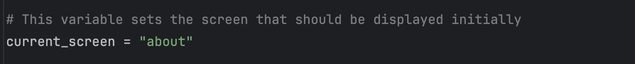

**Tests Table:**

|  |  |  |  |  |  |
| --- | --- | --- | --- | --- | --- |
| Test No. | Description | Type of test | Test data | Expected Result | Actual Result |
| 1 | Does text display? | Valid | Press run button in the IDE | The text – title and description, are displayed on the About screen | Pass  Evidence:  Video 5.14 |
| 2 | Does the close button display? | Valid | Press run button in the IDE | The button is displayed in the right top corner | Pass  Evidence:  Video 5.14 |
| 3 | Does the background design display? | Valid | Press run button in the IDE | Displays the background design as shown in the actual prototype (see About Screen design) | Pass  Evidence:  Video 5.14 |
| 4 | Does the about screen window open when the program is run? | Valid | Press run button in the IDE | A correctly sized window should be opened | Pass  Evidence:  Video 5.14 |
| 5 | Does the text displayed is rendered in the needed font? | Valid | Press run button in the IDE | The text should look like in the design prototype (see About Screen design) | Pass  Evidence:  Video 5.14 |

## Stage 5 Review

This stage was all about enhancing the user experience and making the game feel more polished. Designing the menu and abouts screens was a fun and creative process. In addition comparing the result to the initial designs I can say that I have done this stage pretty well.

## Stage 6 – Functionality of the Screens

### Substage – Menu Screen

**Summary:**

This stage aims to make two buttons functional – Play and About (represented by “?”), which is crucial to improving the user's experience with the menu and the game overall. The data dictionary is not shown for this stage as there are no new variables that have to be created.

**Requirements met in this stage:**

|  |  |
| --- | --- |
| Requirement number and name | Test No. checking this requirement |
| 1e. Play button | 1 |
| 1f. “?” (About) button | 2 |

**Has to be implemented:**

|  |  |
| --- | --- |
| Functionality | Justification |
| “Play” button | Add functionality to the “Play” button, created and designed in stage 5. |
| “?” button | Add functionality to the “?” button, created and designed in stage 5. |

**Example Tests Table:**

|  |  |  |  |  |  |
| --- | --- | --- | --- | --- | --- |
| Test No. | Description | Type of test | Test data | Expected Result | Actual Result |
| 1 | Does the “Play” button open a game screen when clicked? | Valid | Click on the “Play” button | The game screen is displayed after clicking the button |  |
| 2 | Does the “?” (About) button open the About Menu? | Valid | Click on the “?” button | The About Menu is displayed after clicking the “?” button |  |
| 3 | Does the “Play” button open a game screen when user clicks outside of the button’s hitbox? | Invalid | Click close to the “Play” button, but not exactly on it | It shouldn’t do anything, as the user doesn’t interact with the button |  |
| 4 | Does the “?” button open an about screen when user clicks outside of the button’s hitbox? | Invalid | Click close to the “?” button, but not exactly on it | It shouldn’t do anything, as the user doesn’t interact with the button |  |

## Stage 6 Flowchart

### Summary:

This flowchart represents the functionality of the menu screen. It shows that when the mouse is hovered over one of the buttons, its colour changes to a darker shade, providing a visually responsive element required by stakeholders. Moreover, the function checks if either of the buttons has been clicked on, if so, the needed screen is displayed.

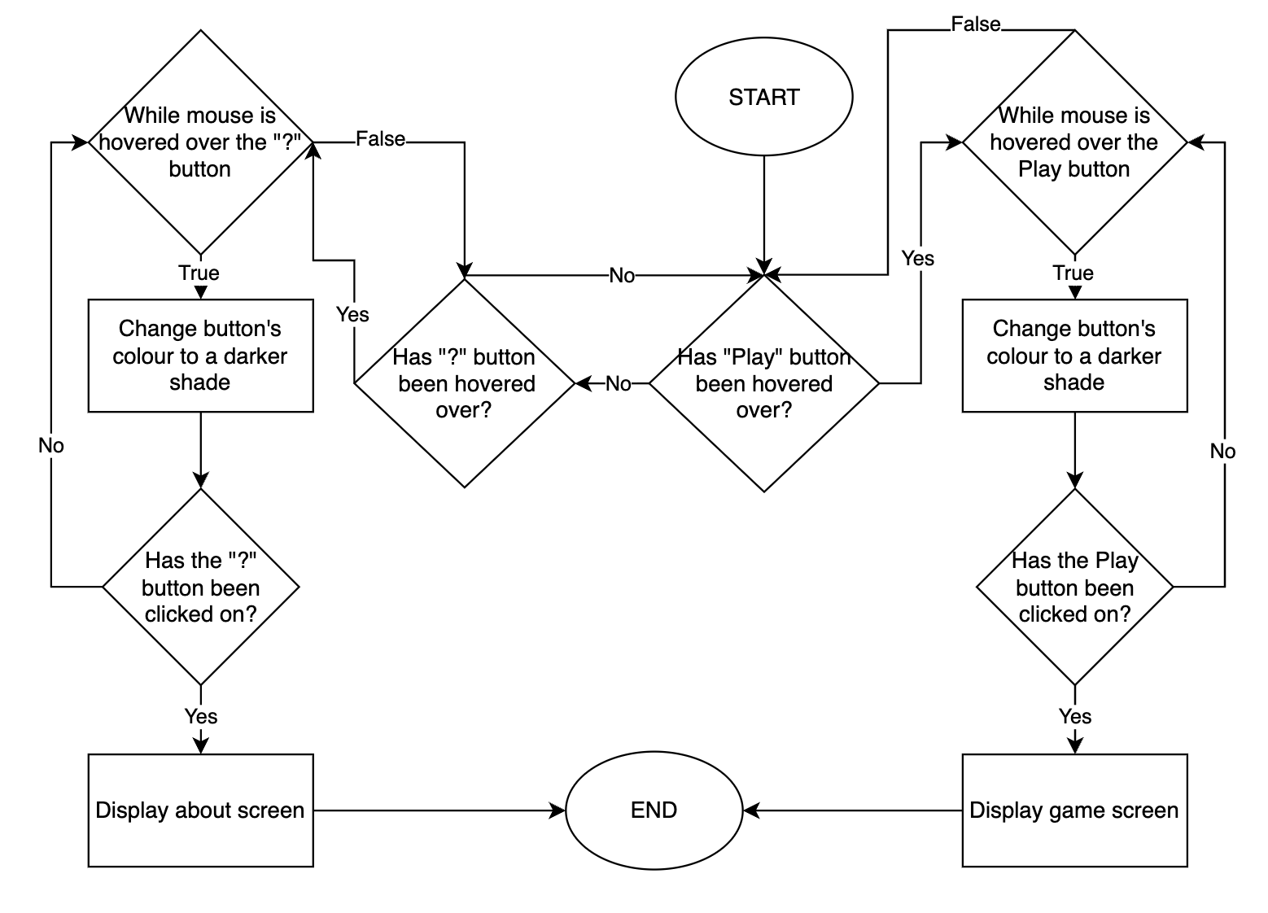

## Stage 6 Development

### Summary:

This stage presents screenshots of the development of the menu screen functionality, such as how buttons and elements respond to the user’s actions.

This section of the code is responsible for changing the colour of buttons based on whether the mouse is hovering over them or not. The way it works:

If the mouse coordinates are within the specified range, then a rectangle with a darker shade is drawn at certain coordinates.

If the mouse is not hovering over the button, a rectangle with a lighter shade is drawn at the same coordinates.

The same method is used for the “?” button but a circle is drawn instead of a rectangle.

These changes in colour provide visual feedback to the user, indicating the interactive nature of the buttons when the mouse hovers over them as was required by stakeholder.

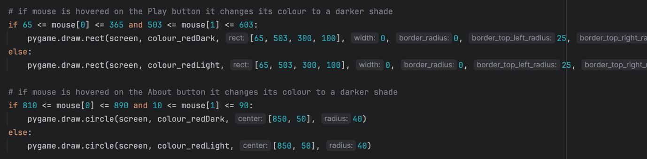

This part of the code handles events, particularly mouse button clicks, and updates the `current_screen` variable based on the user's interactions. Such as displaying different screens or exiting the program.

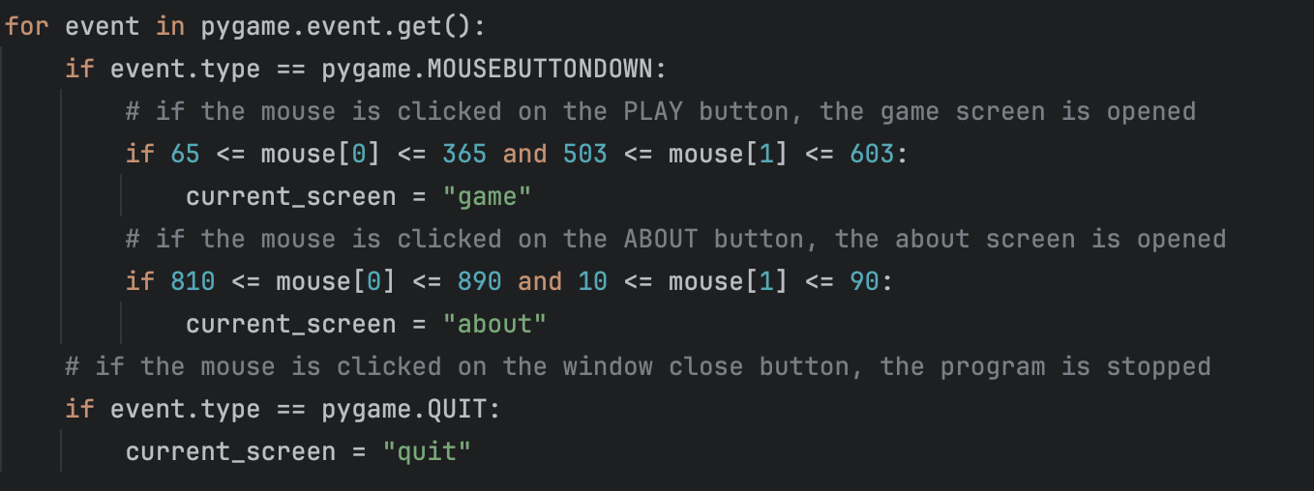

The `coatOfArms` image functions as an Easter egg, representing a hidden feature in the program. It is known that Easter eggs are elements that users can uncover by doing certain actions. In this context, the `coatOfArms` image is exposed when the user hovers the mouse in the bottom-right corner of the screen. This feature was added as a recommendation from one of the stakeholders.

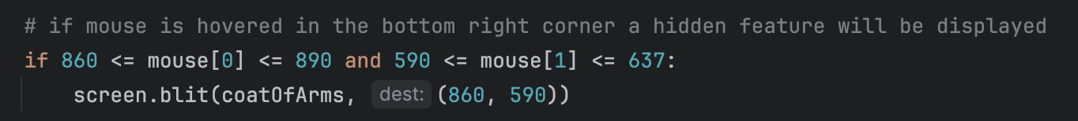

Video 6.5 - in the video, it can be seen how the colour of the buttons changes when the mouse hovers over them.

Video 6.6 and 6.14 - this video shows the changes that occur when the mouse clicks on the buttons.

Video 6.7 - this video provides a demonstration of the process of uncovering the hidden feature.

Bug Fixes:

No bugs were found during functionality implementation, but while running the tests it was noticed that buttons hitboxes are bigger than the buttons themselves, videos 6.8 and 6.17 demonstrate that. Even though the mouse is not hovering over the button, its colour still changes. The reason for that is shown in the images below. The image on the left-hand side illustrates how the button looks to the user and on the right the way a computer sees it when checking for the mouse hovering over is shown. Basically, it does not consider the rounded angles.

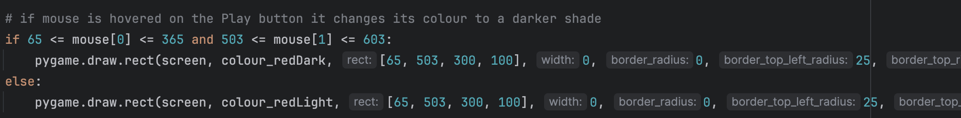

Unfortunately, a feasible solution was not found and as the bug does not significantly influence user experience, it was decided to leave it as it is.

**Tests Table:**

|  |  |  |  |  |  |
| --- | --- | --- | --- | --- | --- |
| Test No. | Description | Type of test | Test data | Expected Result | Actual Result |
| 1 | Does the “Play” button open a game screen when clicked? | Valid | Click on the “Play” button | The game screen is displayed after clicking the button | Pass  Evidence:  Video 6.6 |
| 2 | Does the “?” (About) button open the About Menu when clicked? | Valid | Click on the “?” button | The About Menu is displayed after clicking the “?” button | Pass  Evidence:  Video 6.14 |
| 3 | Does the “Play” button open a game screen when user clicks outside of the button’s hitbox? | Invalid | Click close to the “Play” button, but not exactly on it | It shouldn’t do anything, as the user does not interact with the button | Fail - Video 6.8  Explanation of the bug is in the Bug Fixes section above |
| 4 | Does the “?” button open an about screen when user clicks outside of the button’s hitbox? | Invalid | Click close to the “?” button, but not exactly on it | It shouldn’t do anything, as the user does not interact with the button | Fail - Video 6.9  Explanation of the bug is in the Bug Fixes section above |
| 5 | Does window close button close the window and stop the program? | Valid | Click on the window close button | The window should be closed, and the program should be stopped. | Pass  Evidence:  Video 6.10 |

## Stage 6 – Functionality of the Screens

### Substage – About Screen

**Summary:**

In this substage, the only functionality that has to be added is to make the close button send the user back to the menu when clicked and make sure that the window close button works. The data dictionary is not shown for this stage as there are no new variables that have to be created.

**Requirements met in this stage:**

|  |  |
| --- | --- |
| Requirement number and name | Test No. checking this requirement |
| 2d. Close button | 1 |

**Has to be implemented:**

|  |  |
| --- | --- |
| Functionality | Justification |
| Close button | Add functionality to the close button, created and designed in stage 5. |

**Example Tests Table:**

|  |  |  |  |  |  |
| --- | --- | --- | --- | --- | --- |
| Test No. | Description | Type of test | Test data | Expected Result | Actual Result |
| 1 | Does the close button send the user back to the menu when clicked? | Valid | Click on the close button | The menu screen is displayed after clicking the button |  |
| 2 | Does the close button open the menu screen when user clicks outside of the button’s hitbox?  CHANGED: In the previous stage the bug with buttons hitboxes was found out. So, this test would be failed as well, and it was not added to the main test table for this reason | Invalid | Click close to the close button, but not exactly on it | It shouldn’t do anything, as the user doesn’t actually interact with the button |  |
| 3 | Does window close button close the window and stop the program? | Valid | Click on the window close button | The window should be closed, and the program should be stopped. |  |

## Stage 6 Flowchart

### Summary:

This flowchart illustrates the logic behind About Screen and how it handles user interactions.

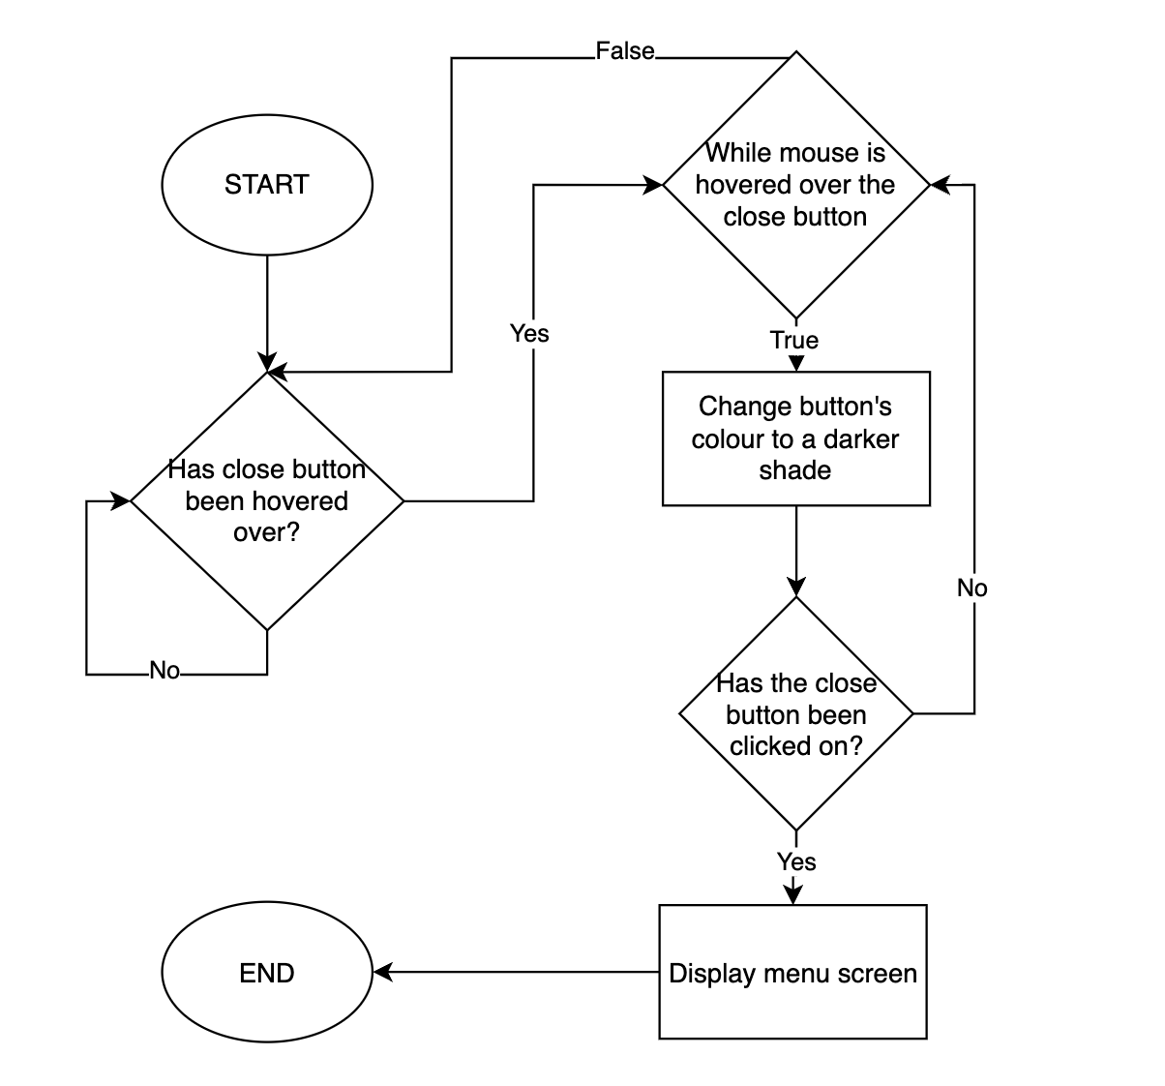

## Stage 6 Development

### Summary:

The development of this stage involves making a button functional.

This part of checks whether the mouse is hovered over the close button, if so it changes colour of the button to a darker shade, otherwise it is kept the same.

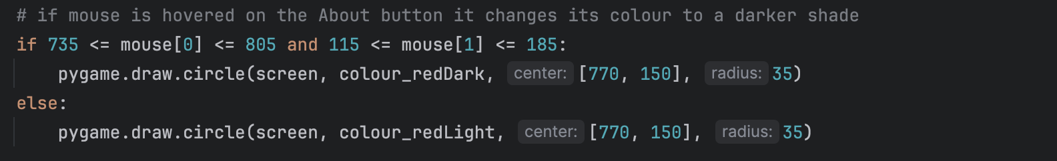

This part of the code handles events, particularly mouse button clicks, and updates the `current_screen` variable based on the user's interactions. Such as displaying game screen or exiting the program.

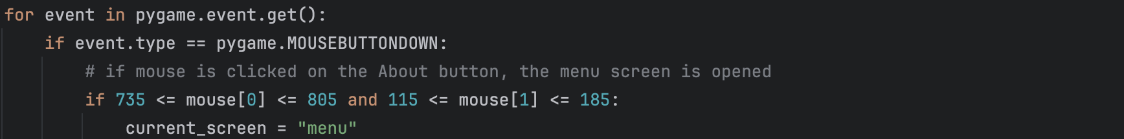



Bug Fixes:

This stage only required adding several lines of code, so no bugs were encountered.

**Tests Table:**

|  |  |  |  |  |  |
| --- | --- | --- | --- | --- | --- |
| Test No. | Description | Type of test | Test data | Expected Result | Actual Result |
| 1 | Does the close button send the user back to the menu when clicked? | Valid | Click on the close button | The menu screen is displayed after clicking the button | Pass  Evidence:  Video 6.15 |
| 2 | Does window close button close the window and stop the program? | Valid | Click on the window close button | The window should be closed, and the program should be stopped. | Pass  Evidence:  Video 6.16 |

## Stage 6 Review

As the project progressed, it was time to make the menu and about screens functional. This stage was not only about functionality, but it was also about making a polished product. By adding all these features, I not only improved usability but also provided players with some information about the game.

On the other hand, I am not satisfied that I could not fix the issue with buttons’ hit boxes. This is not critical and lots of people might not even notice it, but I expected it to work properly.

To conclude, I am happy with the result and, moreover, I only now realise what a good decision was to add this stage to the end and not to do it at the very beginning, as if I did not have time, the game would still work without the menu or abouts screens, but without AI it would not.

## Stage 7 – Settings

### Substage – Design development

### Summary:

The main point of this stage is to develop a design for the setting menu, think of the possible parameters that could be changed or displaying infographics. Then it will be coded but without adding functionality.

**Requirements met in this stage:**

|  |  |
| --- | --- |
| Requirement number and name | Test No. checking this requirement |
| 6a. Settings Influencing AI’s learning rate | 3 |
| 6c. Background Design | 5 |
| 6d. Close Button | 4 |
| 6e. Settings Button | 6 |

**Has to be implemented:**

|  |  |
| --- | --- |
| Feature | Justification |
| Text | Title and explanations of what each button does |
| Buttons | Buttons that will allow user to change Q learning parameters and get the Q-values for any states have to be designed. In addition, a button that sends the user back to the game screen should be added. |
| Background design | To keep the general style the window should look like a pop-up window, something similar to about screen. So, the design will show the game screen in the background and a container with text and buttons in the middle. |

**Example Tests Table:**

|  |  |  |  |  |  |
| --- | --- | --- | --- | --- | --- |
| Test No. | Description | Type of test | Test data | Expected Result | Actual Result |
| 1 | Does title display? | Valid | Open “Settings” screen | The title saying “Settings” is displayed. |  |
| 2 | Does text explaining what each button does display? | Valid | Open “Settings” screen | All the text as in the design prototype is displayed. |  |
| 3 | Do all the buttons display? | Valid | Open “Settings” screen | Buttons shown in the design prototype are displayed |  |
| 4 | Does the close button display? | Valid | Open “Settings” screen | The button is displayed in the right top corner |  |
| 5 | Does the background design display? | Valid | Open “Settings” screen | Displays the background design as shown in the actual prototype |  |
| 6 | Does the setting button display on the game screen? | Valid | Open “Game” screen | Should be displayed in the right top corner of the game screen |  |

**Data Dictionary:**

|  |  |  |  |
| --- | --- | --- | --- |
| Name | Data Type | Description | Validation |
| buttonHeight | Integer | Using the experience of creating the grid, it was decided to use variables for all the button parameters. As they are all equally spaced, just by taking initial Y coordinate of the button and then adding a multiple of spacing to it will give a Y coordinate of the next button. X coordinate is kept the same. |  |
| buttonWidth | Integer |  |
| spacing | Integer |  |
| buttonXcoord | Integer |  |
| buttonYcoord | Integer |  |
| font | Font | There will be several variables storing different fonts that will be applied to certain texts |  |
| text | Text | A number of variables storing the text with the font parameters applied. |  |

## Stage 7 Flowchart

### Summary:

The setting screen design flowchart shows the design process of the screen. It initially checks if the settings button has been clicked on and if so, displays a background image, text, and buttons.

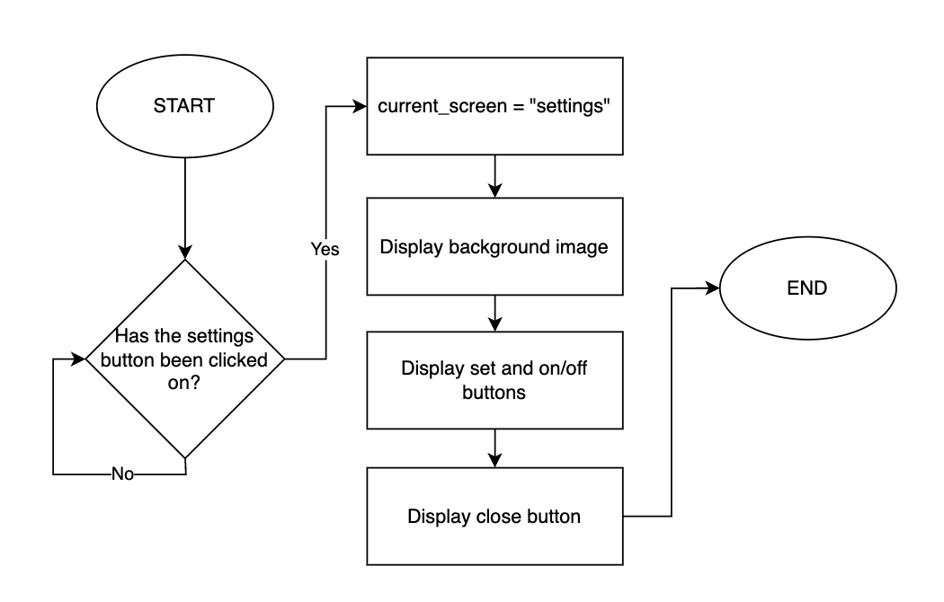

## Stage 7 Development

### Summary:

The development process is split into two stages. The first stage illustrates how the design has been created and talks about the decisions that have been made during the development. The second stage is about coding the design, fixing bugs, and testing it.

### Design development:

I started with the development of the settings menu design, ensuring intuitive navigation and accessibility of various game options. After that, a settings icon was added to the design of the game menu, which would be used to access the settings menu.

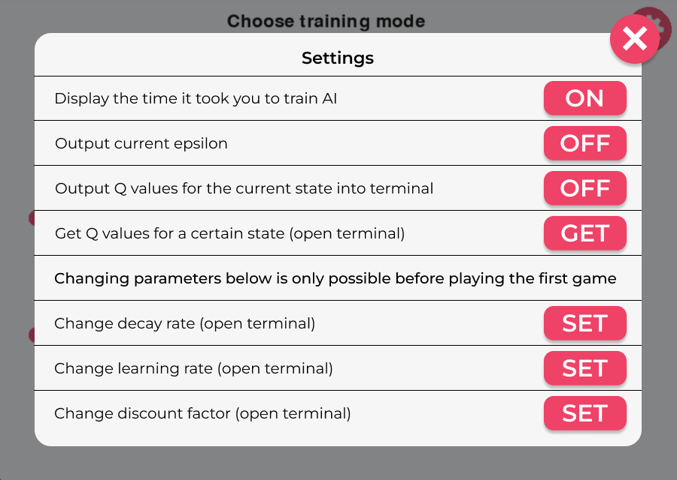

The on/off buttons are changing the text written on them when they are clicked.

When the set and get buttons were being designed, there was an idea to add input fields instead of them to keep the user’s interactions with the game within one window, but it would take a lot of time to code, so it was decided to use the terminal instead.

Moreover, there is a text saying – “Changing parameters below is only possible before playing the first game”, which is essential as all the set buttons will be blocked after the first move because they significantly affect AI’s learning abilities, and the Q-values might be calculated incorrectly if these parameters are changed during the game.

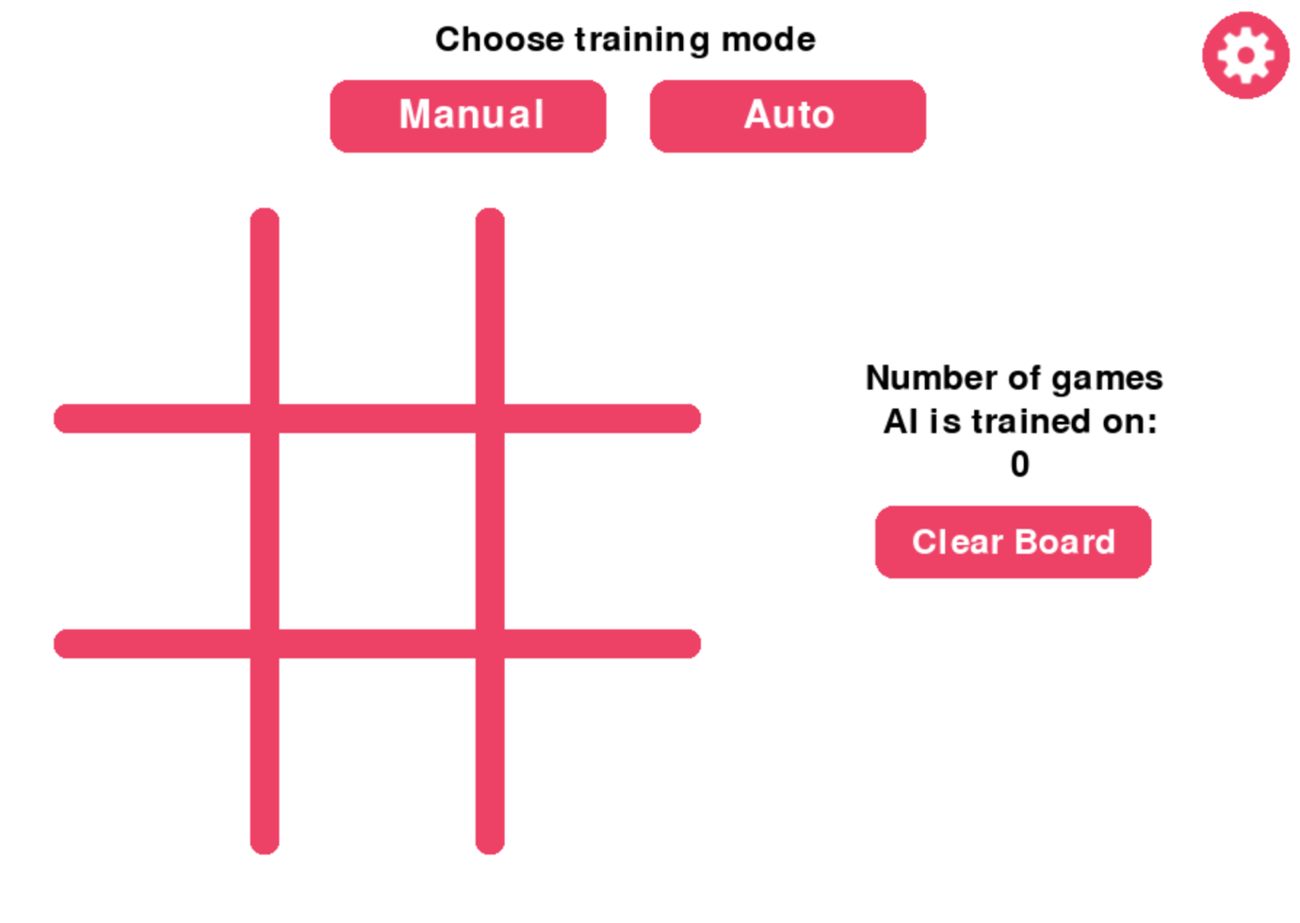

This picture shows the changes that will be done to the game screen to let the user access the settings menu. This will be done by pressing a button with the gear icon in the right top corner.

### Programming the design:

This function sets up the settings screen, accessing global variable called current_screen.



These variables define the positioning and dimensions of buttons. The `buttonXcoord` and `buttonYcoord` variables determine the starting position of the buttons, while `buttonWidth` and `buttonHeight` specify their dimensions. The `spacing` variable controls the vertical gap between buttons. Additionally, `text_spacing1` and `text_spacing2` control the spacing between text elements associated with the buttons, contributing to a well-organized and visually appealing settings interface. There are two different text spacings due to the heights of the words being different.

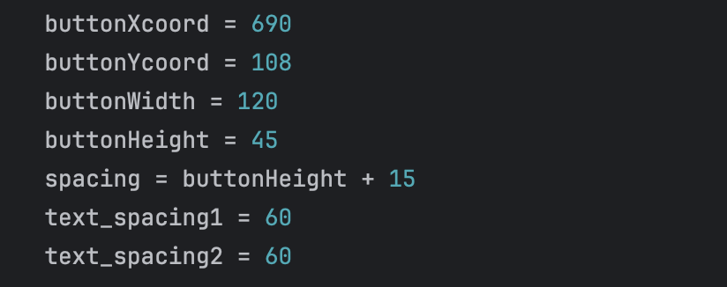

This code segment fills the screen with a white colour background and then covers it with the settings background image (`settingsBG`)



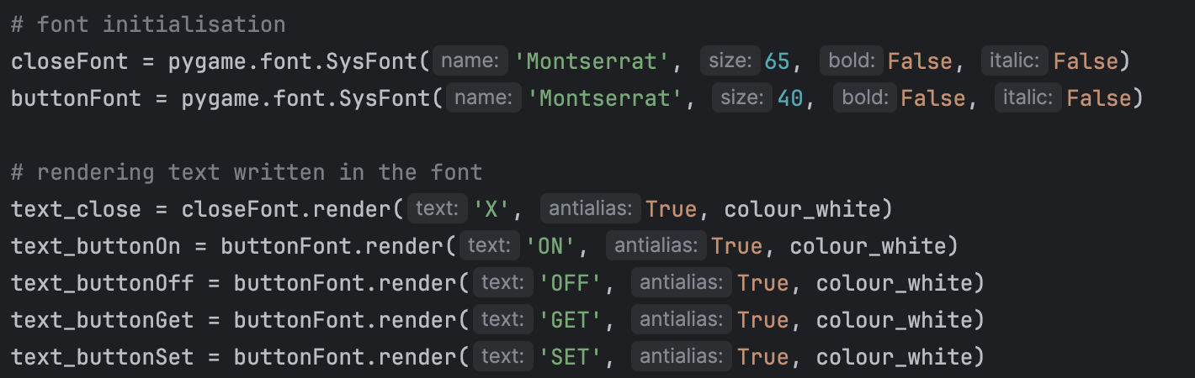

These lines of code draw a circle representing a close button, the text is rendered and displayed above the button

This section of code initialises font objects for different text elements on the settings screen. It sets up fonts for buttons and other text

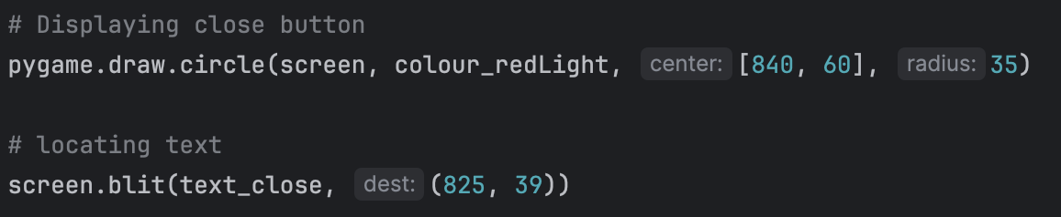

These lines of code display text “OFF”, "GET", and "SET" on the buttons. Text “ON” is not displayed at any button at this point, as the functionality to the buttons has not been added yet.

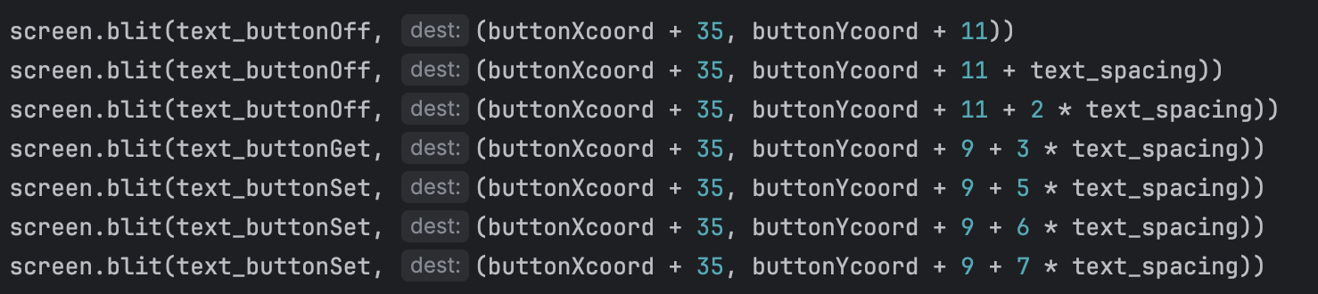

These lines of code draw rectangular buttons on the screen, each representing a setting option.

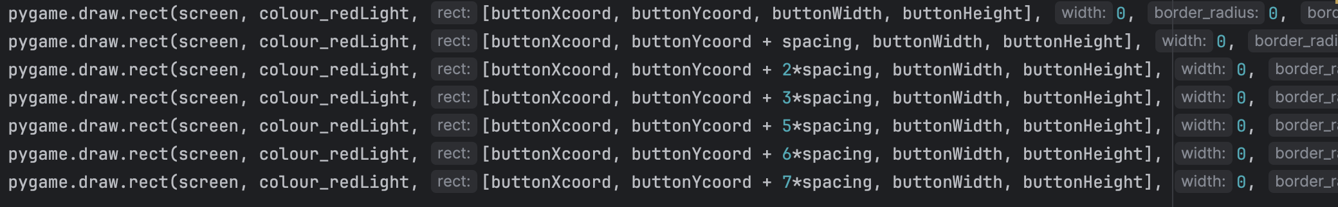

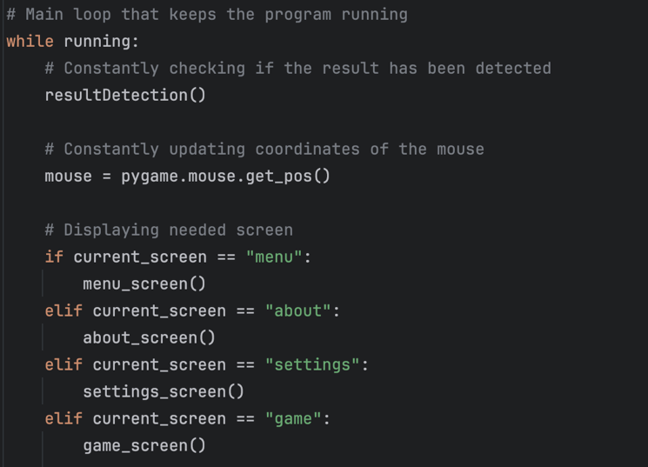

This block of code illustrates that a new if statement has been added which calls the settings_screen() function when current_screen is set to “settings”.

Bug Fixes:

No significant bugs were encountered during development, requiring only minor fixes.

This is how the game has changed:

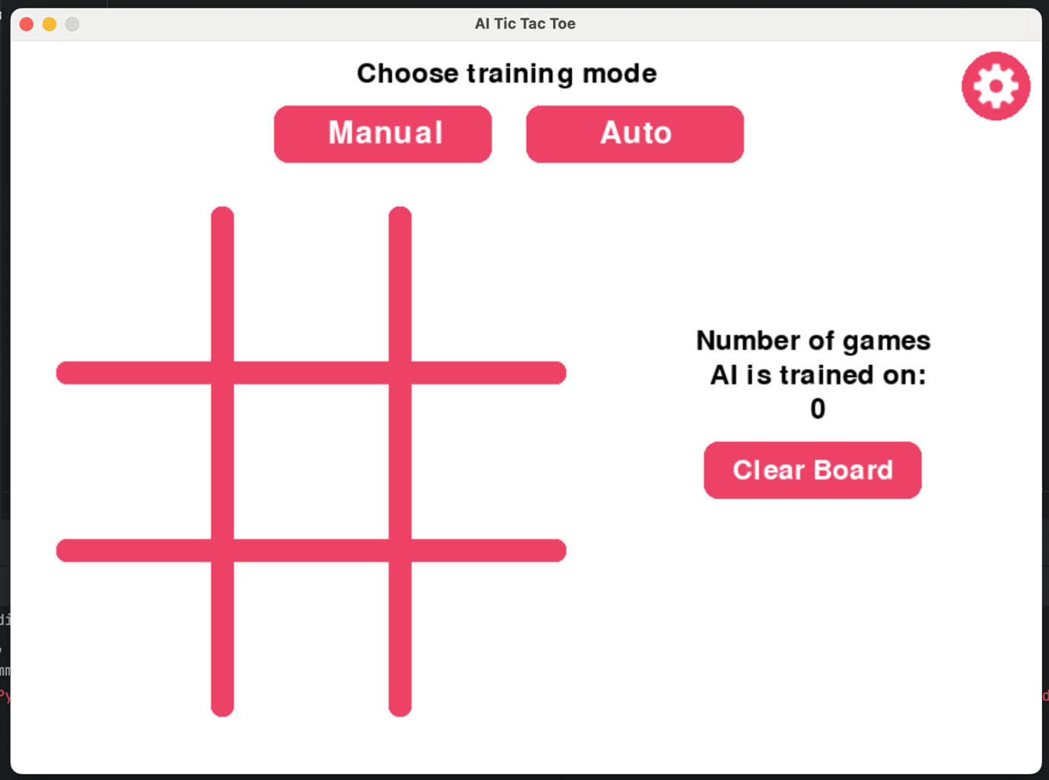

For now, to access the settings menu, current_screen has to be set to “settings” by default

And that is how the settings menu looks like when accessed:

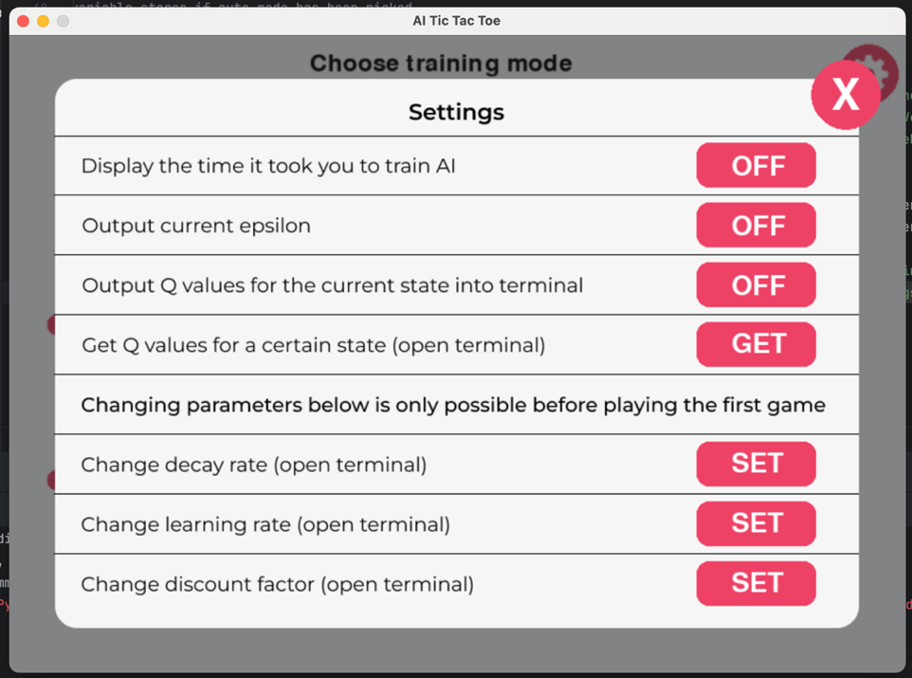

The second this screenshot was added, I realised that “Output current epsilon” can be combined with “Output Q-values for the current state” which will free some space for another setting. And this setting will be a graph, which will give users a visual understanding of how AI develops over time. It will be developed in Stage 8, as it requires a lot of changes to the code.

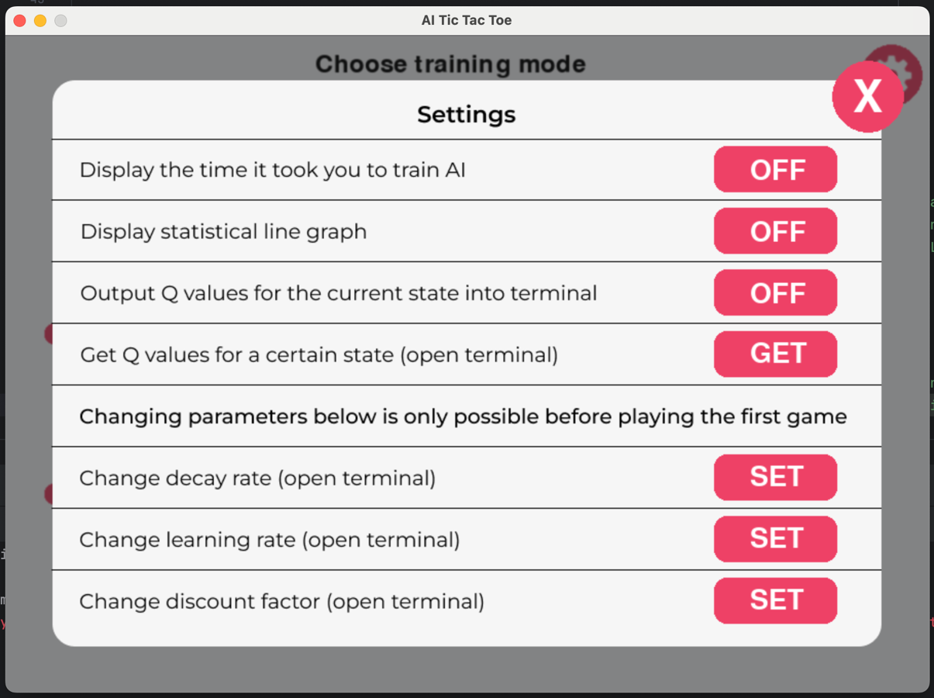

**Tests Table:**

|  |  |  |  |  |  |
| --- | --- | --- | --- | --- | --- |
| Test No. | Description | Type of test | Test data | Expected Result | Actual Result |
| 1 | Does title display? | Valid | Open “Settings” screen | The title saying “Settings” is displayed. | Pass  Evidence:  Image 7.10 |
| 2 | Does text explaining what each button does display? | Valid | Open “Settings” screen | All the text as in the design prototype is displayed. | Pass  Evidence:  Image 7.10 |
| 3 | Do all the buttons display? | Valid | Open “Settings” screen | Buttons shown in the design prototype are displayed | Pass  Evidence:  Image 7.10 |
| 4 | Does the close button display? | Valid | Open “Settings” screen | The button is displayed in the right top corner | Pass  Evidence:  Image 7.10 |
| 5 | Does the background design display? | Valid | Open “Settings” screen | Displays the background design as shown in the actual prototype | Pass  Evidence:  Image 7.10 |
| 6 | Does the setting button display on the game screen? | Valid | Open “Game” screen | Should be displayed in the right top corner of the game screen | Pass  Evidence:  Image 7.10 |

## Stage 7 – Settings

### Substage – Functionality implementation

### Summary:

In this stage, the focus is on adding functionality to the existing graphical user interface (GUI) of the settings menu. This involves adding functionalities such as changing epsilon, decay rate, and other parameters, also allowing users to access the Q Table for any state, which will require their input and hence the validation. The aim is to ensure that users can interact with the settings menu easily and intuitively, allowing them to customise the game according to their preferences.

**Requirements met in this stage:**

|  |  |
| --- | --- |
| Requirement number and name | Test No. checking this requirement |
| 6a. Settings Influencing AI’s learning rate | 1-17 |
| 6d. Close Button | 18 |
| 6e. Settings Button | 19 |

**Has to be implemented:**

|  |  |
| --- | --- |
| Feature | Justification |
| Button 1 - Display the time elapsed | Displaying the time elapsed will give users an ability to track the progress. When turned on, the time will appear on the game screen. |
| Button 2 - Output current epsilon | Outputting the current epsilon value allows users to understand what the chances of the move are being exploratory or exploitational. |
| Button 4 - Get Q-values for current state | Getting Q-values for the current state allows users to see the progress of AI and how filled out the table is. |
| Button 5 - Change decay rate | Changing the decay rate of exploration (epsilon decay) can adjust the exploration-exploitation balance, allowing users to change the behaviour of the AI. |
| Button 6 - Change learning rate | Changing the learning rate adjusts the speed at which the AI agent updates its Q-values, influencing the rate of learning and adaptation to new information. |
| Button 7 - Change discount factor | Changing the discount factor varies the importance of future rewards affecting the agent's willing to prioritise short-term gains or long-term rewards. |
| Settings button | The settings button provides access to the settings from the game menu. |
| Close button | The close button allows users to exit the settings menu (return the game menu). |

**Example Tests Table:**

|  |  |  |  |  |  |
| --- | --- | --- | --- | --- | --- |
| Test No. | Description | Type of test | Test data | Expected Result | Actual Result |
| 1 | Does button 1 change its text to ON from OFF and the other way round when pressed? | Valid | Press button 1 | The text on the button should change from OFF to ON or the other way round |  |
| 2 | Does time elapsed display on the game screen when button 1 is set to OFF? | Invalid | Press button 1 | The time elapsed should not be displayed on the game screen |  |
| 3 | Does time elapsed display on the game screen when button 1 is set to ON? | Valid | Press button 1 and open the game screen (press close button in the settings menu) | The time elapsed should be displayed on the game screen |  |
| 4 | Is time elapsed measured accurately? | Valid | Use a stopwatch on the phone and start it at the same time as the button in the setting is pressed. Then open the game screen to compare. | The time is measured accurately |  |
| 5 | Does button 2 change its text to ON from OFF and the other way round when pressed? | Valid | Press button 2 | The text on the button should change from OFF to ON or the other way round |  |
| 6 | Is the current epsilon printed into the terminal after each AI’s move when button 2 is set to OFF? | Invalid | Press button 2 | The current epsilon should not be output |  |
| 7 | Does button 3 change its text to ON from OFF and the other way round when pressed? | Valid | Press button 3 | The text on the button should change from OFF to ON or the other way round |  |
| 8 | Are the Q-values for the current state being output into the terminal when button 3 is set to OFF? | Invalid | Press button 3 | The Q-values should not be output into the terminal |  |
| 9 | Are the Q-values for the current state being output into the terminal when button 3 is set to ON? | Valid | Press button 3, close the settings, make a move (in manual mode), and check the terminal | The Q-values should be output into the terminal |  |
| 10 | Is the current epsilon printed into the terminal after each AI’s move when button 3 is set to ON? | Valid | Press button 3, close the settings, make a move (in manual mode), and check the terminal | Current epsilon should be output |  |
| 11 | Does epsilon decrease over time? | Valid | Press button 3, close the settings, make several moves (in manual mode), and check the terminal | The epsilon should decrease over time (the decrease rate depends on decay rate and other factors) |  |
| 12 | Does a message saying “Enter ID of the state you want to see the Q Table for: ” appear in the terminal when button 4 is pressed? | Valid | Press button 4 and check the terminal | The message should appear in the terminal |  |
| 13 | Are the Q-values for the state entered by the user being output into the terminal? | Valid | Press button 4, enter StateID, and check the terminal | The Q-values are output for all the actions for current state |  |
| 14 | Does a message saying “Enter a new value for the decay rate: ” appear in the terminal when button 5 is pressed? | Valid | Press button 5 and open terminal | The message should appear in the terminal |  |
| 15 | Does a message saying “Enter a new value for the learning rate: ” appear in the terminal when button 6 is pressed? | Valid | Press button 6 and open terminal | The message should appear in the terminal |  |
| 16 | Does a message saying “Enter a new value for the discount factor: ” appear in the terminal when button 7 is pressed? | Valid | Press button 7 and open terminal | The message should appear in the terminal |  |
| 17 | Does anything happen when buttons 5, 6, or 7 are pressed after making the first move? | Invalid | Make a move, open settings, try to press button 5, 6, and 7. | The buttons should be inactive |  |
| 18 | Does game screen appear when close button is pressed? | Valid | Press close button (not the actual window close button) in the right top corner. | Once the close button is pressed, the game screen should appear |  |
| 19 | Does settings menu appear when settings button is pressed (in the game screen)? | Valid | Press settings button (gear icon in the circle in the right top corner) in the game screen | Once the settings button is pressed, the setting menu should appear |  |
| 20 | Does the program stop and window close when the window close button is pressed? | Valid | Press actual window close button | Once the window close button is pressed, the program window should close, and the execution should be stopped |  |
| 21 | Does the program crash when an invalid input is entered? | Invalid | Press either button 5, 6, or 7, open the terminal, and enter an invalid input | The program should not crash, and it should ask for an input again |  |

**Data Dictionary:**

|  |  |  |  |
| --- | --- | --- | --- |
| Name | Data Type | Description | Validation |
| button1,  …,  button7 | Boolean | These variables will be used as flags to show that the button has been pressed |  |
| displayTime | Boolean | This will be a flag that indicates that time should be displayed on the game screen. I will not use button variables (button1, …) as it could be confusing to understand what is supposed to happen |  |
| outputQvalues | Boolean | This will be a flag that indicates that the Q-values should be output into the terminal |  |
| startTime | Integer | This variable will store the time the game is executed |  |

## Stage 7 Flowchart

### Summary:

The flowchart illustrates the functionality of each button in the settings menu. It outlines processes such as displaying time elapsed, displaying graph(will be developed in Stage 8), outputting Q-values, getting Q-values for the current state, and changing parameters like decay rate, learning rate, and discount factor.

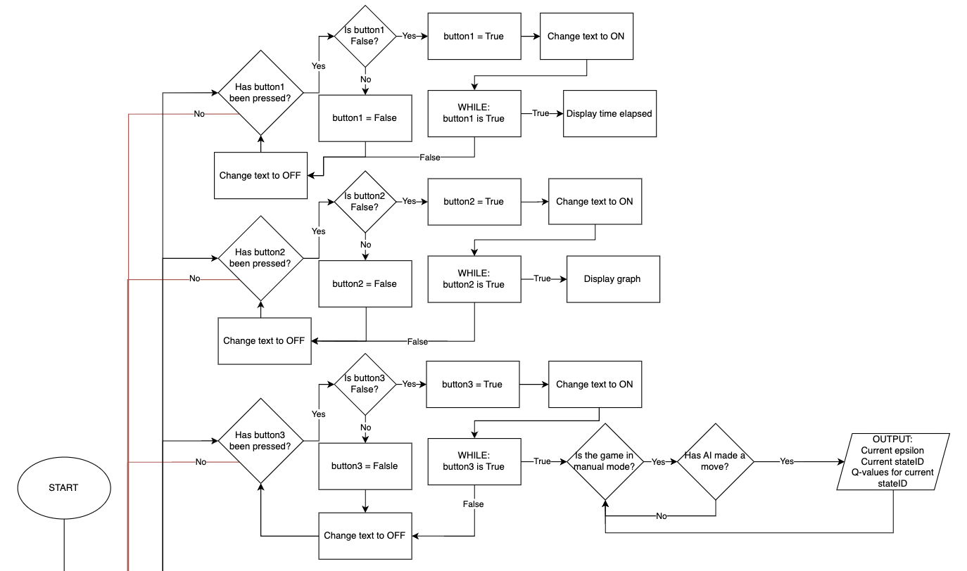

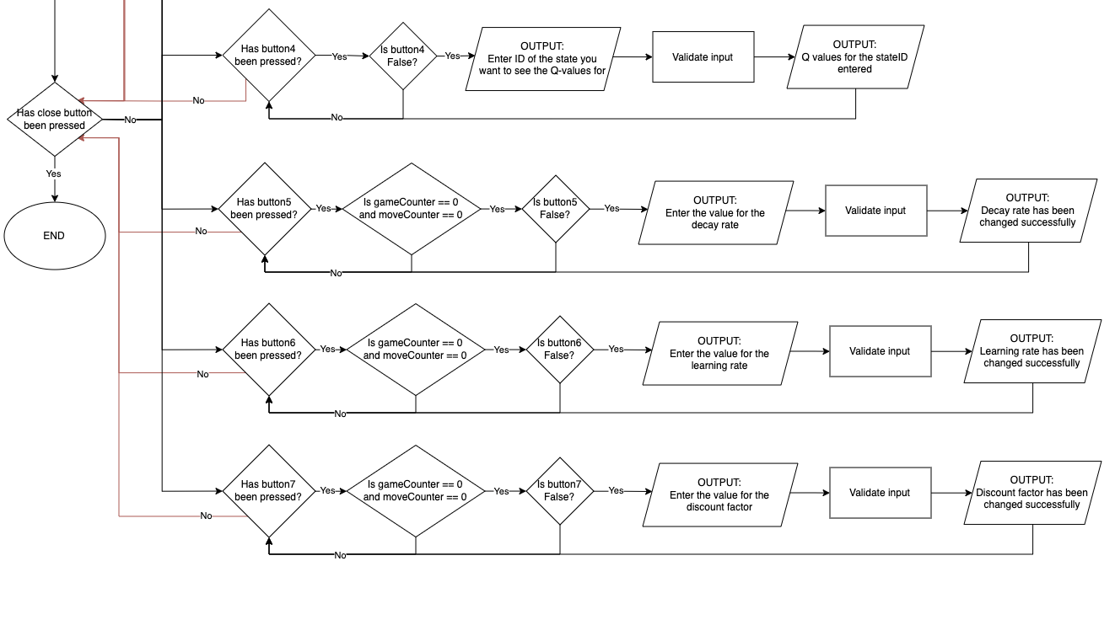

## Stage 7 Development

### Summary:

The development process involved analysing the GUI layout, assigning functions to each button (e.g., displaying time elapsed, adjusting parameters), and a huge number of tests to ensure proper functionality.



In order to implement the functionality for the time elapsed function, a library ‘time’ had to be imported

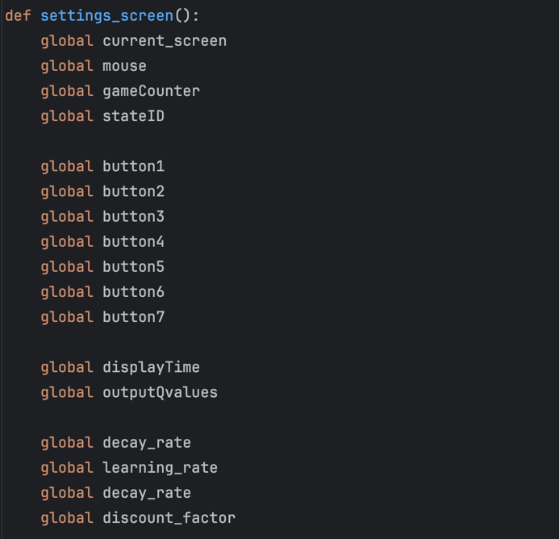

The screenshot on the left shows all the variables that are accessed globally within settings_screen function.

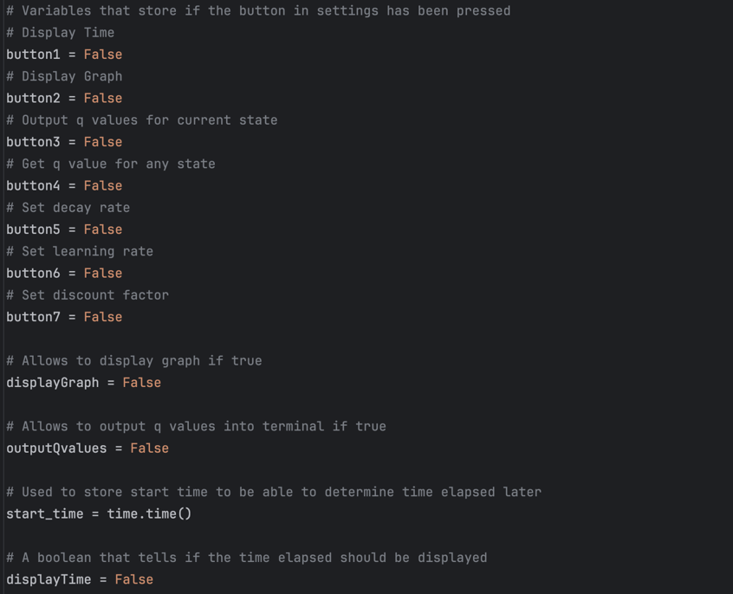

Screenshots 7.15 and 7.16 (two screenshots on left) show where those variables are initialised. Most of them are flags which indicate that something should or should not be displayed.

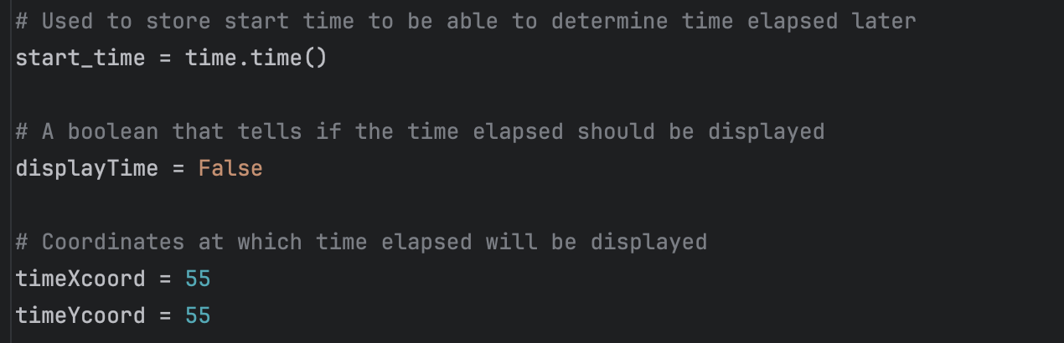

This code segment shows the implementation of button hover effects for close button and 7 settings buttons. These hover effects improve the user experience by providing visual feedback, indicating to the user that the buttons are interactive elements.

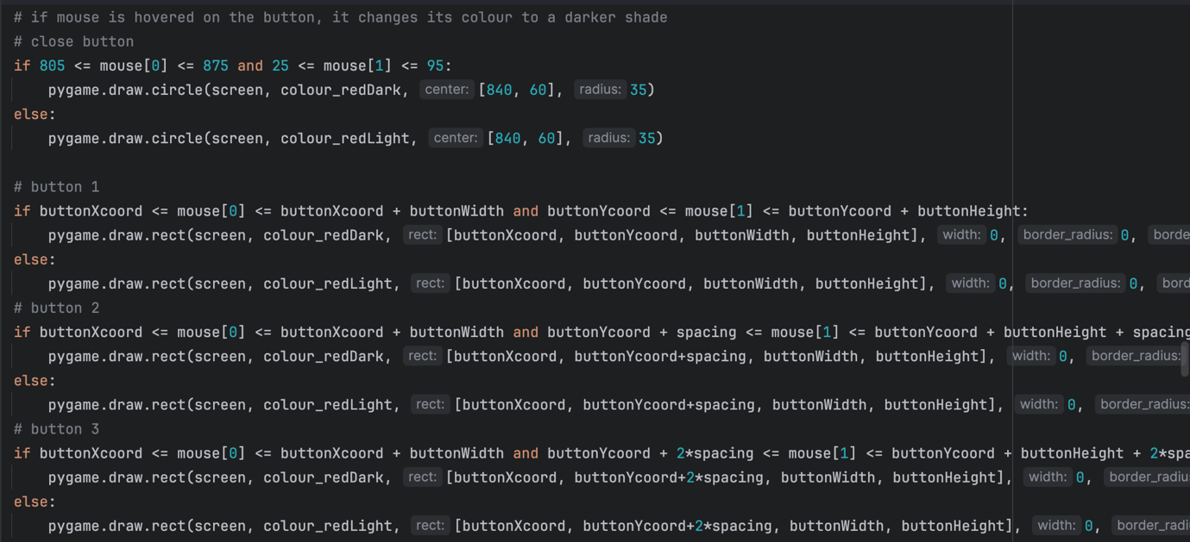

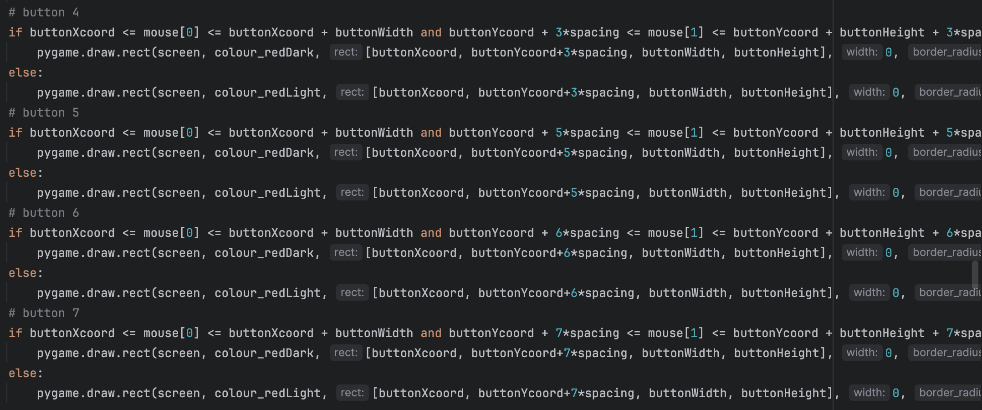

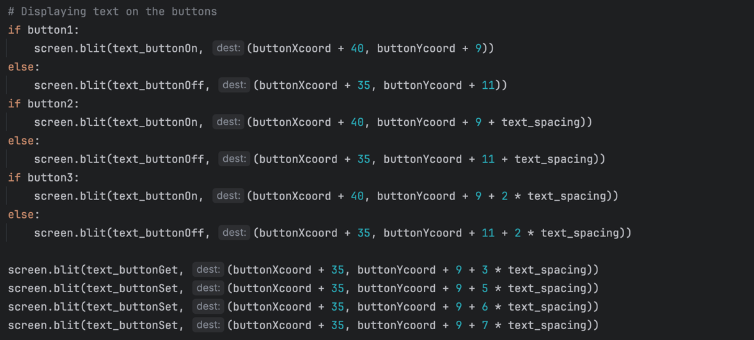

These lines of code determine which text has to be displayed on each button based on the state of corresponding boolean variables (“button1”, “button 2”, and “button3”). If a button is activated (True), the text "ON" is displayed on it, otherwise, the text "OFF" is displayed. Additionally, "GET" and "SET" buttons are displayed with their respective texts.

This code segment below handles mouse button events. When user clicks on the first button, its boolean called button1 is set to True and a flag displayTime is also set to True indicating that time elapsed has to be displayed.

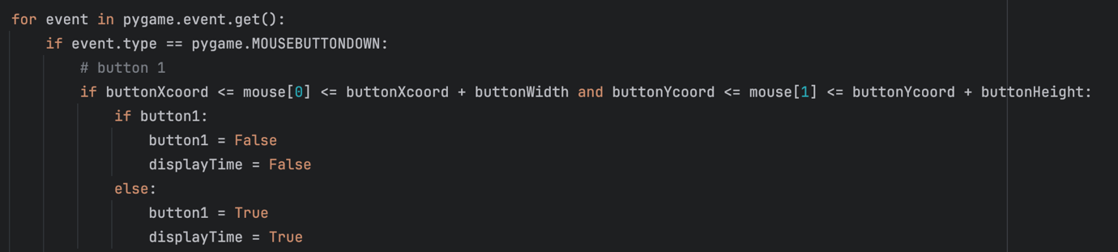

This function calculates the time elapsed by taking current time and subtracting the time when program was executed from it. Getting the time difference, which is elapsed time, in seconds. Then it converts the time into hours, minutes, seconds format and makes it a single string.

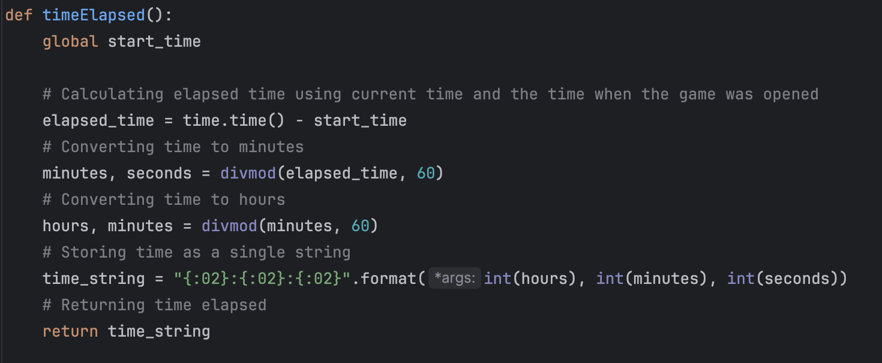

Screenshot 7.30

Screenshot 7.27 shows lines of code which display text “Time elapsed:” and the time itself, which is returned from the timeElapsed() function (screenshot 7.30), on the game screen at specific coordinates. Snippet 7.29 illustrates the text being rendered in a certain font.

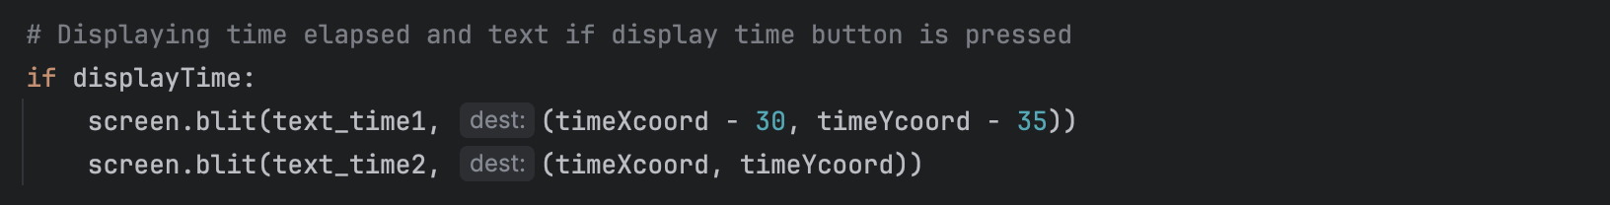

Screenshot 7.27



Screenshot 7.29

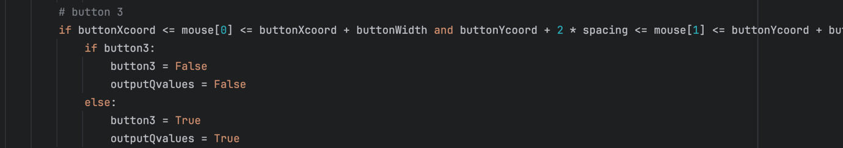

This code snippet checks if the mouse click occurs within the boundaries of `button3`. And then if `button3` is currently active (True), clicking it sets `button3` and `outputQvalues` to False. In contrary, if `button3` is currently inactive, clicking it sets `button3` and `outputQvalues` to True.

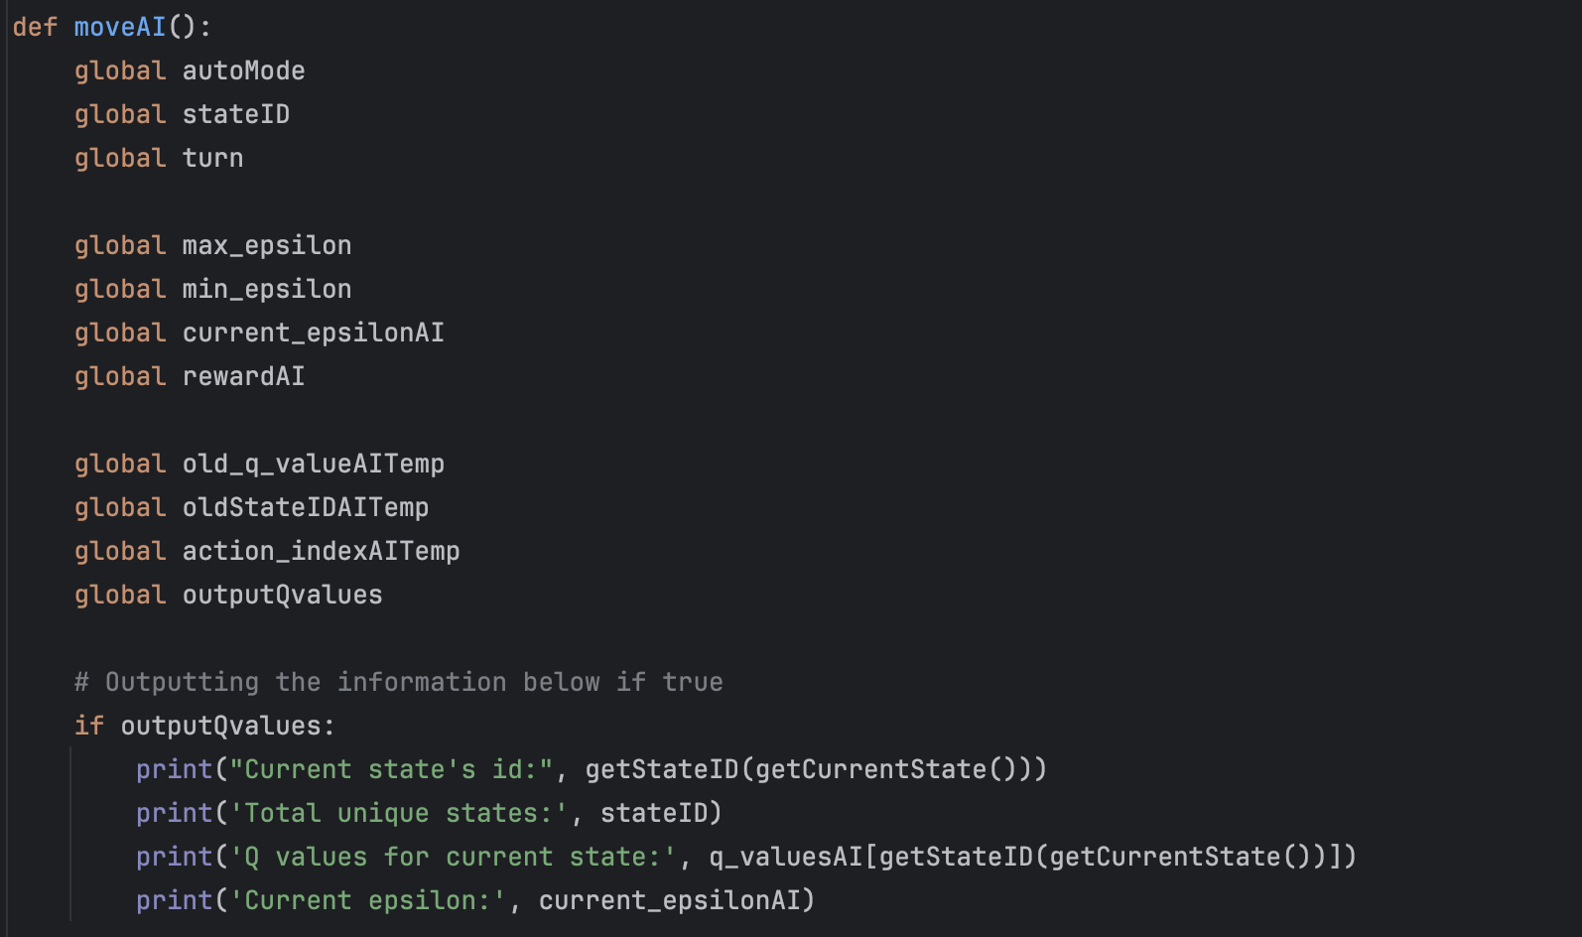

When outputQvalues is set to True and AI makes a move in manual mode all these values are output into terminal. It was added only into manual mode, as when the game is in automatic mode it is impossible to see the actual moves, so seeing the values would be useless.

This code block manages mouse button events for the fourth button. If button4 is inactive then it set to active, and the while loop starts. It used to handle user input for displaying Q-Table information. The loop asks the user to input the state ID they want to see the Q-Table for, and it continues until the user enters -1 to exit, hence the loops ends and button4 is set to False. The input is validated, and if valid, the corresponding Q-Table information is displayed. Otherwise, the user is asked again.

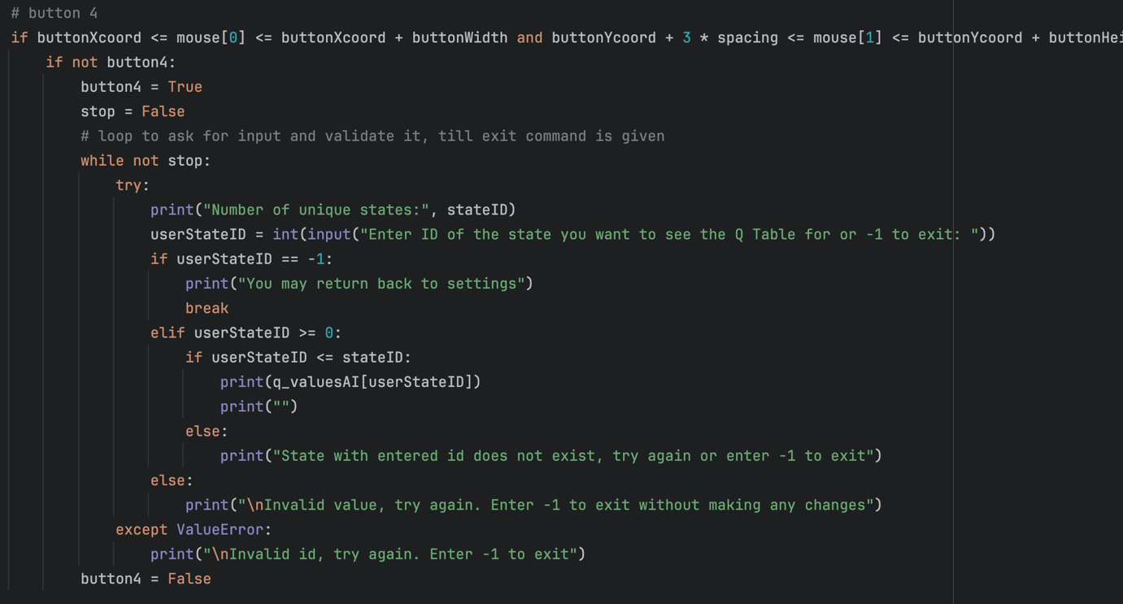

As buttons 5, 6, and 7 can only be accessed before making the very first move, an if statement checks if this condition is met. When button5 is active, the code starts a loop to handle user input for setting the decay rate parameter. The loop continues until the user enters -1 to exit or provides a valid decay rate value within the specified range (0 to 1). Validated input updates the `decay_rate` variable.

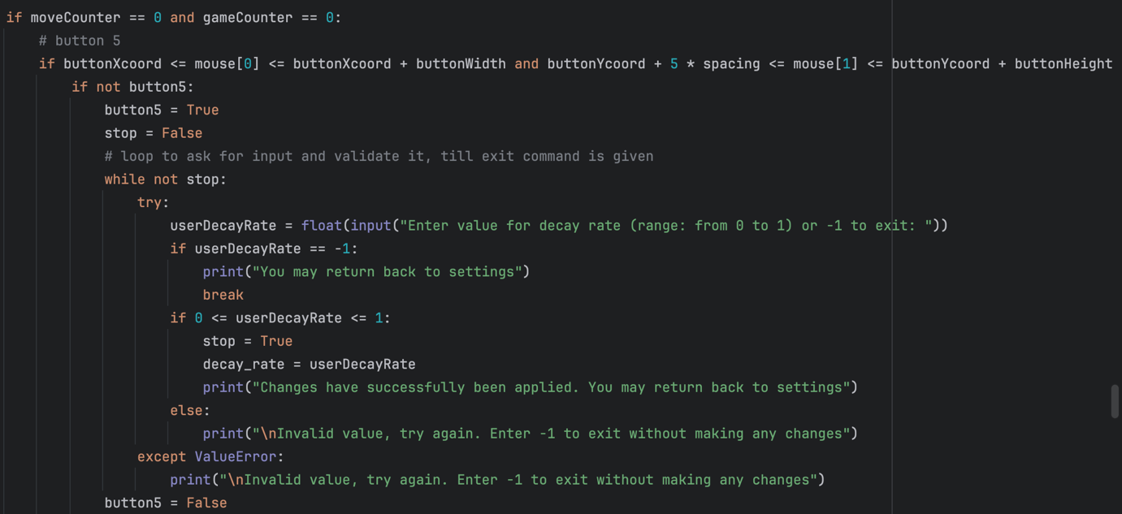

Screenshot 7.23

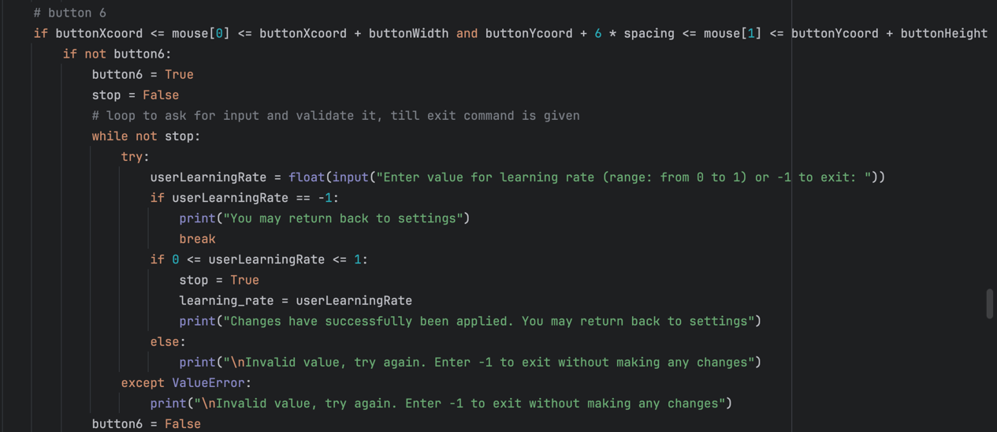

When button6 is active, the code starts a loop to handle user input for setting the learning rate parameter. It is the same as for the decay rate (Screenshot 7.23)

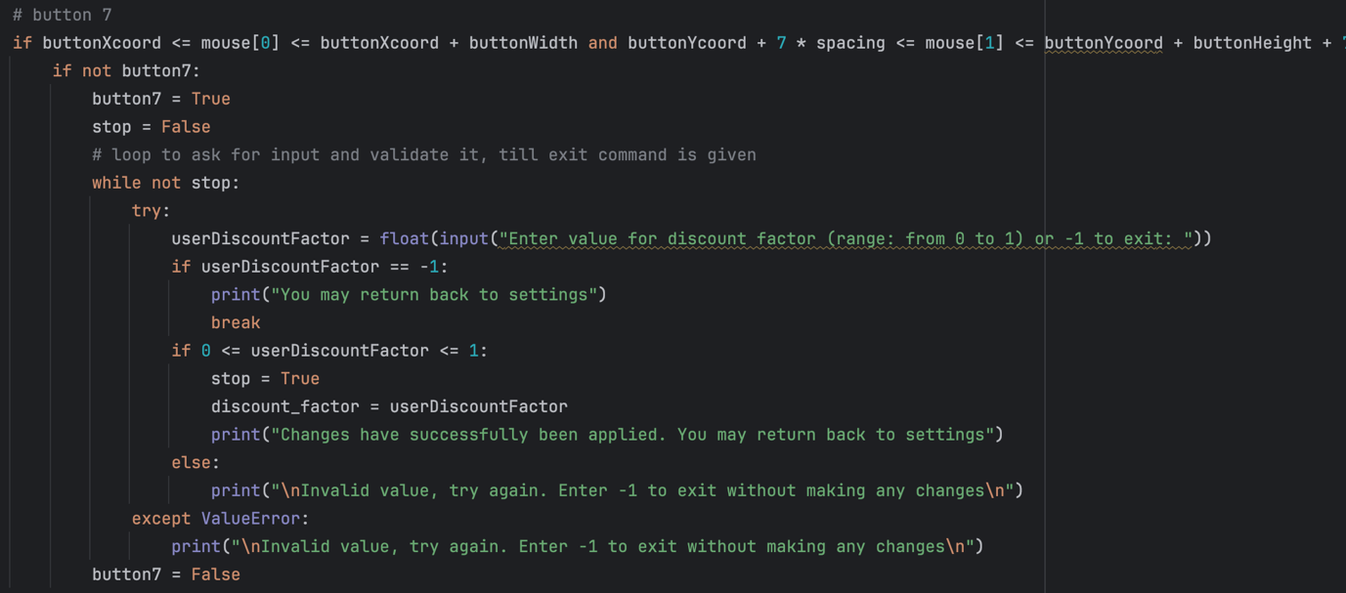

This code segment handles mouse click events for the close button that’s send user back to game screen and the window close button that stops the program. In addition, it checks if all these buttons (button4, button5, button6, button7) are not active (False), only then the game screen is reopened (It is explained in bug fixes section why this if statement is added).

When button7 is active, the code starts a loop to handle user input for setting the discount factor parameter. It is the same as for the decay rate (Screenshot 7.23)

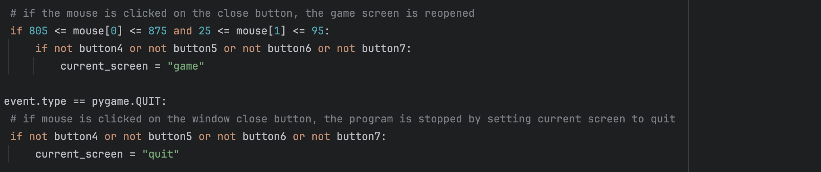

This code segment handles mouse click events for the close button that’s send user back to game screen and the window close button that stops the program. In addition, it checks if all these buttons (button4, button5, button6, button7) are not active (False), only then the game screen is reopened (It is explained in bug fixes section why this if statement is added).

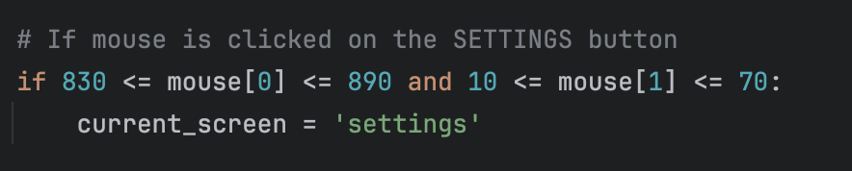

Bug Fixes:

During the bug fixes phase, numerous minor bugs were found and a few significant ones. While most fixes were minor, there were some significant bugs which had to be resolved to improve the overall performance and user experience.

The first significant problem was with taking user input and validating it. The screenshot below shows how the input-taking system looked initially, the problem was that the user allowed to enter the ID just once and if the person wanted to see the Q Table for another stateID, it would require pressing the button again which was inconvenient.

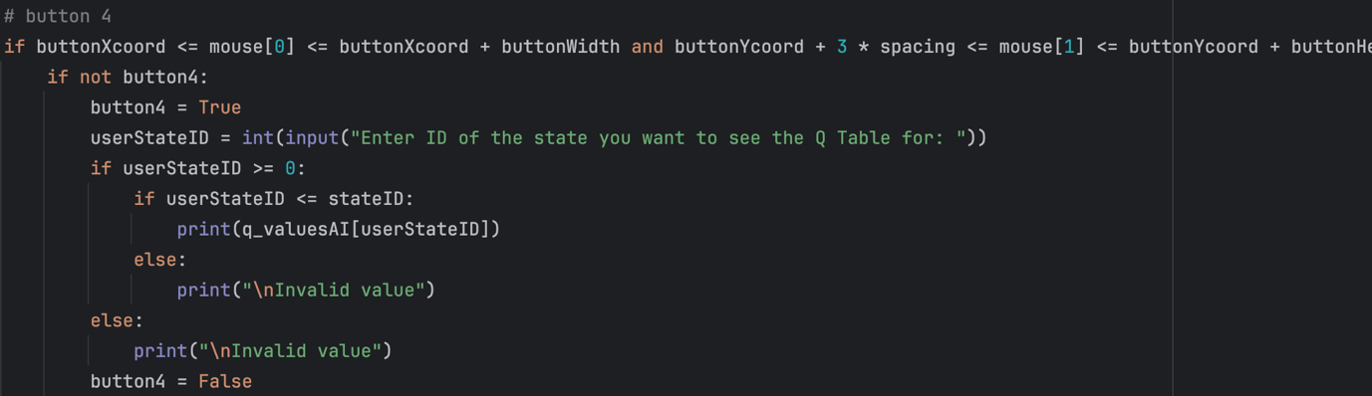

Therefore, a while loop was implemented, which would ask the user to enter stateID again and again till button in settings is pressed.

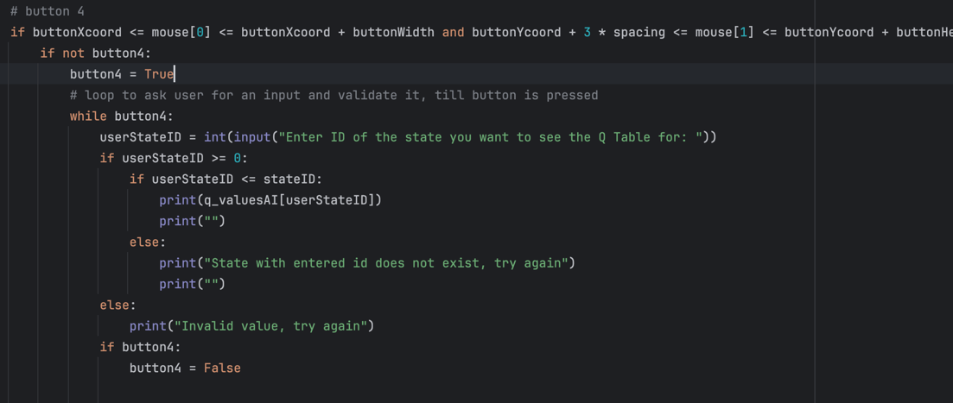

As I found out, when the program is waiting for input in the terminal, the Pygame window completely freezes till input is entered. Which meant that the button could not be pressed, video 7.34 illustrates the problem. Hence, it was decided to add an exit command into the while loop – a special input which would mean that the loop should stop, and the button should be set to False. Moreover, an output saying a number of unique states has been added as it is not clear what is the maximum that can be entered.

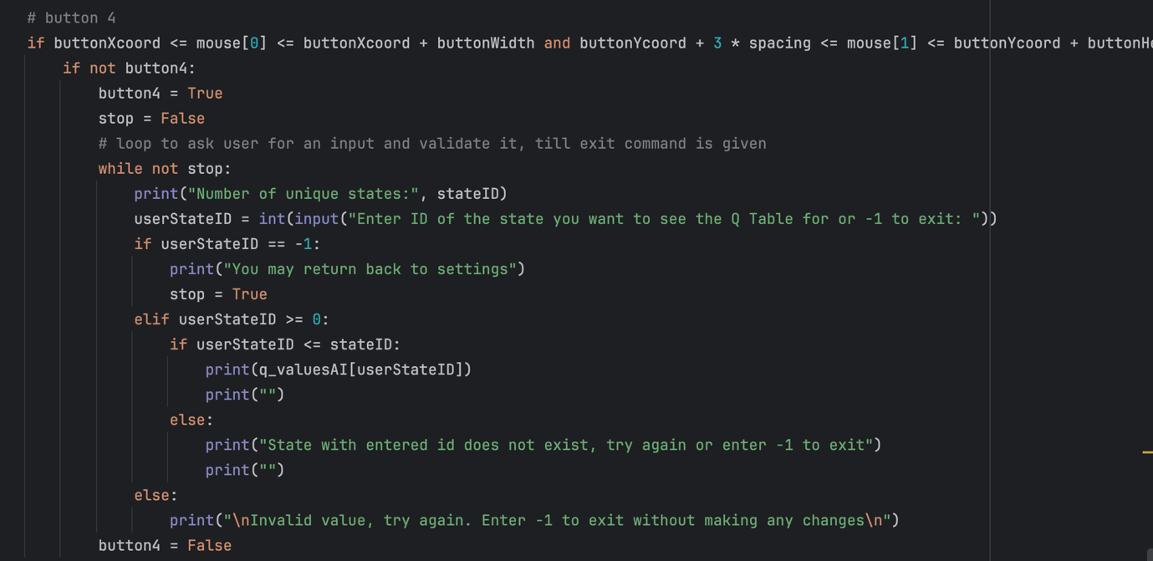

This system worked well till the point when not an integer is entered. The game would crash as it could not validate a string or a decimal number. After many attempts of trying to convert all the inputs into strings and some other inefficient solutions, I decided to read more about exceptions and how they can be handled and found some useful information which allowed me to write this block of code.

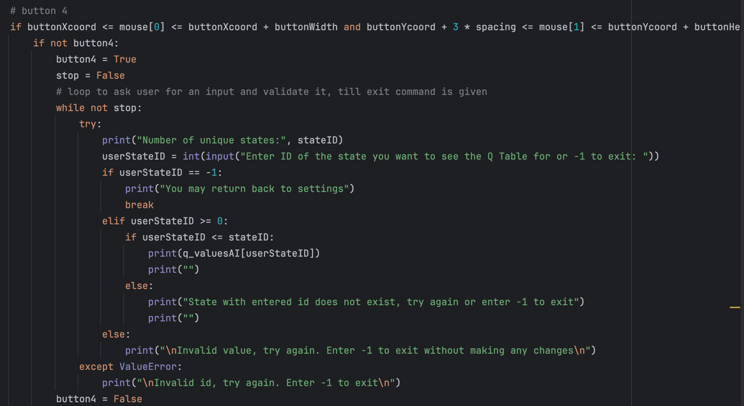

Later I used the same system to validate inputs when buttons 5, 6, and 7 are pressed.

Video 7.37 shows how button 4 works with valid and invalid inputs.

**Tests Table:**

|  |  |  |  |  |  |
| --- | --- | --- | --- | --- | --- |
| Test No. | Description | Type of test | Test data | Expected Result | Actual Result |
| 1 | Does button 1 change its text to ON from OFF and the other way round when pressed? | Valid | Press button 1 | The text on the button should change from OFF to ON or the other way round | Pass  Evidence:  Video 7.38 |
| 2 | Does time elapsed display on the game screen when button 1 is set to OFF? | Invalid | Press button 1 (make it OFF) and close settings menu | The time elapsed should not be displayed on the game screen | Pass  Evidence:  Video 7.39 |
| 3 | Does time elapsed display on the game screen when button 1 is set to ON? | Valid | Press button 1 and open the game screen (press close button in the settings menu) | The time elapsed should be displayed on the game screen | Pass  Evidence:  Video 7.39 |
| 4 | Is time elapsed measured accurately? | Valid | Use a stopwatch on the phone and start it at the same time as the button in the setting is pressed. Then open the game screen to compare. | The time is measured accurately | Pass  Evidence:  Video 7.39 |
| 5 | Does button 2 change its text to ON from OFF and the other way round when pressed? | Valid | Press button 2 | The text on the button should change from OFF to ON or the other way round | Pass  Evidence:  Video 7.38 |
| 6 | Does button 3 change its text to ON from OFF and the other way round when pressed? | Valid | Press button 3 | The text on the button should change from OFF to ON or the other way round | Pass  Evidence:  Video 7.38 |
| 8 | Are the Q-values for the current state being output into the terminal when button 3 is set to OFF? | Invalid | Press button 3 (make it OFF) and make a move in manual mode | The Q-values should not be output into the terminal | Pass  Evidence:  Video 7.41 |
| 9 | Are the Q-values for the current state being output into the terminal when button 3 is set to ON? | Valid | Press button 3, close the settings, make a move (in manual mode), and check the terminal | The Q-values should be output into the terminal | Pass  Evidence:  Video 7.40 |
| 10 | Is the current epsilon printed into the terminal after each AI’s move when button 3 is set to ON? | Valid | Press button 3, close the settings, make a move (in manual mode), and check the terminal | Current epsilon should be output | Pass  Evidence:  Video 7.40 |
| 11 | Does epsilon decrease over time? | Valid | Press button 3, close the settings, make several moves (in manual mode), and check the terminal | The epsilon should decrease over time (the decrease rate depends on decay rate and other factors) | Pass  Evidence:  Video 7.40 |
| 12 | Does a message saying “Enter ID of the state you want to see the Q Table for: ” appear in the terminal when button 4 is pressed? | Valid | Press button 4 and check the terminal | The message should appear in the terminal | Pass  Evidence:  Video 7.37 |
| 13 | Are the Q-values for the state entered by the user being output into the terminal? | Valid | Press button 4, enter StateID, and check the terminal | The Q-values are output for all the actions for current state | Pass  Evidence:  Video 7.37 |
| 14 | Does a message saying “Enter a new value for the decay rate: ” appear in the terminal when button 5 is pressed? | Valid | Press button 5 and open terminal | The message should appear in the terminal | Pass  Evidence:  Video 7.43 |
| 15 | Does a message saying “Enter a new value for the learning rate: ” appear in the terminal when button 6 is pressed? | Valid | Press button 6 and open terminal | The message should appear in the terminal | Pass  Evidence:  Video 7.43 |
| 16 | Does a message saying “Enter a new value for the discount factor: ” appear in the terminal when button 7 is pressed? | Valid | Press button 7 and open terminal | The message should appear in the terminal | Pass  Evidence:  Video 7.43 |
| 17 | Does anything happen when buttons 5, 6, or 7 are pressed after making the first move? | Invalid | Make a move, open settings, try to press button 5, 6, and 7. | The buttons should be inactive | Pass  Evidence:  Video 7.44 |
| 18 | Does game screen appear when close button is pressed? | Valid | Press close button (not the actual window close button) in the right top corner. | Once the close button is pressed, the game screen should appear | Pass  Evidence:  Video 7.42 |
| 19 | Does settings menu appear when settings button is pressed (in the game screen)? | Valid | Press settings button (gear icon in the circle in the right top corner) in the game screen | Once the settings button is pressed, the setting menu should appear | Pass  Evidence:  Video 7.42 |
| 20 | Does the program stop and window close when the window close button is pressed? | Valid | Press actual window close button | Once the window close button is pressed, the program window should close, and the execution should be stopped | Pass  Evidence:  Video 7.42 |
| 21 | Does the program crash when an invalid input is entered? | Invalid | Press either button 5, 6, or 7, open the terminal, and enter an invalid input | The program should not crash, and it should ask for an input again | Pass  Evidence:  Video 7.37 |
| 22 | Does the program ask for another input when an invalid one is entered? | Invalid | Press either button 5, 6, or 7, open the terminal, and enter an invalid input | The program should ask for an input again if the previous one was invalid | Pass  Evidence:  Video 7.37 |
| 23 | Do buttons 1, 2, 3, 4, 5, 6, 7 change their colour when the mouse is hovered over them? | Valid | Hover over buttons 1, 2, 3, 4, 5, 6, 7 | The buttons should become darker when the mouse is hovering over them | Pass  Evidence:  Video 7.38 |

### Stage 7 Review

Stage 7 is a significant upgrade that added customisation to the game. Exploring different settings options and seeing how they affect the gameplay is both fun and informative. It was satisfying to see how these additions enhanced the overall user experience.

For this stage, lots of planning and coding has been done. There are so many different settings that could possibly be added, but there is not enough space on the screen, so I picked only the main ones.

To sum up, I am satisfied with the result and ready to move onto the graph stage to make the game even more engaging.

## Stage 8 – Statistical Graph

### Summary:

This stage is focused on creating a visual representation of the percentage of AI wins over time which will provide users with an easy interpretation of AI development progress. This involves designing and implementing the graph's interface, data collection method, and plotting function.

**Requirements met in this stage:**

|  |  |
| --- | --- |
| Requirement number and name | Test No. checking this requirement |
| 6b. Settings Displaying Statistics | 1 - 11 |

**Has to be implemented:**

|  |  |
| --- | --- |
| Feature | Justification |
| Data collection | To collect game outcome data over time, giving analysis of AI win percentages and performance trends |
| Plotting function | To visualise the collected data in the form of a statistical graph by plotting the points on the graph |
| Graph’s interface | Displaying an image of a graph to provide users with an intuitive and visually appealing display of the statistical graph, which will improve the overall user experience |

**Example Tests Table:**

|  |  |  |  |  |  |
| --- | --- | --- | --- | --- | --- |
| Test No. | Description | Type of test | Test data | Expected Result | Actual Result |
| 1 | Does button 2 change its text to ON from OFF and the other way round when pressed? | Valid | Press button 2 | The text on the button should change from OFF to ON or the other way round |  |
| 2 | Does the graph appear on the game screen when button2 is set to True? | Valid | Press button 2 (make it ON), open game screen | The graph should be displayed on the game screen |  |
| 3 | Are the points plotted on the graph? | Valid | Display the graph and analyse it | The point should be plotted on the graph |  |
| 4 | Are the point being plotted every plotStep number of games? | Valid | Display the graph and analyse it | The point should be plotted on the graph every multiple of plotStep number of games |  |
| 5 | Are the points plotted connected by a line? | Valid | Display the graph and analyse it | The line should go through all the points connecting them |  |

**Data Dictionary:**

|  |  |  |  |
| --- | --- | --- | --- |
| Name | Data Type | Description | Validation |
| plotStep | Integer | To decrease the load on the compute the point will be plotted every 50 or 100 games and plotStep is the variable that will set this step |  |
| multiplier | Integer | As plotStep remains constant and gameCounter is not reset at regular intervals (e.g. every 50 games), a multiplier is needed to synchronise plotStep with gameCounter. |  |
| victoryNumAI | Integer | This variable will keep track of number of victories of AI, which will be used to plot a graph |  |
| xAxis | list of integers | A list that stores all the x coordinates of the points. (Number of games) |  |
| yAxis | list of integers | A list that stores win percentages for respective x values | Values within the list have to be:  >=0 and <=100 |
| displayGraph | Boolean | A flag to indicate that the graph has to be displayed |  |

## Stage 8 Flowchart

### Summary:

In this stage, a flowchart and pseudocode were developed to illustrate the implementation of the statistical graph. The pseudocode shows the logic of calculating and storing the points that will be plotted later.

These two lines of code will be in the game_screen function, making this if statement be checked after each move, which ensures that the graph will be constantly updated.

if plotStep * multiplier == gameCounter THEN  
 storePointsGraph()

The function storePointsGraph will require access to the lists - xAxis and yAxis, to be able to update them.

To calculate the ratio a variable victoryNumAI will be used. It will store the total number of AI victories and then be divided by the total number of games. It will also be multiplied by 100 to get a percentage value.

After each iteration of the function, a variable multiplier will be incremented.

function storePointsGraph()  
 global gameCounter  
 global multiplier  
 global victoryNumAI  
 global xAxis  
 global yAxis  
 xAxis.append(plotStep * multiplier)  
 ratio = victoryNumAI / gameCounter  
 percentage = ratio * 100  
 yAxis.append(pecentage)  
 multiplier = multipler + 1

endfunction

The flowchart outlines the logic for plotting function execution and displaying the graph.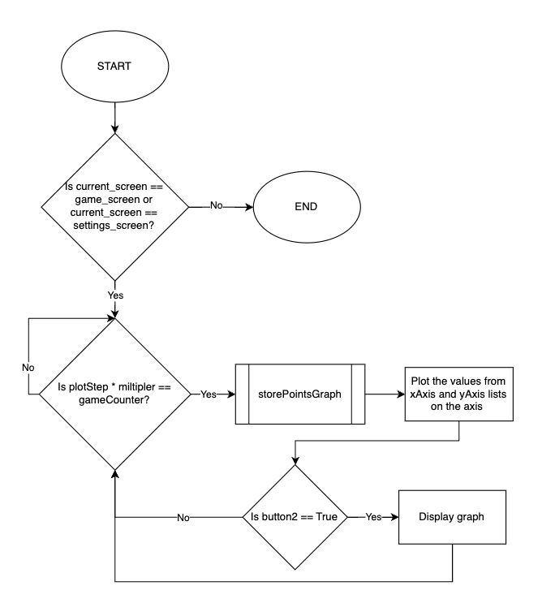

## Stage 8 Development

### Summary:

Before starting the coding phase, a design phase was done. This involved planning the layout and visual elements. By sorting these aspects beforehand, it gave a clear direction for the coding process and allowed a more structured development approach.

### Design development:

I started with coding a test graph to see how the library works and what the graph looks like.

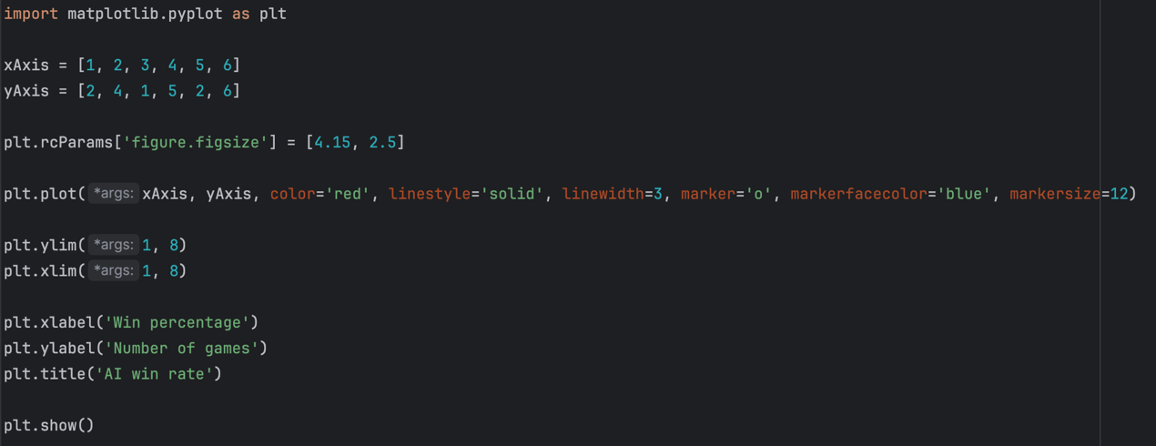

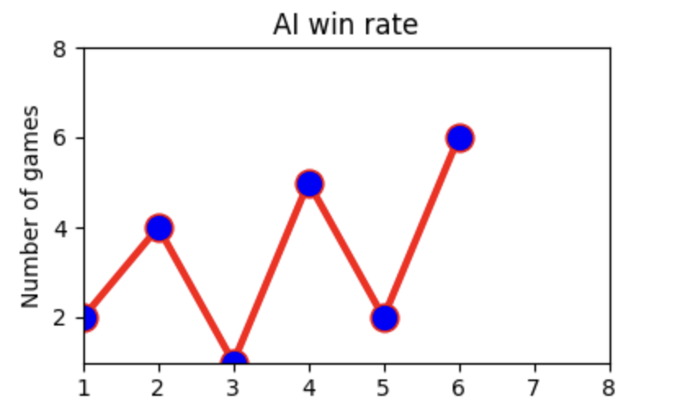I realised that having the markers showing the point would not make any sense when there are thousands of points, so that was deleted.

The next step was to decide where the display the graph. Moreover, I thought it would be a good idea to display the lose rate as well.

That was the first design concept. The screen would appear when button 2 is pressed in settings. This version looked good enough, so I started coding and understood that once a different screen is opened, the moves are not made on the grid, which meant that it would not be possible to view the graph updating in real time. Therefore, it was decided to display the graph on the game screen.

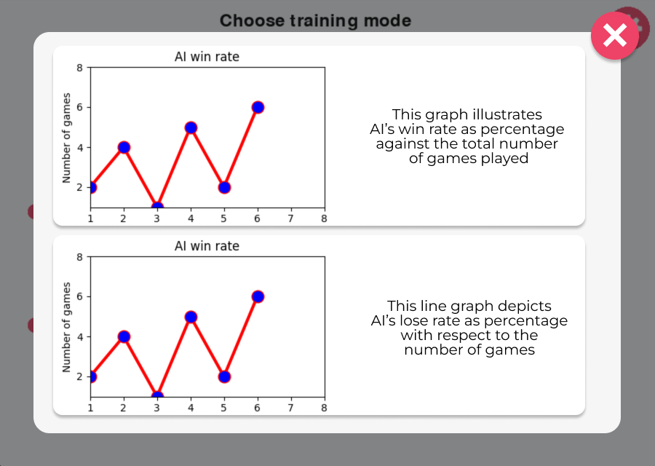

The image below shows the version of what will be coded. As I wanted to have several graphs, but here is clearly not enough space. Therefore, I will plot several lines on the same axis. Last but not least, it can be noticed that the clear board button and the text of number of games are shifted up. This is done to fit the graph on the screen, so some extra coding in the location of these elements will have to be done. 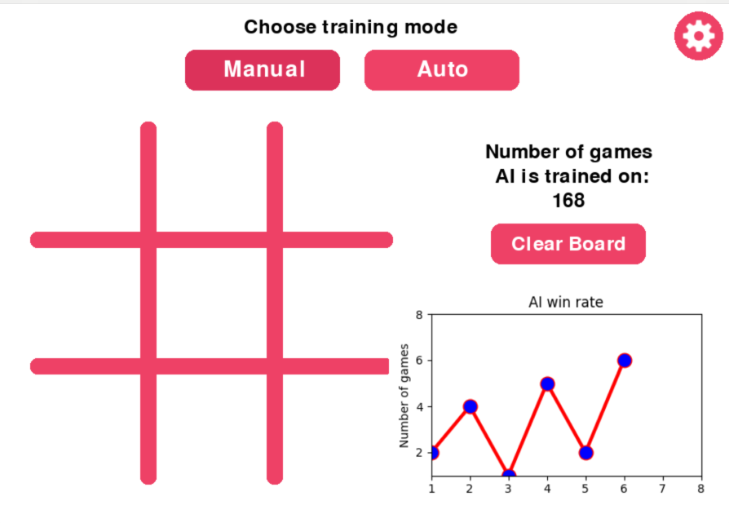

### Coding:

After the design phase, the coding stage commenced. With the design version finalised, I started implementing the planned layout, visual elements, and functionality. In the screenshots below, a final version of the code is shown. In the bug fixes section, I will talk more about adding the legend of the graph, plotting three different lines, and, of course, bugs.

This line imports the `matplotlib.pyplot` module, which is a plotting library.



In the screenshot the initialisation of the function plotGraph() is shown. It also shows global variables for tracking game counts and outcomes, as well as coordinates for plotting being referenced.

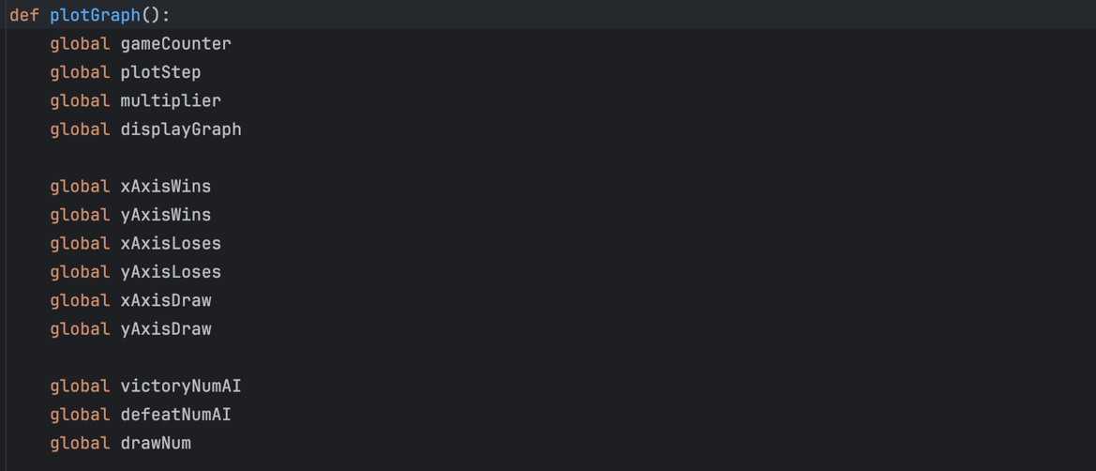

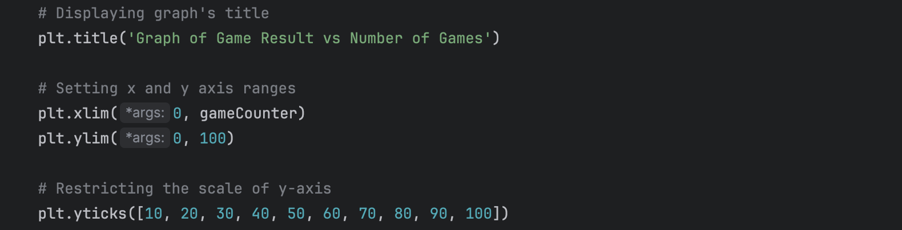

The provided code snippet sets up the title and axis ranges for the graph to be plotted within. It sets the title of the graph as "Graph of Game Result vs Number of Games" and restricts the x-axis range from 0 to the current game count (`gameCounter`), so the range widens as the gameCounter increases. The y-axis range is set from 0 to 100, and the y-axis ticks are defined at intervals of 10%.

These lines of code append values to the lists `xAxisWins`, `xAxisLoses`, and `xAxisDraw`. These lists are used to store the x-axis values for the different categories of game results - wins, losses, and draws. The values appended to these lists are calculated by multiplying the `plotStep` by the `multiplier`.

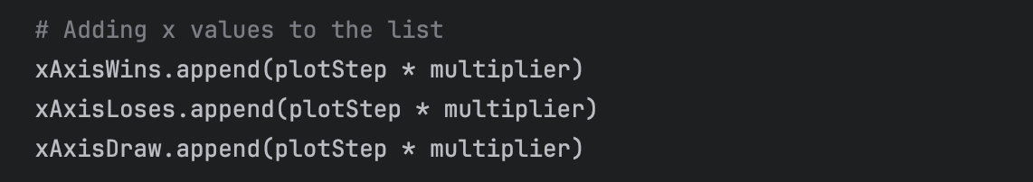

These lines of code calculate the percentage values of wins, losses, and draws based on the number of games equal to plotStep. The variables `victoryNumAI`, `defeatNumAI`, and `drawNum` store the respective counts of wins, losses, and draws. The percentages are calculated by dividing the count of each outcome by `plotStep` and then multiplying by 100 to get the percentage value. Finally, these percentages are converted to integers using the `int()` function.

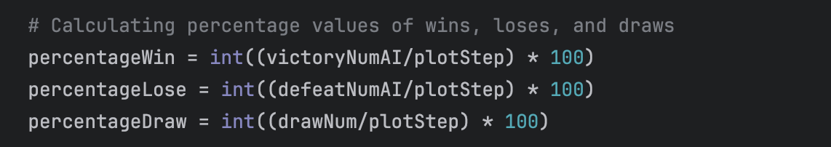

These lines of code add the calculated percentage values of wins, losses, and draws to their respective lists (`yAxisWins`, `yAxisLoses`, `yAxisDraw`).

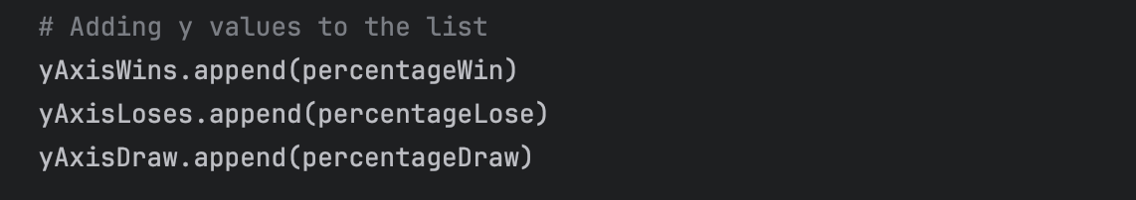

This block of code plots the graphs for wins, losses, and draws using the values stored in the respective lists (`xAxisWins`, `yAxisWins`, `xAxisLoses`, `yAxisLoses`, `xAxisDraw`, `yAxisDraw`) if displayGraph is True.

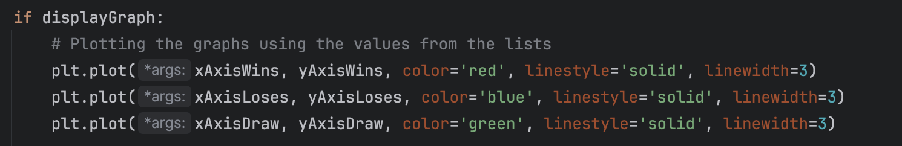

This section of the code converts the calculated percentage values for wins, losses, and draws from integers to strings as in order to display the values on the graph legend, they have to be strings.

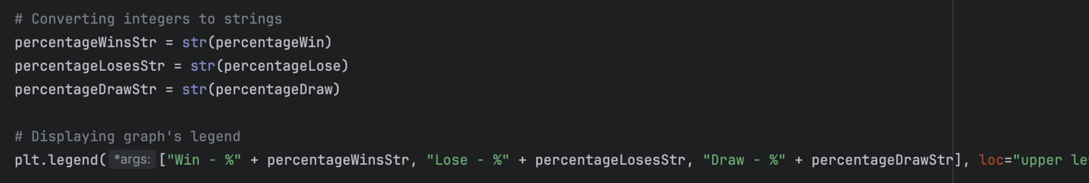

Saves the graph as an image file named "graph.png". Which can then be updated and displayed on the game screen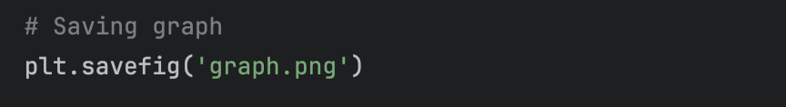

This part of the code resets the variables storing the number of wins, losses, and draws to zero. This is done to prepare for calculating new percentage values for the next set of games (next plotStep number of games).

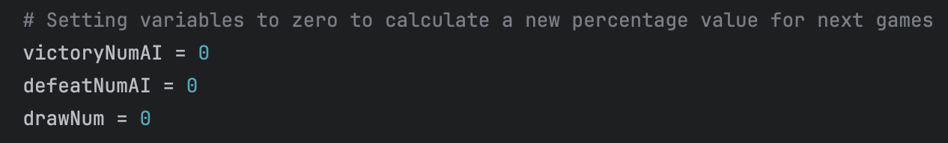

These lines of code inside the `game_screen` function check if a certain number of games have been played since the last update of the graph, and if so, it triggers the plotting of the graph using the `plotGraph()` function.

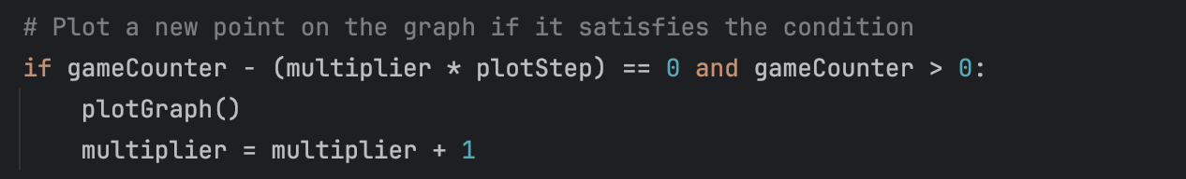

This screenshot shows that if the graph is displayed, the hit box of the "Clear Board" button is adjusted and the button with text is shifted providing space for the graph image to be displayed.

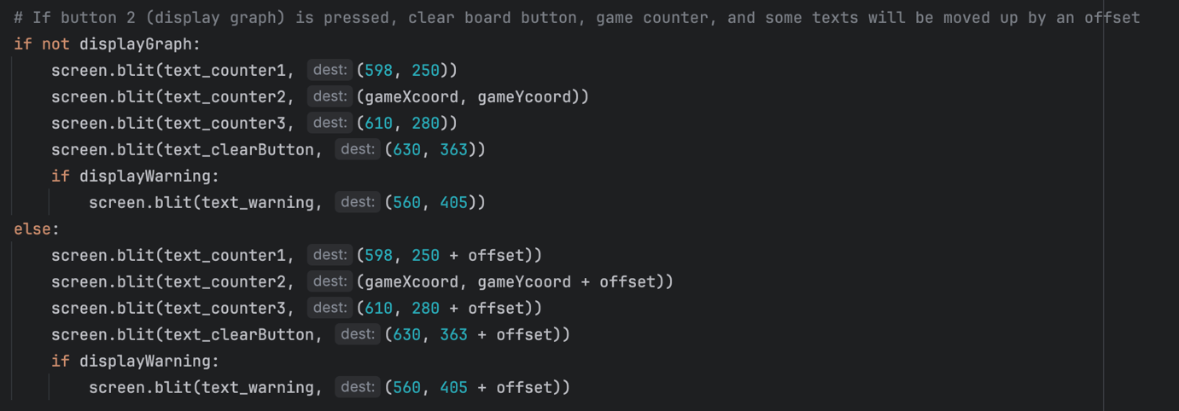

In the settings screen, this section of code defines the functionality for button 2. It checks if the mouse click occurs within the boundaries of button 2. If the button is not already active and the gameCounter is greater than or equal to 50, clicking the button activates it and displays the graph. Otherwise, clicking the button deactivates it and hides the graph.

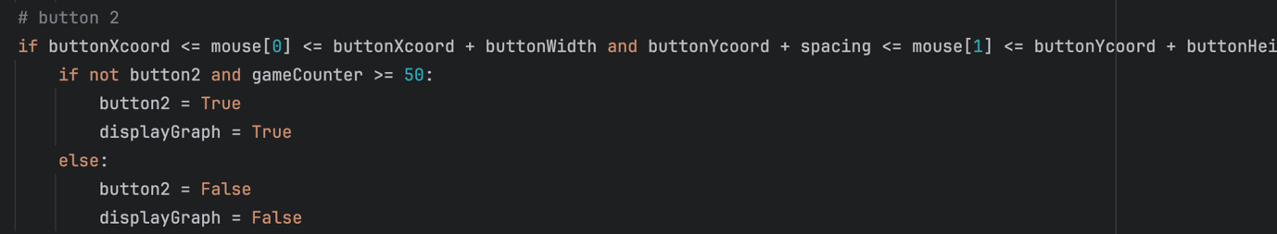

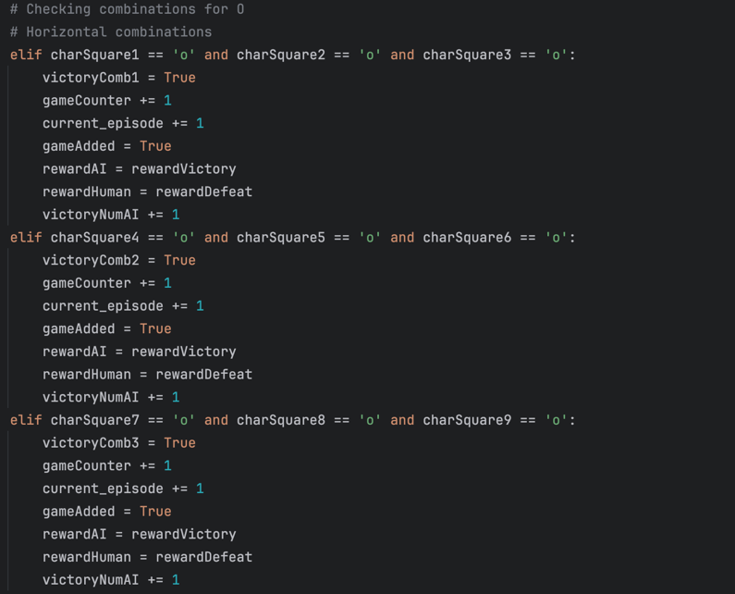

To keep track of the number of wins, losses, and draws, variables victoryNumAI, defeatNumAI, drawNum, were added to the resultDetection function. Once the result is reached a variable of this result is incremented (if it is a draw, then drawNum = drawNum + 1)

To make the graph’s image on the game screen be updated and displayed, its image is constantly loaded from the folder, as it is being resaved there.

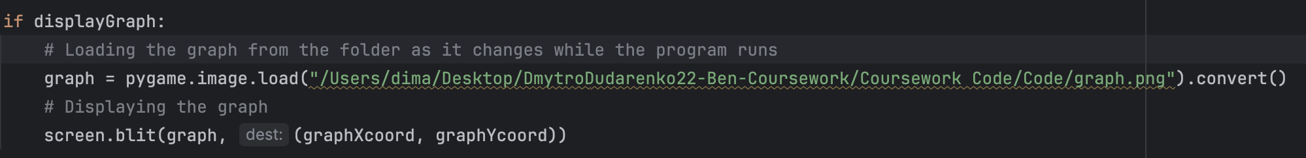

### Bug Fixes:

During the bug fixes stage for the graph, several minor bugs were found along with a few significant ones. The focus was on resolving issues related to plotting function and the graph's interface to ensure smooth functionality and accurate representation of game results.

This is how the first working version of the graph looked like. When I was trying to add the text to display on the axis, it would not fit into the image, as I restricted the scale of the graph. Hence, I had to code the legend for it to add some explanation of what the graph illustrates.

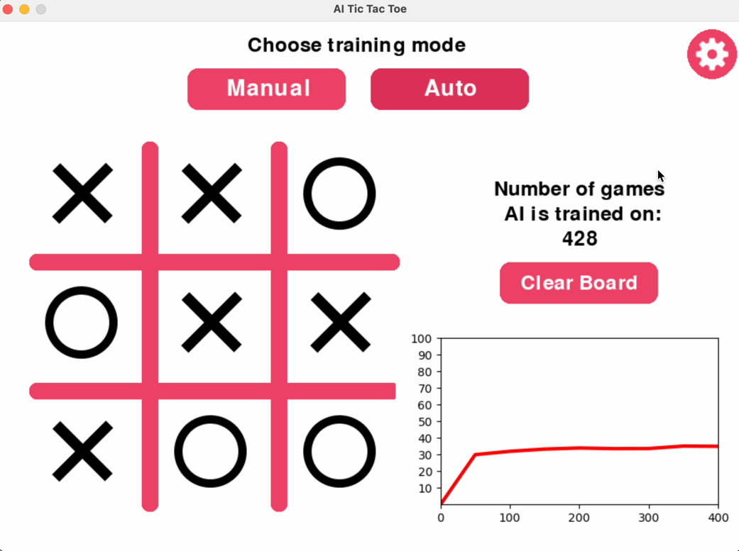

Luckily, all these elements are provided in the library, so it did not take long. However, an error occurred, and the game crashed when the graph was supposed to be updated. Video 8.18 and screenshots below illustrate the bug. 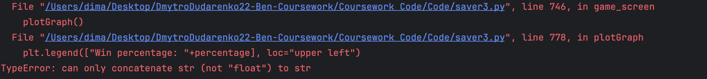

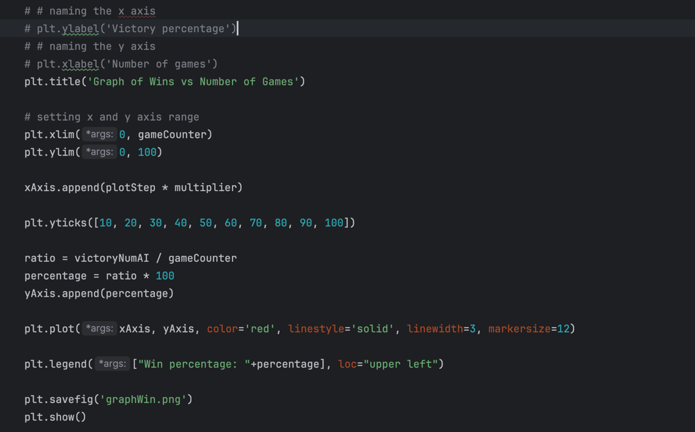

This was due to not converting a “percentage” (percentage of victories) value into string which is required in order to be shown it in the graph legend. The screenshot below illustrates the fix.

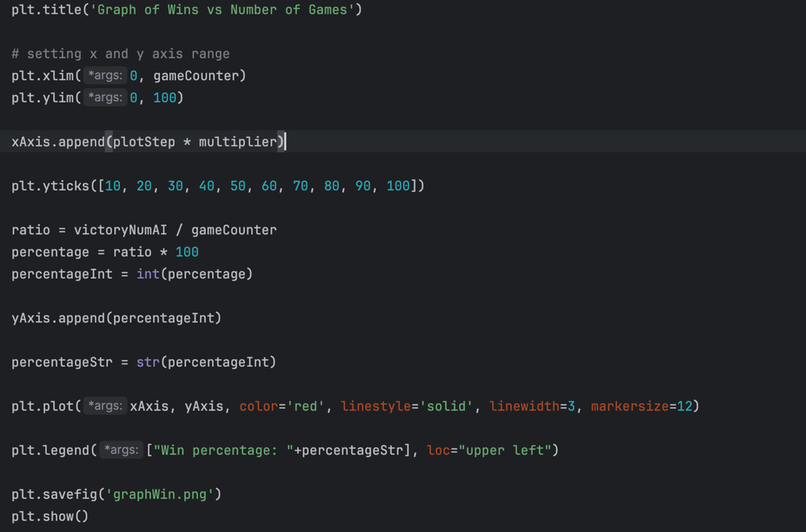

Video 8.22 shows how it works when fixed.

As the first graph was working properly, I decided to calculate defeat and draw rates. To implement this, I created four more lists.

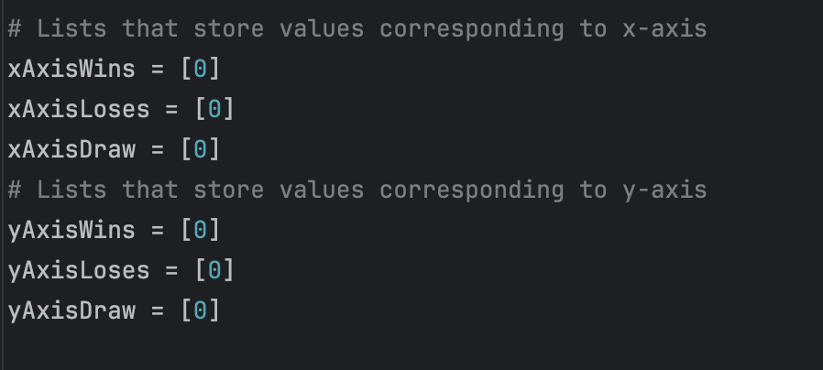

Changed the colour of the lines and added more information to the legend.

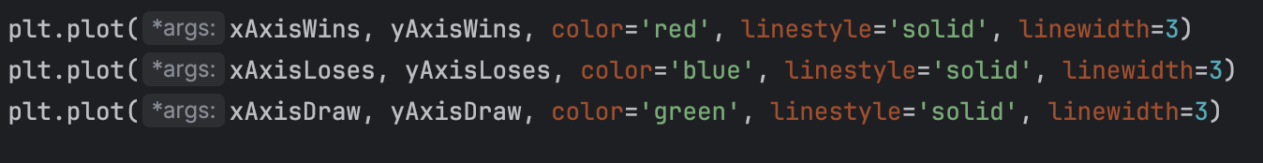

This screenshot illustrates what the new graph image looks like:

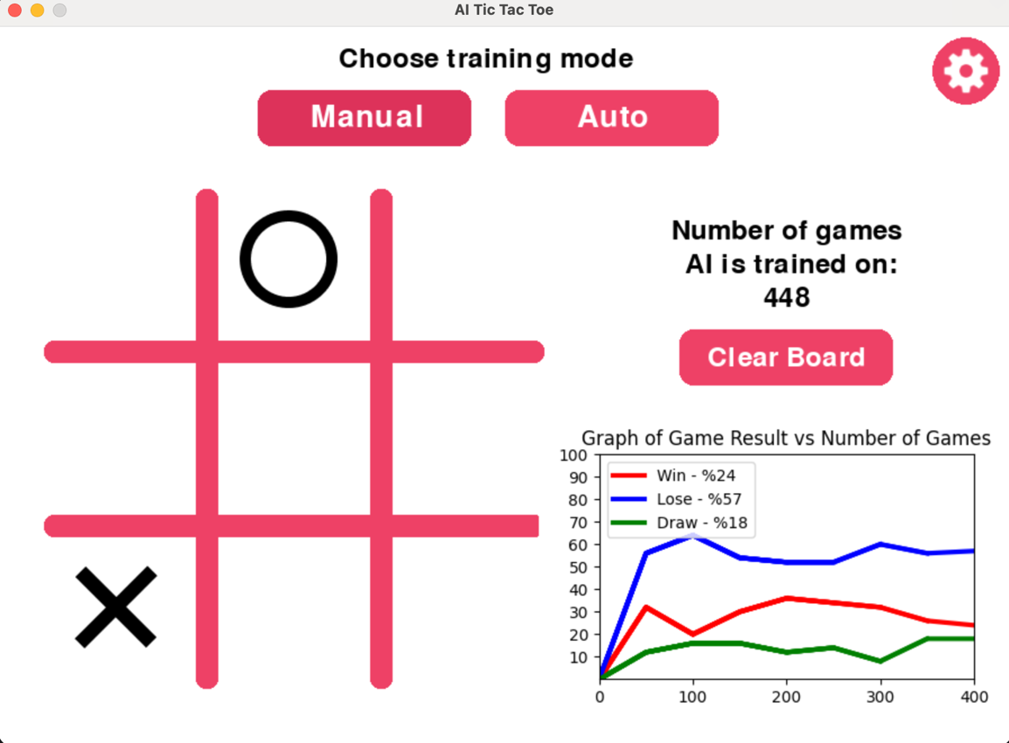

While I was testing how the graph works, I noticed that the game starts freezing every time the graph is updated even though it is not displayed. The video 8.28 shows the freezes. The reason for that was the image was updated every time the plotGraph() function was called, so the solution would be to only update the lists if the graph is not displayed.

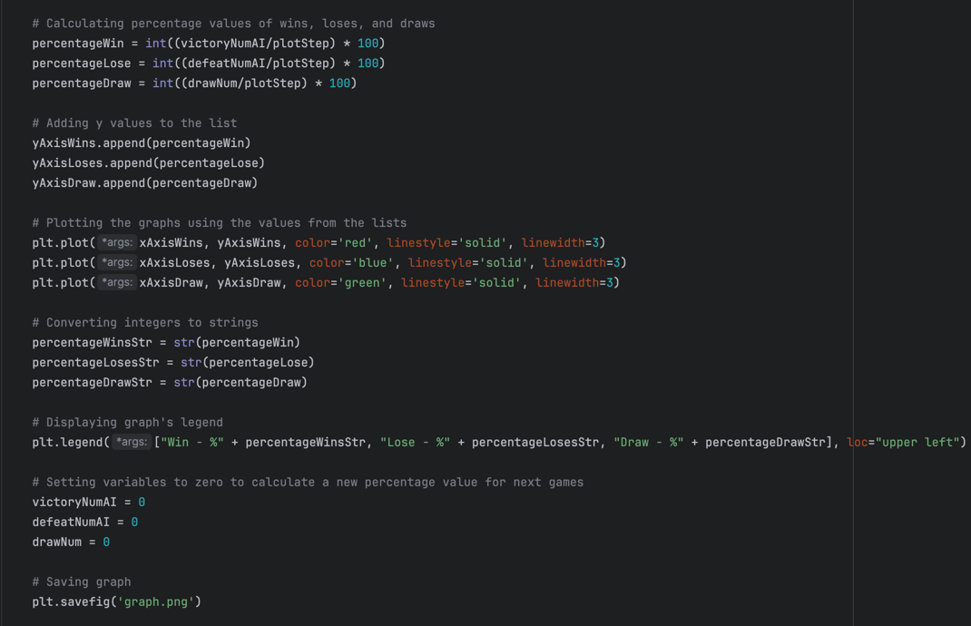

In the screenshot below the changes in code are shown and an optimised version of the game is shown in video 8.31.

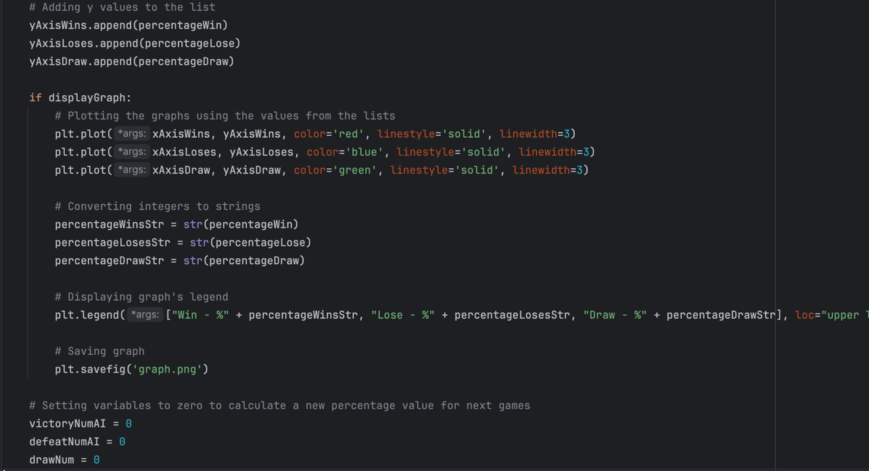

Furthermore, I found one more thing which would reduce the load on the computer because of the graph. X-axis values are the same for all the lines, so there is no point in having three separate lists. Therefore, I merged them into one and changed some lines of code to make the graphs use that list.

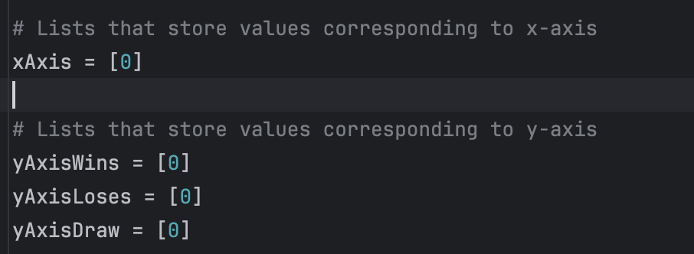

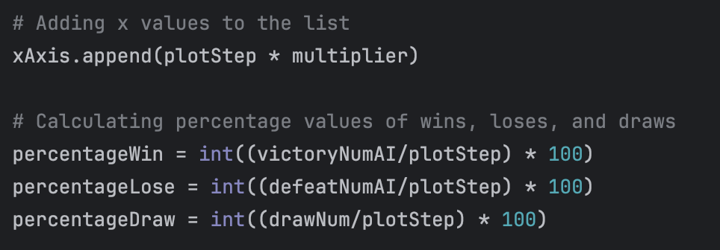

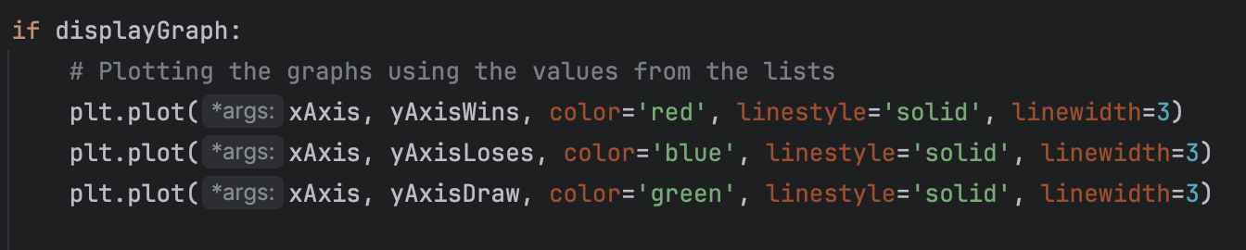

**Tests Table:**

|  |  |  |  |  |  |
| --- | --- | --- | --- | --- | --- |
| Test No. | Description | Type of test | Test data | Expected Result | Actual Result |
| 1 | Does button 2 change its text to ON from OFF and the other way round when pressed? | Valid | Press button 2 | The text on the button should change from OFF to ON or the other way round | Pass  Evidence:  Video 8.36 |
| 2 | Does the graph appear on the game screen when button2 is set to True? | Valid | Press button 2 (make it ON), open game screen | The graph should be displayed on the game screen | Pass  Evidence:  Video 8.36 |
| 3 | Are the points plotted on the graph? | Valid | Display the graph and analyse it | The point should be plotted on the graph | Pass  Evidence:  Video 8.36 |
| 4 | Are the point being plotted every plotStep number of games? | Valid | Display the graph and analyse it | The point should be plotted on the graph every multiple of plotStep number of games | Pass  Evidence:  Video 8.36 |
| 5 | Are the points plotted connected by a line? | Valid | Display the graph and analyse it | The line should go through all the points connecting them | Pass  Evidence:  Video 8.36 |
| 6 | Do all three lines appear on the graph? | Valid | Display the graph and play (use Auto Mode) | All three lines should be shown on the graph | Pass  Evidence:  Video 8.36 |
| 7 | Is graph being updated as the games are being played? | Valid | Display the graph and play (use Auto Mode) | The graph should be updated every plotStep number of games (50 games) | Pass  Evidence:  Video 8.36 |
| 8 | Do values written in the legend update? | Valid | Display the graph and play (use Auto Mode) and look at the legend | The values should be updated every plotStep number of games (50 games) | Pass  Evidence:  Video 8.36 |
| 9 | Are values written in the legend the same as the point on the graph? | Valid | Display the graph and play (use Auto Mode) and analyse the graph | The values should be the same as the y value of the last point plotted | Pass  Evidence:  Video 8.36 |
| 10 | Does button activate when pressed if game counter is 50 or more? | Valid | Open settings and click on button 2 (game counter has to be 50 or more) | The button should be clickable | Pass  Evidence:  Video 8.36 |
| 11 | Does button activate when pressed if game counter is less than 50? | Invalid | Open settings and click on button 2 (game counter has to be 50 or more) | The button should not be clickable | Pass  Evidence:  Video 8.36 |

## Stage 8 Review

The final stage involved implementing a graph to visualise game statistics, particularly the percentage of wins, defeats, and draws. While I was pleased with the end result, there were some technical challenges to overcome, such as freezing when displaying the graph. In fact, if the graph is displayed the game would still freeze and might not register user’s clicks every time, so I would recommend displaying the graph only when in Auto Mode. Despite these issues, the graph added an informative and visually appealing element to the game, giving players insight into the AI learning process.

# Post-Development Stage

## Testing For Function

I have been doing my alpha test plans during the development process (see development stages), and to test the program further I will do a full run of the game displaying each of the features and then move to Beta/Acceptance testing and then to Robustness.

Full Run of the game with voice-over is shown in the video called “FullRun”.

## Beta/Acceptance testing

### Plan

Now that all functionality has been added, and I have tested the program myself, I will beta-test the program. I have gathered a group of people, to test the program. They will then be asked to fill in a form for feedback.

### Questions to ask stakeholders:

|  |  |
| --- | --- |
| Questions | Answer Options |
| 1. How intuitive was the functionality of the buttons throughout the game? | Rating 1 – 10 (10 being completely intuitive and 1 not intuitive at all) |
| 2. How intuitive was the navigation through the menus? | Rating 1 – 10 (10 being completely intuitive and 1 not intuitive at all) |
| 3. How many games did it take you to teach AI to play well (Playing well - the game result is a draw or AI's win)? | Less than 5 000,  5 000 – 10 000,  10 000 – 20 000,  More than 20 000 |
| 4. How useful was the information about the AI's learning process (graph, accessing Q tables, time elapsed, etc.)? | Rating 1 – 10 (10 being extremely useful and 1 not useful at all) |
| 5. How many bugs have you experienced? | 0, 1-2, 3-5, 6+ |
| 6. If you have experienced any bugs, tell which. | Text input field |
| 7. How useful did you find the settings menu? | Rating 1 – 10 (10 being extremely useful and 1 not useful at all) |
| 8. Which setting/settings did you find the most useful? | Time elapsed,  Graph,  Printing out Q-Table for current state,  Getting Q-values for certain state,  Changing decay rate,  Changing learning rate,  Changing discount factor |
| 9. How well did you understand what each of the settings was doing? | Rating 1 – 10 |
| 10. How would you rate the “?” (About) screen design? | Rating 1 – 10 |
| 11. How useful was the “?” (About) menu to help you understand what to do and what the project was about? | Rating 1 – 10 |
| 12. How would you rate the Game Screen design? | Rating 1 – 10 |
| 13. Rate how much did you enjoy the teaching process and playing the game? | Rating 1 – 10 |
| 14. How smoothly did the game run? | Rating 1 – 10 |
| 15. Is there anything that you think has to be improved? | Text input field |

### Survey Results and Feedback Review:

|  |  |  |
| --- | --- | --- |
| No. | Results Review | Possible Resolution |
| 1 | The functionality of the buttons throughout the game was generally rated as intuitive, with an average score of 8 out of 10. This indicates that users found the buttons easy to understand and use for interacting with the game interface. | However, there is room for improvement to further enhance the intuitiveness of certain button functions based on this feedback. For instance, as mentioned by stakeholder 5 in question 15, the use of Manual and Auto modes buttons was not intuitive. So, adding game instructions or making these two buttons a single button would solve this issue. |
| 2 | The navigation through the menus was rated as highly intuitive, with an average score of 8.5 out of 10. This indicates that users found it easy and straightforward to move through different menu screens and access various features. The consistent design and layout of the menus likely contributed to this high rating. | No improvement needed. |
| 3 | The feedback indicates that users spent a significant amount of time playing the game, as it took them between 5,000 to 10,000 games, to teach the AI to play well. | This suggests an opportunity for improvement by reducing the time required for AI development, potentially through more efficient learning algorithms or optimisation of Q-Learning. |
| 4 | Based on user feedback, the information about the AI's learning process received a high rating of 7.8 out of 10 in terms of usefulness. This indicates that users found the provided information, including the graph, accessing Q tables, and time elapsed, beneficial. | This could be improved by adding interactive elements like trackbars instead of text input fields that would allow users to adjust learning parameters. |
| 5 | Users reported experiencing zero bugs, indicating a smooth and bug-free experience. | No improvement needed. |
| 6 | No bugs have been experienced | No improvement needed. |
| 7 | Users found the settings menu to be useful, giving it a rating of 7.5 out of 10. This positive rating suggests that the settings menu effectively provided users with the options they needed to customise their gameplay experience. | To further improve the settings menu, I could add icons to represent different settings to improve accessibility and enhance the overall user experience. |
| 8 | Based on the survey results, the most useful settings identified by stakeholders were the Graph (4 responses) and Time Elapsed (3 responses). Changing the learning rate received 1 response. It's possible that with clearer explanations other functions such as changing the decay rate, printing out Q-Table for the current state, getting Q-values for a certain state, or changing the discount factor could be used more frequently. | A possible resolution would be to add clearer explanations and talk about the functionality of each setting. |
| 9 | Based on the feedback provided, the understanding of what each setting was doing received a rating of 9 out of 10. Which is quite high even though people could not understand the impact of each setting. | I will provide more detailed descriptions for each setting within the menu. For instance, I will add clear explanations, which will help users to understand the purpose and impact of each setting better, reducing confusion. Additionally, organising settings into logical categories will make it easier for users to find and adjust the parameters. |
| 10 | The "?" (About) screen design received a solid rating of 9.3 out of 10. Users found it informative and visually appealing. | It could be improved by adding more interactive elements to the game or implementing Feature 5 – Additional elements, would definitely make the game more engaging . |
| 11 | The "?" (About) menu proved to be useful, earning a good rating of 7.8. Users found it useful on what the project was about and what to do. Its content helped users understand the game's goals. This positive feedback indicates that the menu significantly contributed to user satisfaction. | Adding some game instructions to the description or explaining the functionality of each setting from the settings menu would make it more useful. |
| 12 | The Game Screen design received a rating of 9.8 out of 10. Users liked its layout and visual elements, which allowed them to enjoy gaming experience. The design showed the game's key features and provided intuitive navigation overall. | There were problems with the Manual and Auto modes buttons and also that users expected to have a button allowing them to go back to the main menu which was not provided. Therefore, fixing these issues would make the rating higher. |
| 13 | Users rated their enjoyment of the teaching process and gameplay as 9.3 out of 10. The teaching process allowed users to see the development process of the AI and even influence it. | It could be improved by adding a pre-trained model so the users could play with a well-trained AI instead of having it to train form the very beginning every time. |
| 14 | Users found that the game ran smoothly, giving it a score of 9 out of 10. This means that the overall performance of the game was on a good level, with minimum technical issues. While there may have been some minor freezes, possibly due to the graph, the majority of users experienced smooth gameplay. | Fixing the issue with the graph (explained in stage 8) is the only improvement I would suggest. |
| 15 | Stakeholders had lots of ideas for improvements and here is the summary:  Users suggested that there should be an explanation of every step in the game's process. Meaning that they would expect to read about AI's decision-making process. Additionally, creating a pause between the user's move and the AI's response was suggested. This feedback will help to enhance the game's usability and enjoyment in the future. | I think it would be definitely worth implementing additional instructions as stakeholders mentioned that the game was not extremely intuitive. However, creating a pause in between moves would only make the game slower and not improve user experience in my opinion, hence I would probably not implement it. |

## Robustness testing

### Plan

Now that all functionality has been added, I have tested the program myself, and my stakeholders have given feedback on the main areas. I will test the boundaries of my program trying to break it and find its maximum performance abilities. Furthermore, my task will also be to identify the parts of the system that are most vulnerable to failure and to determine how the system can be made more resistant to failure.

### Tests table

|  |  |  |  |  |  |
| --- | --- | --- | --- | --- | --- |
| Test No. | Description | Test Data | Type | Expected Result | Actual Result |
| 1 | Does the game run according to the requirements on different OS? | Windows, MacOS | Valid | The game will function the same on different OS. | Pass  Evidence (Robustness Folder):  Video FullRun – MacOS  Video 1 - Windows |
| 2 | Does the game freeze or crash if the buttons are pressed a lot of times in a short period of time? | Clicking on the button very fast | Valid | It should not affect the game | Pass  Evidence:  Video 2 |
| 3 | Does AI have enough time to analyse and make a new move if user makes moves really fast? | Putting characters on the grid fast | Valid | Machine’s speed is way faster than a user can possibly click, so it will not affect the program | Pass  Evidence:  Video 3 |
| 4 | Does the counter display the number in the wrong place as it reaches 6-digit values? | Turn Auto Mode and wait till game counter reaches 100 000 | Valid | The counter should be displayed correctly even when there are six digits | This boundary has been foreseen in the development process, so the counter’s location will be correct up till the 9-digit value, which is extremely unlikely to be reached.  Evidence:  Video 4 – 100 000 Games  Video 5 – 1 000 000 Games |
| 5 | Is entering incorrect values for the inputs in the settings menu being validated? | Press on the buttons that require terminal input and enter a value that is out of range or a character. | Invalid | A message asking for another input is output and an incorrect value is not accepted | Pass  Evidence:  Video 6 |

## Evaluation

### Summary

In this section, I will be evaluating the work from my development stages against my initial user requirements and design. I will also discuss where and how my solution can be improved, as well as what impact it has on users based on the feedback received from the beta testing.

### Evaluating Features (user requirements and success criteria)

I will be evaluating the features implemented in the final product against the user requirements p.11 and stages of development p.24 and explain in detail how each of them has or has not been met as well as possible improvements.

**Feature #1 – Menu Screen:**

This feature included several sub-features – Title, Sub-Title, Robot Image, Background Image, and Play Button and a button “?” (About screen)

**Success Criteria:** All the sub-features are implemented – text and background images are displayed; Play Button is displayed and sends the user to the game screen on click as well the “?” button which opens the about screen. The menu screen looks the same as on the design concept

**Criteria Met:** MET

**Development:** Video1 (Evaluation folder) or refer to Stage 5 – Menu Screen and Stage 6 – Menu Screen in the Development Section for more details

**Test Evidence:**

**Stage 5**

|  |  |
| --- | --- |
| Requirement number and name | Test No. checking this requirement |
| 1a. Title | 2 |
| 1b. Sub-title | 2 |
| 1c. Robot image | 5 |
| 1d. Background image | 5 |
| 1e. Play button | 3 |
| 2a. “?” (About) button | 4 |

**Stage 6**

|  |  |
| --- | --- |
| Requirement number and name | Test No. checking this requirement |
| 1e. Play button | 3 |
| 2a. “?” (About) button | 4 |

**Comments:** This criterion was successfully met; the system allowed the user to navigate through the menus and access the about and the game screens. Furthermore, the text is displayed as well as the background images. In addition, an element called “Easter Egg”, which was recommended by one of the stakeholders, has been implemented.

**Improvements:** The main thing I am not happy about is the buttons’ hitboxes (see Stage 6, bug fixes, p88) which are greater than the visually represented buttons. This could have been fixed by getting rid of the rounded shapes, but the whole design is built using rounded objects (buttons, grid, background images, etc), therefore I decided not to change that and keep the bug with hitboxes as it does not have a noticeable negative influence on the game.

**Feature #2 – About Screen:**

This feature included several sub-features – Title, Description, Background design, and Close Button.

**Success Criteria:** All the sub-features are implemented – title, description, and background design are displayed; Close Button is displayed and sends the user back to the menu screen on click. The about screen looks the same as on the design concept

**Criteria Met:** PARTIALLY MET

**Development:** Video1 (Evaluation folder) or refer to Stage 5 – About Screen and Stage 6 – About Screen in the Development Section for more details

**Test Evidence:**

**Stage 5**

|  |  |
| --- | --- |
| Requirement number and name | Test No. checking this requirement |
| 2b. Title | 1 |
| 2c. Description | 1 |
| 2d. Background Design | 3 |
| 2e. Close Button | 2 |

**Stage 6**

|  |  |
| --- | --- |
| Requirement number and name | Test No. checking this requirement |
| 2e. Close Button | 2 |

**Comments:** This criterion was partially met. This was due to the fact that it was not as useful as I thought it would be (the reason why is explained later). However, this screen looks exactly as it was designed initially and the functional side is working correctly.

**Improvements:** From the feedback form (Review of Question 9) I have understood that it is not clear what some of the settings are doing, for instance, how does changing decay rate influence AI’s training progress. And this information could go into the about screen along with other technical details, which would make the about screen much more useful and it would become more useful. This would not require a lot of effort or time.

One more possible improvement is to change the design of the about screen and make it more like a guide through the game by showing the buttons, where the user can find them, and telling what they do rather than having pure text

**Feature #3 – Game Screen:**

This feature initially included many sub-features which were essential and not. In the development process, the plan has changed and consequently the success criteria, it is discussed in Stage 4 why the game screen layout was changed.

Essential - Text – “Pick a character”, Grid, A character appearing on the grid when the user clicks, Line crossing winning combinations, Clear Board button.

Inessential - Button for “X”, Button for “O”, Score, Games played number.

**Success Criteria:** All the essential sub-features are implemented – text is displayed, the grid appears on the screen and each square is functional, the line crossing winning set is displayed when victory is detected, and the clear board buttons reset the grid when the user clicks on it.

**Criteria Met:** MET

**Development:** Refer to Stage 1, Stage 2, Stage 3 – A Win, and Stage 3 – A Tie, in the Development Section

**Test Evidence:**

**Stage 1**

|  |  |
| --- | --- |
| Requirement number and name | Test No. checking this requirement |
| 3a. Text – Pick a character | 7 |
| 3b. Button for “X” | 4 |
| 3c. Button for “O” | 5 |
| 3d. Score | 3 |
| 3e. Grid | 2 |
| 3h. Games played number | 3 |
| 3i. Clear Board button | 6 |

**Stage 2**

|  |  |
| --- | --- |
| Requirement number and name | Test No. checking this requirement |
| 3f. A character appearing on the grid when the user clicks | 1a, 1b, 2a, 2b |
| 3h. Number of games played | 3 (is completed in stage 3) |
| 3i. Clear Board button | 4 |

**Stage 3**

|  |  |
| --- | --- |
| Requirement number and name | Test No. checking this requirement |
| 3g. Line crossing winning combination | 1a, 1b, 1c |
| 3h. Games played number | 2a, 2b, 2c |

**Comments:** The initial criterion was successfully met, as I spent less time on it than I expected, I decided to implement inessential features such as games played number, Button for “X”, Button for “O”, and Score. When AI was implemented the game screen experienced significant changes, and I realised that it was not worth implementing those inessentials.

From the feedback form, I understood that it was not clear to the stakeholders how to use the buttons Manual and Auto. In fact, the way to turn them off was not clear. They were trying to click on the same button they used to turn the mode on to turn it off, for instance, they clicked on the auto button and turned it on and then to turn it off they had to click on the manual button, but they were clicking on the auto mode button.

**Improvements:**

The main improvement is to make the mode-changing buttons more intuitive. The solution is to display text below the buttons like if manual mode is picked, then text – “make a move” is displayed. If auto mode is picked, then press manual button to stop is displayed. I guess this will help to get rid of the confusion and improve the user experience. This can be easily done and will not require a lot of time, but as it seemed intuitive for me in the development process, I did not expect that to be a problem and therefore did not add it.

**Feature #4 – AI:**

This feature included these sub-features:

Essential – AI Development.

Inessential – Second AI.

**Success Criteria:** The AI is implemented and fully functional. It develops as it plays more games, analyses the board’s state, and makes a decision on what is the best move to make in each situation.

**Criteria Met:** MET

**Development:** Refer to Stage 4

**Test Evidence:**

**Stage 4**

|  |  |
| --- | --- |
| Requirement number and name | Test No. checking this requirement |
| 4a. AI Development | 1, 2, 3, 4, 5, 6, 7, 8, 9, 10, 11, 12, 13, 14 |
| 4b. Second AI | 9, 10, 11 |

**Comments:** The essential criterion has been met, AI is making moves, it analyses the states of the board, keeps track of them, assigns each possible in each state its Q-Value and uses it to decide on the next move. As described in Stage 4 (see page 60) a second AI was added to the game, which was an inessential feature but as I understood that it would significantly increase the AI’s learning rate and, hence, improve user experience, I decided to add it.

**Improvements:**

The main improvement would be to give users access to the trained model. This could be done by training a model, saving the Q-Table for it, and offering users the option to select between training the AI themselves or using the pre-trained model.

**Feature #5 – Additional elements:**

This feature consists of such sub-features:

Inessential – Sounds, Animations, Localisation, Colour Theme

**Success Criteria:** The sound effects are added to the game. There is background music and every click on the game element (button, grid, etc) is represented by a sound. The characters are displayed with an animation and the line crossing the winning set smoothly crosses the characters within that set. Moreover, there is a visual response on the user’s click on the button. In addition, there is a button which allows user to change the language of the game.

**Criteria Met:** NOT MET

**Development:** Has not been implemented at all, so no stages to refer to.

**Test Evidence:** Has not been implemented at all, so there is no test evidence.

**Comments:** This feature has not been implemented at all. On one side it would enhance the use experience, improve accessibility, make the game look much more polished, and even make it more engaging. On the other side it would put additional load on the computer and the game was already freezing because off the graph, so this could make the game unplayable. Obviously, the implementation would also require a lot of time which I did not have. Therefore, I decided not to do it.

In the design form that stakeholders filled out, they said they expected localisation, so it was a bit disappointing for them to see the final version without it. However, when I explained the reason for not implementing it, they agreed that I made a good decision.

**Improvements:**

The improvements to the game would be to fulfil all the requirements for that criterion. I would start by creating a condition that animation is only shown when the game is in manual mode to decrease the load on the PC. Then I would add the animation to line crossing the winning set as it would make the most visible difference and the background music. After that, I would test the game on how much it froze, and if the performance was good enough, I would continue adding animations.

Another criterion to fulfil is localisation. I would create a button in the settings menu which would alternate from English to Ukrainian on click or if there were more than two languages it would look like a dropdown menu with several languages as options.

**Feature #6 – Settings Menu:**

This feature consists of such sub-features:

Inessential – Settings influencing AI’s learning rate, Settings displaying statistics, Background design, Close Button, Settings Button.

**Success Criteria:** The settings menu is accessible from the game screen, settings influencing AI’s learning rate and settings displaying statistics are implemented. The design is minimalistic and similar to the About Screen design. Close and settings buttons are functional.

**Criteria Met:** MET

**Development:** Stage 7, Stage 8 in the Development Section

**Test Evidence:**

**Stage 7**

|  |  |
| --- | --- |
| Requirement number and name | Test No. checking this requirement |
| 6a. Settings Influencing AI’s learning rate | 1-17 |
| 6d. Close Button | 18 |
| 6e. Settings Button | 19 |

**Stage 8**

|  |  |
| --- | --- |
| Requirement number and name | Test No. checking this requirement |
| 6b. Settings Displaying Statistics | 1 - 11 |

**Comments:** The success criteria for the settings menu have been achieved. From that menu users can influence the AI's learning rate and also have a greater control over the game. Additionally, the settings display relevant statistics like a graph, Q-Table, time elapsed have been added. The background design of the settings menu is similar to the design of the About Screen which keeps a visual consistency. Both the Close Button and Settings Button are fully functional, allowing users to navigate the settings menu easily.

**Improvements:**

The first and most significant improvement that I wish I could have made is to fix the freezes that occur when the graph is displayed, and that user’s clicks are not detected from the first time when it is displayed. More details about this problem are provided in Stage 8, also in video 3 (Evaluation folder) illustrates it. It can be seen that the more games are played, the more points appear on the graph, and the more the game freezes. Therefore, one of the improvements is to split the program into separate threads, which is quite complicated to do. Another way is to decrease the number of points by increasing the plotStep over time or when 50 points are plotted, split them into 5 groups of 10, calculate group averages and plot them, which would make 5 points from 50. This will increase uncertainty in the graph, but in the same make the game freeze less. The reason why it was not implemented is due to deciding to spend more time on this document, as I noticed the problem at the very end of the development.

Another improvement could involve a complete redesign of the menu layout to create some space for button descriptions. This change would provide users with understanding about the function of each button and its impact on AI.

### Evaluating Stakeholder Preferences:

In this section, I will be referring to the survey I asked when doing analysis and comparing the data from it to the final product.

|  |  |
| --- | --- |
| Criterion | Review |
| Additional Menus in the game (main menu, game menu, etc) | The initial rating of importance for this criterion was 7.2. The criterion has successfully been met, with a total of four menus present in the game: main, game, about, and settings. However, there is room for improvement in the design and layout of the about and settings menus to improve their functionality and design. Further development could focus on developing these aspects to provide a better user experience across all menus. |
| Changing parameters influencing AI’s learning rate | The initial survey indicated that 66% of stakeholders expected to be able to change parameters influencing the AI's learning rate. This criterion has been successfully met, satisfying stakeholders' expectations. On the other hand, it could be improved by implementing a text input field directly within the settings menu. This would improve the user experience, increasing accessibility, and usability, as there would be no need for users to access the terminal to change parameters. |
| Visual representation of AI’s learning rate | The survey indicated that 56% of stakeholders expected a visual representation of the AI's learning rate, which has been successfully implemented. However, there are some issues with the graph which cause game freezes when it is displayed. In further optimisation the freezing issue has to be fixed to enhance the user experience. |
| Visually responsive elements | The rating for this criterion was 9.6, indicating a high level of importance of this criterion. The implementation of visually responsive elements, such as buttons changing colours on hover, has met stakeholders' expectations. Nevertheless, it could be improved by adding more visually responsive elements in future. |
| Localisation | The initial rating for this criterion was 5.2, showing that stakeholders considered this feature as quite important. Unfortunately, this criterion has not been met. Although localisation could enhance accessibility, it was not really feasible for this project as it will not be used by a large number of people. If I were to develop this further, I would implement localisation to improve accessibility and user experience. |
| Different colour schemes | The rating for this criterion was 5.8, showing moderate importance to stakeholders. However, this criterion has not been met. Offering different colour schemes could enhance accessibility, but this would require creating new designs, uploading different images to the game, and changing text colours, which would probably not be worth it at this stage of the project. However, I would still consider implementing this feature in the future to improve the overall user experience. |

### Evaluating Design Changes:

Throughout the development process, my project has been changing a lot either due to not being able to implement the original design concept or because the changes would improve the user experience and the game look overall. I provided examples of the changes and how they influenced the final design and the way the user interacted with the system.

#### Game screen:

The game screen experienced a substantial number of changes. At first, I thought that the initial design included all the needed elements and that it would look the same at the very end. However, the more elements I added and understood the complexity of the task, the more I realised that the layout had to be changed. Some buttons became useless, and some had to be added instead. These changes allowed me to achieve optimal user experience in the final product.

**Change #1 – Buttons for X and O**

They were created to allow the user to change its side and make AI learn how to play for different characters, as the one who plays for X has more chances to win. However, when AI was implemented, I understood that changing the characters would mean having different AIs which would develop separately and this would mean using more memory and for the user, it would require to spend much more time on teaching AI. Therefore, I decided to get rid of those buttons and add an auto mode button instead, I also added a manual mode button to let the user switch between the modes.

**Change #2 – Score counter**

Having a counter that would show the number of AI wins and losses seemed like a good idea at first glance. But then I realised that the score would quickly become 0 : 100 and then 0 : 1000, which led to a conclusion that it was completely irrelevant.

**Change #3 – Settings Menu**

This menu was planned but as nonessential initially as I was unsure whether or not I would be able to implement all I had planned before the deadline. As I finished coding earlier and still had time, I thought that it would be a good idea to add a settings menu which would allow users to change Q-learning parameters without accessing the actual code. Moreover, when I was testing AI, I would always print the Q Table out for the current state to see if it was being updated, so that was also added as a setting. Therefore, I had to slightly change the design of the game screen and also design a whole new menu.

#### All screens:

**Change #1 – Buttons Design**

In my initial design concept, the buttons consisted of two layers and had a shadow below them (see p20). When I was coding them, I realised that creating a shadow is complicated and timewise it might not be worth it. Moreover, it would not significantly improve the user experience. It was not noticed by the stakeholders, so my decision did not have any drawbacks.

### Evaluating Usability:

In this section, I will be evaluating the usability of the game based on my personal experience and stakeholders’ feedback. In the beta testing section (see page 141) I discussed the program’s usability features and how it can be improved.

#### Main menu:

I can say for sure that the main menu is a success. It provides clear navigation and intuitive design elements. Users can easily navigate between different sections of the game, such as accessing the game menu or learning more about the game through the about menu. Additionally, the visual aesthetics of the main menu contribute to an engaging experience, enhancing overall usability and user satisfaction.

#### The stakeholders rated its usability and navigation high. Users were satisfied with the clear navigation and intuitive design elements present in the main menu. They found it easy to navigate between different sections of the game, such as accessing the game menu or learning more about the game through the about menu. Additionally, stakeholders liked the design of the main menu, which enhanced overall usability.

#### About menu:

The about menu, unfortunately, has not meet the desired level of usability. While it is being an engaging introduction to the game, providing users with background information and context, its utility does not meet my expectations. Personally, I find myself dissatisfied with its contribution to the game's functionality. It could have significantly enhanced usability if I added technical details of the game into the description. Moving forward, I will explore ways to change the about menu to make it a more informative and integral component of the user experience.

#### Settings menu:

The setting menu was a huge success, which exceeded my initial expectations with its functionality and user-friendly design. It was done in the project's style, so it seamlessly integrated into the game providing simple navigation for users. The intuitive layout and clear labelling make it easy for users to explore various settings and adjust the AI. Overall, the setting menu shows an effective usability design, enhancing the overall user experience and contributing to the game's success.

The stakeholders' rating of 7.5 shows that they are happy with the settings menu's usability. It means that they found the menu intuitive and easy to navigate. By analysing feedback and identifying weak areas, I aim to improve the settings menu's usability further by adding input fields, adding localisation, and an option to change the colour scheme of the game into the settings.

#### Gameplay:

I am satisfied with the gameplay experience, both the visual side of the game screen and the functionality of the AI. The gameplay experience is user-friendly, with intuitive controls. Although some minor confusion was encountered with Manual and Auto buttons, as described in the previous section, overall, it was good. Furthermore, the AI implementation fulfilled my expectations, showing a learning mechanism that adapts and improves over time. The grid along with character displaying and result detection algorithm works correctly without any bugs which is also a success.

The gameplay experience has mostly met stakeholders' expectations. Users have found the gameplay to be intuitive and engaging, with positive feedback about design and functionality of the game screen. However, stakeholders wish there was an option to play against a developed version of AI.

### Limitations and Solutions:

All the limitations were discussed and justified in the Analysis Section, p16.

#### System Performance and Space:

**Limitation:** Because of the amount of data stored and updated each fraction of a second, especially when in Auto Mode with the graph displayed, a load on the processor is considerable, therefore it could make the game freeze more on less powerful computers, not allowing to enjoy the gameplay.

**Solution:** It involves implementing different modes tailored for different computer capabilities. For instance, on less powerful PCs, a mode could be designed to optimise performance by not displaying certain visual elements, such as displaying characters on the grid during Auto Mode. This would ensure a smoother gameplay experience for all users, regardless of their computer specifications.

#### Language:

**Limitation:** One notable limitation of the game is its availability only in English, which may create challenges for players who do not speak the language. This limitation can restrict accessibility and may not let potential players enjoy the full gameplay.

**Solution:** To solve this language limitation and enhance accessibility, I will implement multi-language support within the game. This will allow players to choose their preferred language from a list of available options. This will enhance accessibility and broaden access to the game to a bigger audience.

#### Multiple Windows:

**Limitation:** PyGame module does not allow having multiple windows.

**Solution:** I used a single window for all the menus as I basically managed to reset the screen for each menu, allowing the necessary menu design to appear on the screen when needed.

### Maintainability:

During the development process, I was trying to make this project maintainable for future developers using these methods:

|  |  |
| --- | --- |
| Method | Justification |
| Comments | I commented all functions and variables throughout the code, to explain the purposes of each section of the code. |
| Naming | Functions and variables are named clearly and sensibly to give insight into their function. |
| Diagrams and Flowcharts | Throughout the developments process, I have shown flow charts and a structure diagram to explain how algorithms and logic of the game work. |
| Modularity | The code is separated into functions, therefore it is ready to read and maintain. |

**Potential future maintenance:** Updating libraries used to the newer versions, fixing all the bugs found and discussed in the Beta-Testing and Evaluation, implementing desirable features from the user requirements that have not been added.

### Conclusion:

In summary, the AI Tic Tac Toe project has been a combination of ambitious goals and dedicated effort. In the beginning, I wanted to create an engaging gameplay experience that would allow users to train their own AIs. Despite facing problems such as time and system limitations, I successfully managed to bring my initial ideas into reality, prioritising essential features while setting aside less critical elements.

The project's development stages were carefully planned and executed, with a focus on creating an MVP and then improving it. Starting with simpler components helped me get used to how AI works and improve my programming skills along the way. The thorough analysis done before development let me understand the features necessary for AI to function.

Effective time management played a crucial role in maximising productivity and implementation of essential and inessential features to the project.

While the project largely met stakeholder expectations, there are some areas for improvement, particularly in intuitiveness. Feedback from stakeholders highlighted the usability of menus and the design as a strength, however, identified room for improvement in the gameplay experience.

Last but not least, I am dedicated to improving the AI Tic Tac Toe project by resolving current issues, limitations, and adding new features to make the gameplay even better. I aim to make the game more engaging and polished, demonstrating the exciting possibilities of artificial intelligence.

## Development Plan Changes (DPC)

### Summary

This section is created to explain some of the changes that I have made to the initial plan due to the factors that I did not think of beforehand.

|  |  |
| --- | --- |
| Change No. | Explanation |
| 1 | The counter implementation was initially added to Stage 2. However, while coding it, I realised that I wouldn’t be able to use it until the game was somehow functional, meaning that I must add the winning detection function (Stage 3) first and the counter afterwards. For now, I created a variable for the counter and displayed the text related to it. |
| 2 | As I tested the game, I realised that it was not very clear to the user if the character was picked because the only way to find out was to click on the grid and see what was displayed. Due to this, I made the button of the picked character to keep a darker shade to indicate the current user’s side. And as it was not initially planned there were no tests for this, so I added them to the tests table of Stage 2 |
| 3 | In the process of developing AI, I understood that it would be complicated to allow user to change the character as it would influence the Q table, which meant I either had to create 2 separate Q tables and use them depending on user’s choice of character or get rid of this functionality and use that space for something else and I picked second option. |
| 4 | Now the user is unable to reset the board before finishing the game, hence the reward will always be given correctly. |
| 5 | I decided to get rid of this additional check as it does not significantly affect the performance of the game and just adds more work to do. |
| 6 | Later I got rid of the variable called victoryDetected, as I had to access it globally in lots of functions and also there was no sense to keep this variable because I could just make victoryDetected return true or false depending on the result. |